Volume

1

sTOCKTON uNIVERSITY

INFORMATION ASSURANCE & SECURITY

Pen-Test Project

bY:

MICHAEL CHILLEMI

Table of Contents

Installing All Applications 1

Using Media Creating Tool For Windows 10 iso 5

Creating Virtual Machine of Kali Linux and Windows 10 6

Booting, Updating, and Network Configuration in Kali Linux 17

Install Dradis 26

Booting and Network Configuration in Windows 10 34

Verify Conection Between Kali and Victim 56

Attacking Windows Machine 61

Reviewing Dradis Report 87

Conclusion 90

Section

1

Installing All Applications

Steps for Installing virtual box:

To be able to conduct this attack first you will need to install virtual box, kali Linux, and Windows 10 iso.

First you must go on a web browser and download virtual box. (It should be one of the first links on virutlaboc.org)

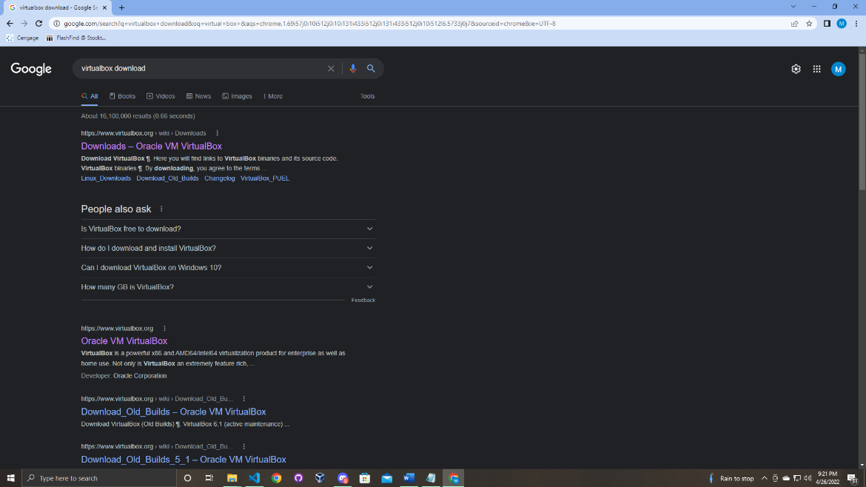

Once you click on the link you should be brought to this page.

Download the proper link for your operating system. (In this manual a windows machine was used)

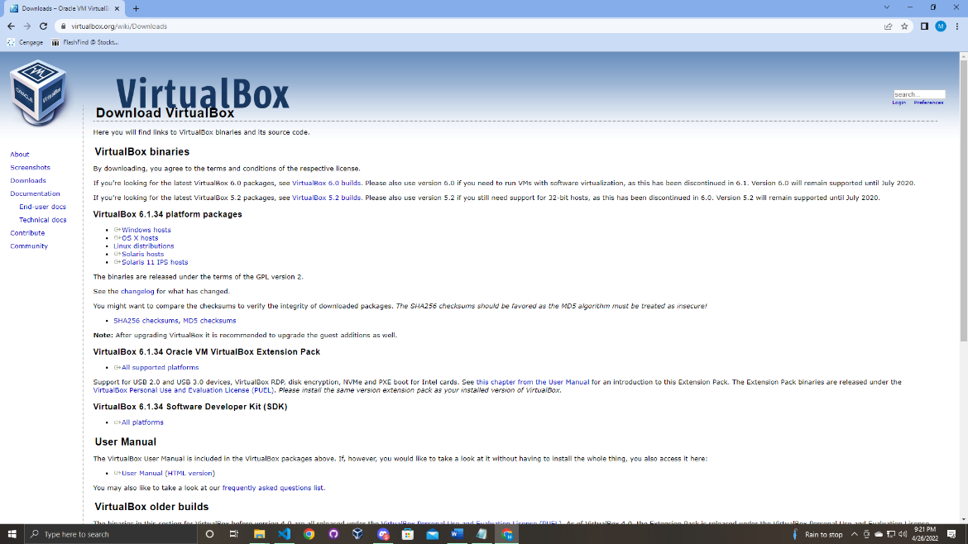

Once you download the installer run it and follow the steps that will be prompted to you.

After virtual box is downloaded do not open it yet.

First you will need to download kali Linux in order to do this go to your web browser again and type in the URL bar “kali Linux download”.

After hitting enter it should be the first link.

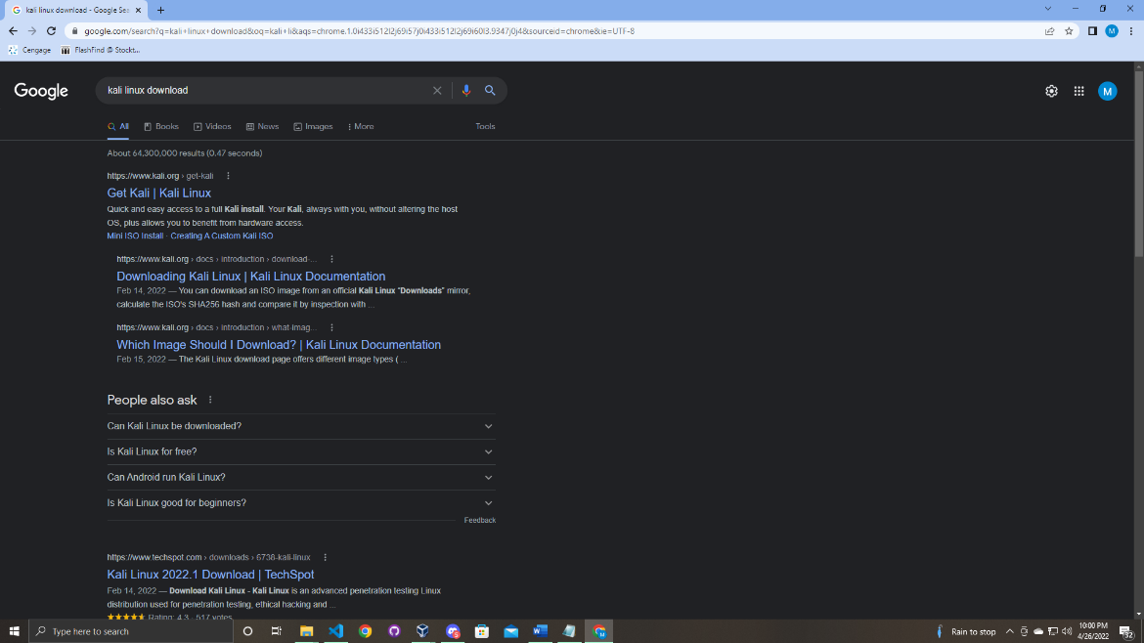

Once opened you will be displayed with many options. (Kali Linux can be used in many ways)

But for this attack to work we will click the virtual machines option.

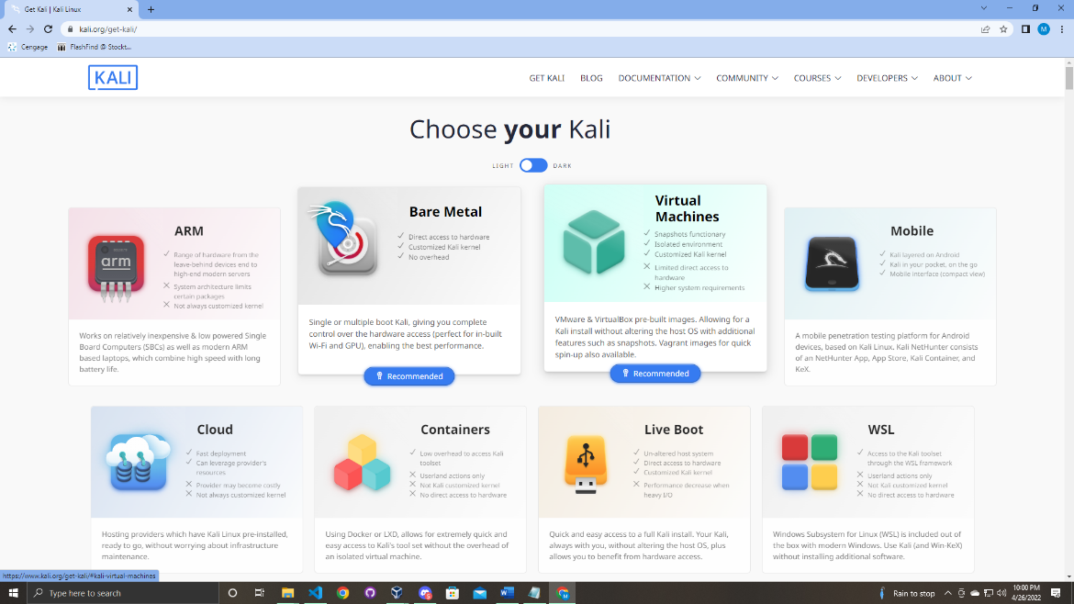

When you are prompted to this page will download the virtual box option.

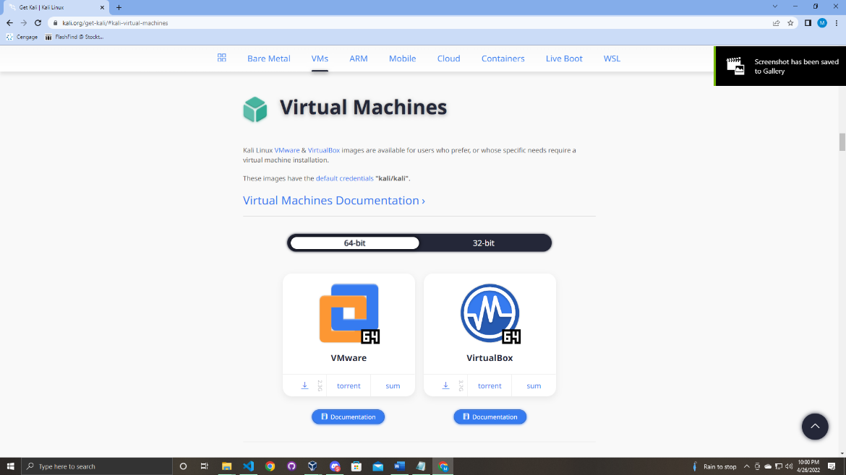

Once download go back to your browser one last time. We need a Windows 10 iso file to create the victim machine.

When in your browser type “windows media creation tool”.

As the same as the above steps, it should be the first link.

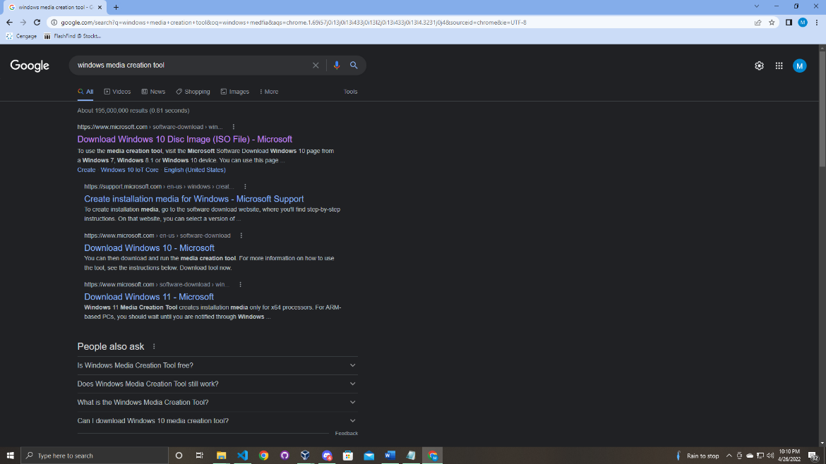

Next you should be prompted on this page download the tool and run the set up once it finishes downloading.

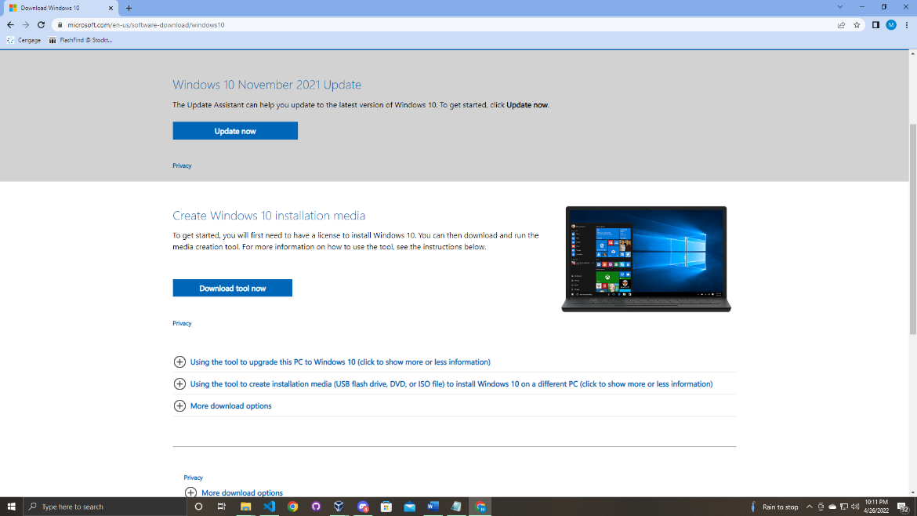

Once the setup is completing follow the steps below to create the windows 10 iso file.

Steps to Creating Windows 10 iso File

1. On the [Windows 10 download page](https://go.microsoft.com/fwlink/p/?linkid=617364), download the media creation tool by selecting **Download tool now**, then run the tool.
2. In the tool, select **Create installation media (USB flash drive, DVD, or ISO) for another PC** > **Next**.
3. Select the language, architecture, and edition of Windows, you need and select **Next**.
4. Select **ISO file** > **Next**, and the tool will create your ISO file for you.
5. To use the ISO file as a backup for your PC or on another PC, burn it onto a DVD.

Once the iso is created a I would move the Kali download and windows iso in a folder that will be easy to find.

Section

2

Creating Virtual Machine of Kali Linux and Windows 10

Next you will open up virtual box. (Note: under tools it should be empty if this is your first time using virtual box)

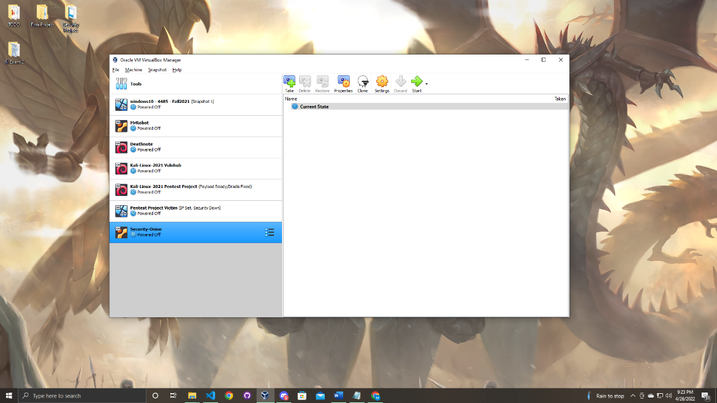

Now first let’s add kali Linux in virtual box.

First navigate to the folder that has the kali download and Windows 10 iso.

Next you will double click on the kali download. (The orange box)

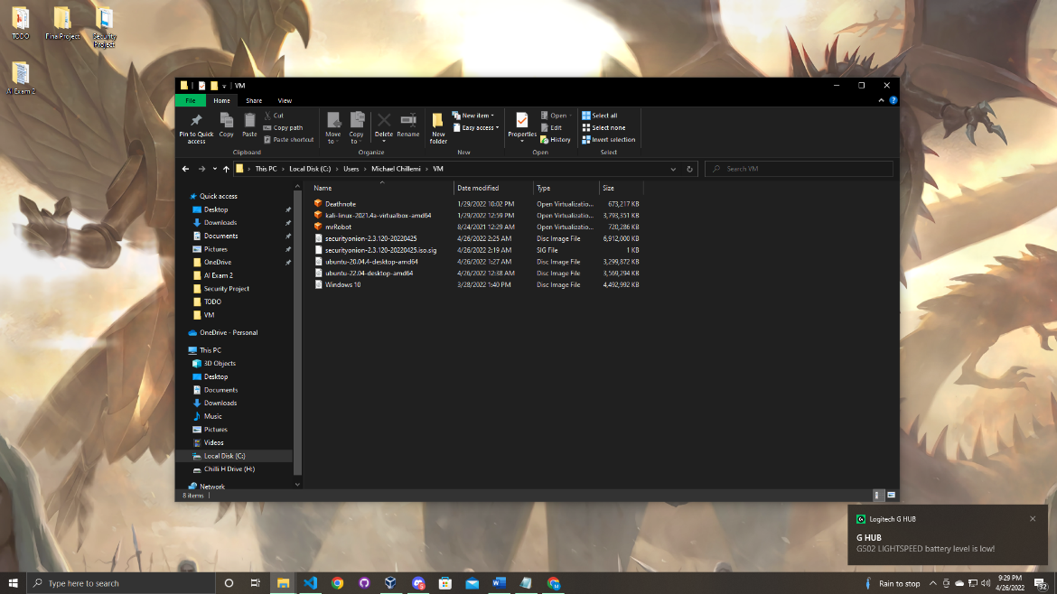

When you double click the image, you will be prompted this page on virtual box.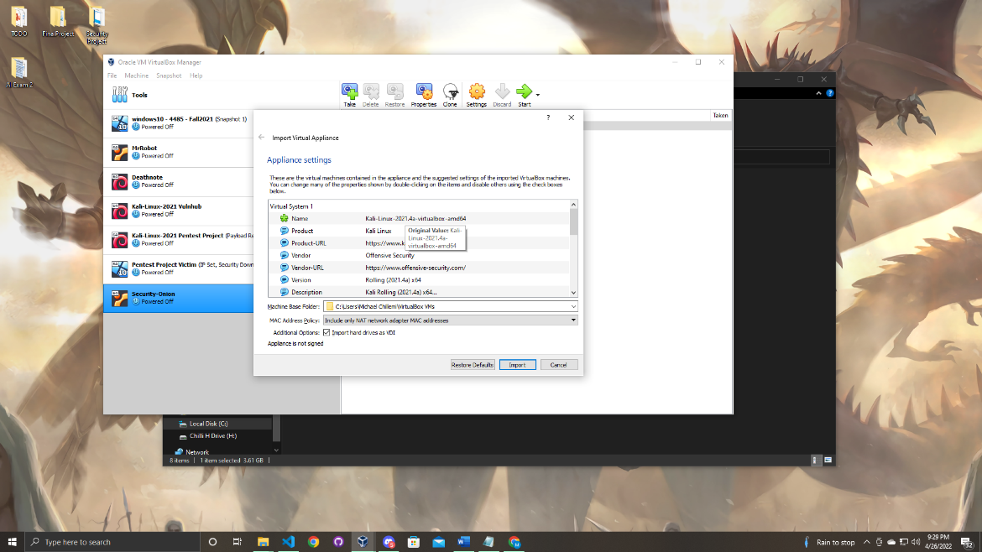

Click import to move to the next then agree to the terms and conditions to start the download.

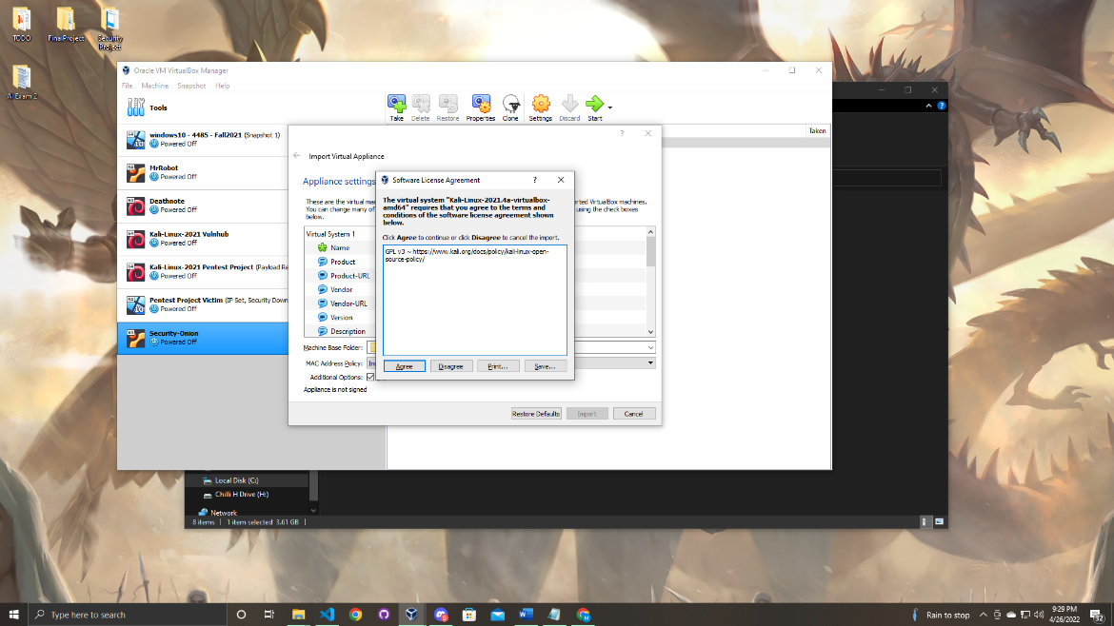

The download will take a few minutes.

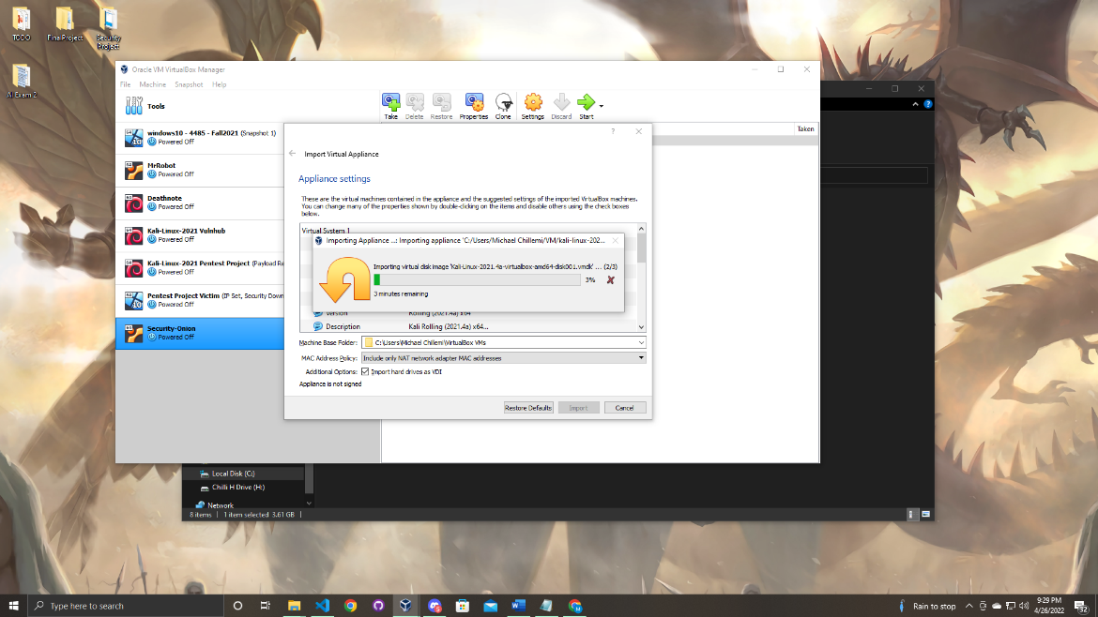

When the download is complete the next step will be adding the windows virtual machine to virtual box.

The first step will be to click machine tab on the top of virtual box.

Next you will click new.

When that step is complete you will be prompted with the create virtual machine menu.

Fill in the name for your device and then choose windows 10 (64-bit) as the version.

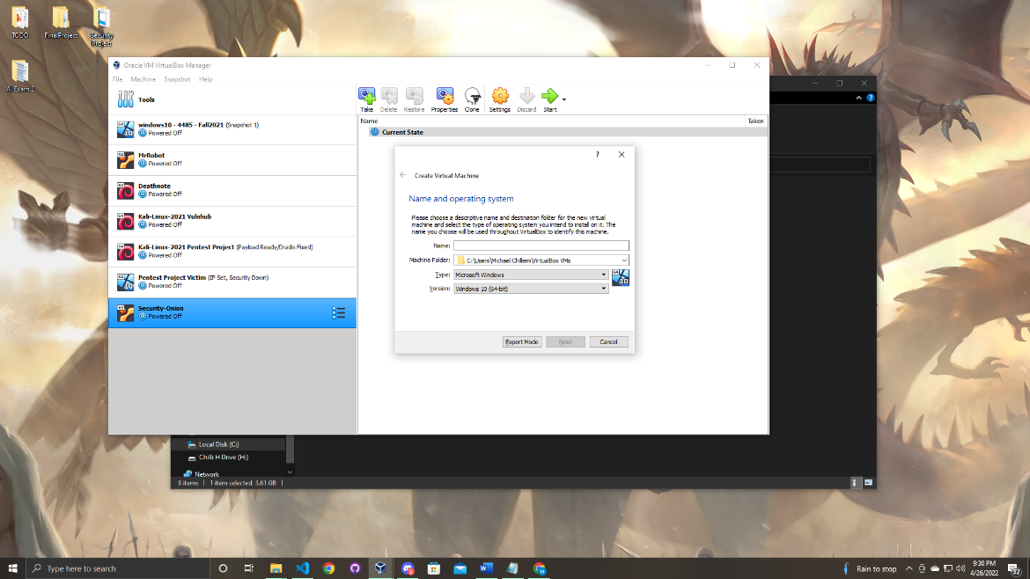

Once that is complete click next.

The next set of steps will be adjusting your windows 10 virtual machine settings. Follow the screenshots below to replicate what I did. (You can add more memory if you would like it is personal preference)

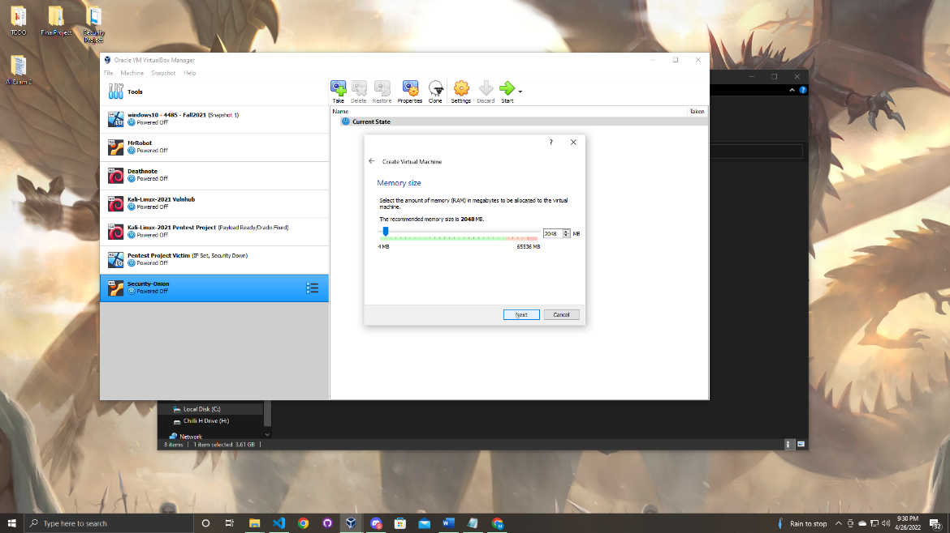

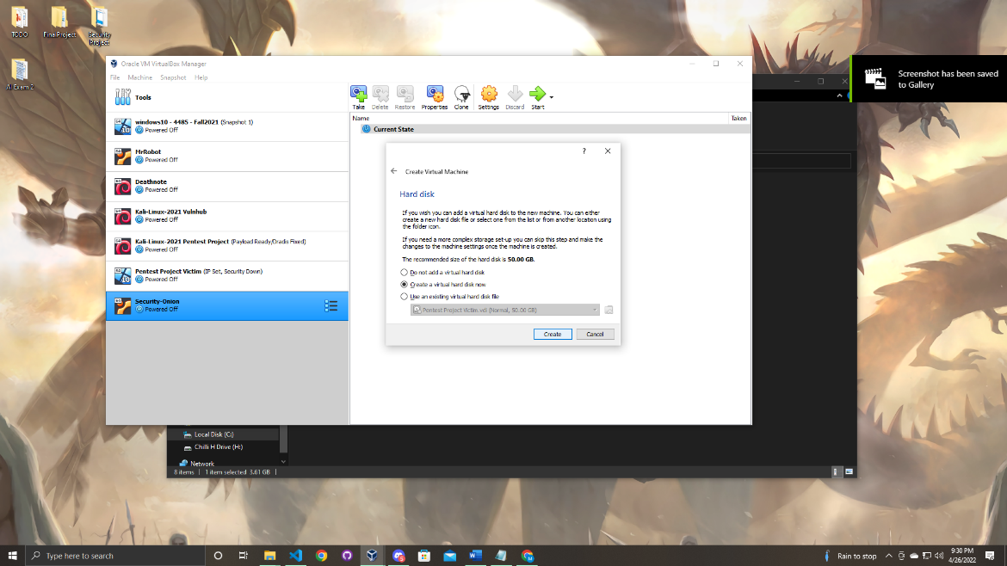

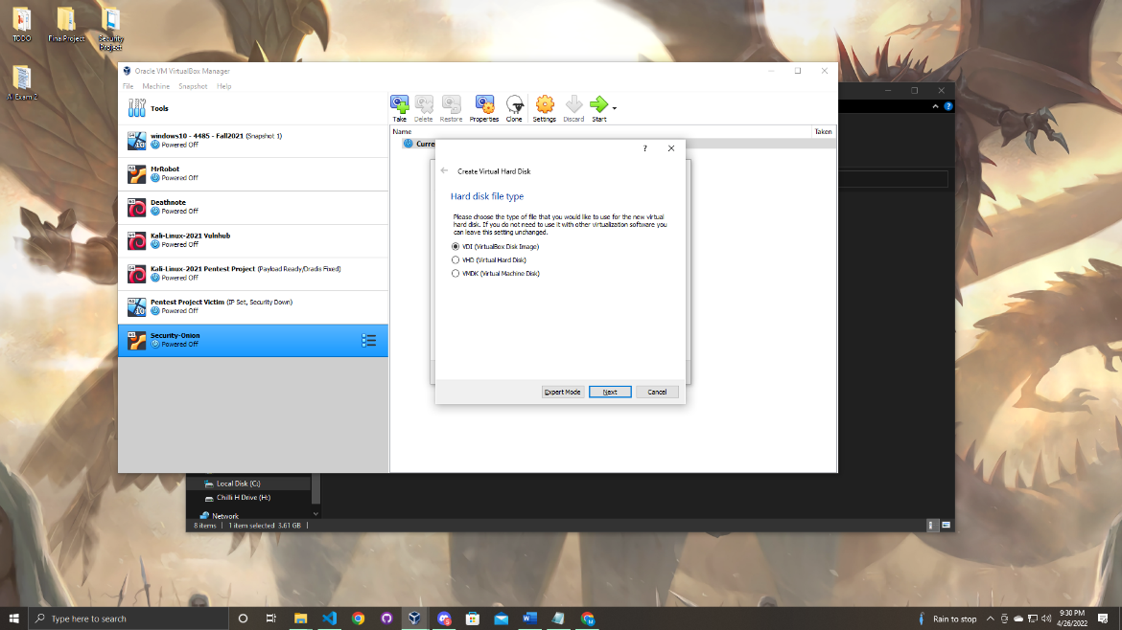

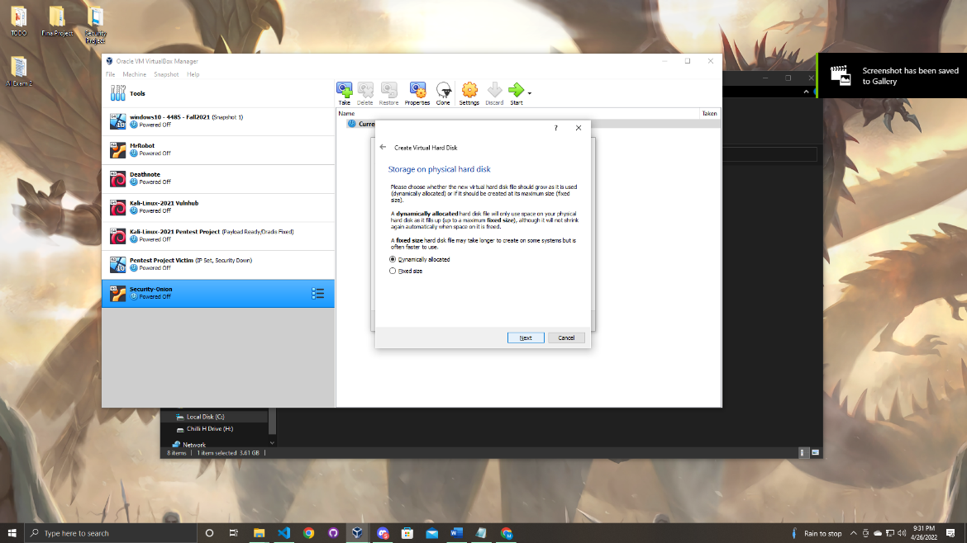



When you get to this step click the create button to make the windows 10 machine.

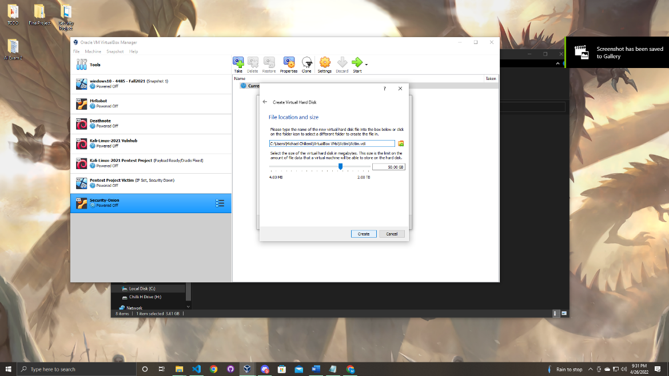

Now you have successfully created the windows machine. But we are not done here yet.

Next right click on the new windows machine you created and go to settings once that step is completed you will be prompted with the settings menu.

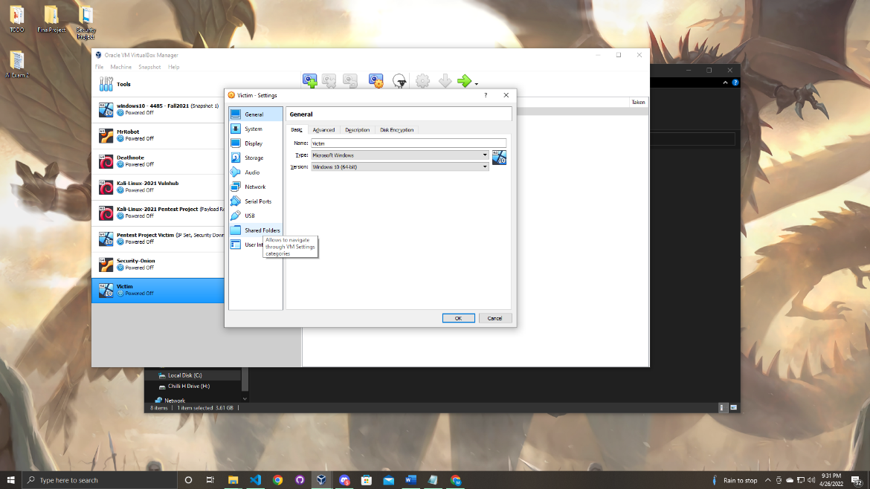

When in the settings menu navigate to the storage tab.

You will notice an icon that looks like a cd that is empty you need to add the windows iso file in order to properly boot up your device.

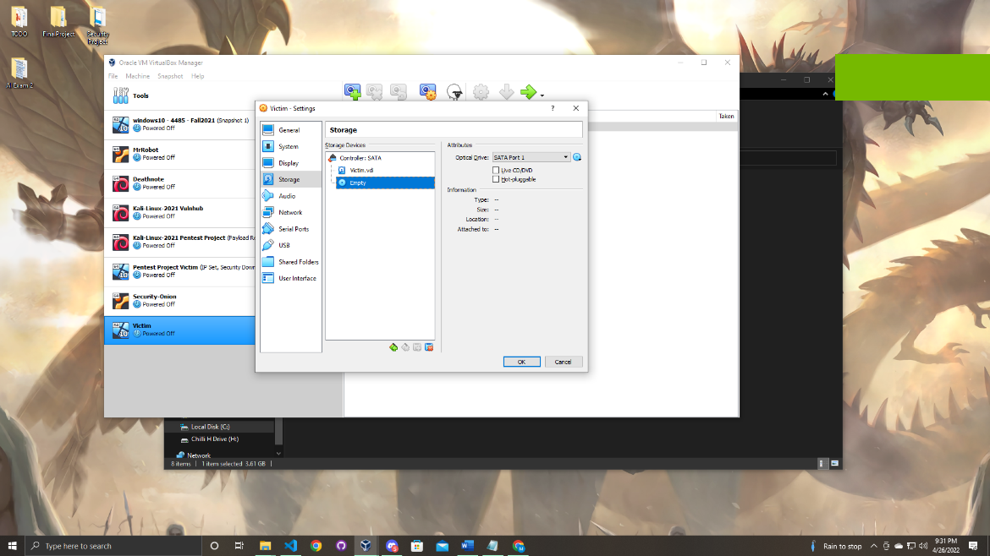

Navigate to the right side of the screen to a cd icon click on the drop-down menu and click browse.

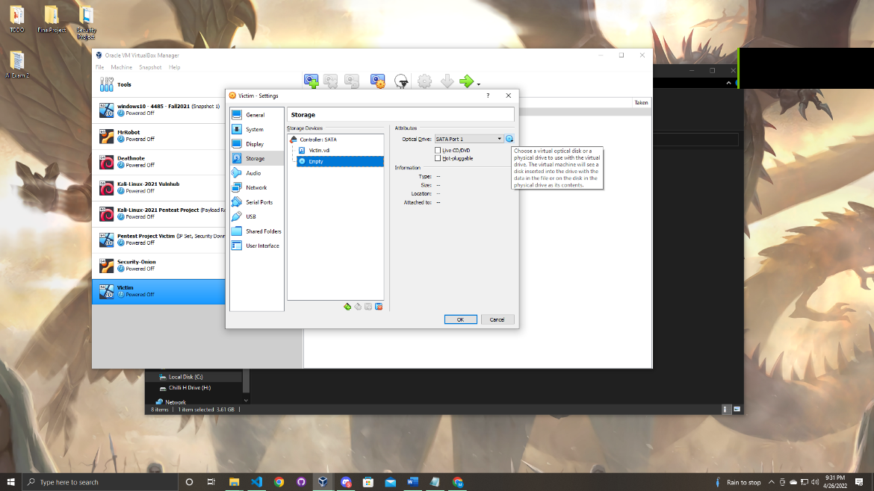

Open the folder that contains the windows 10 iso file and add it.

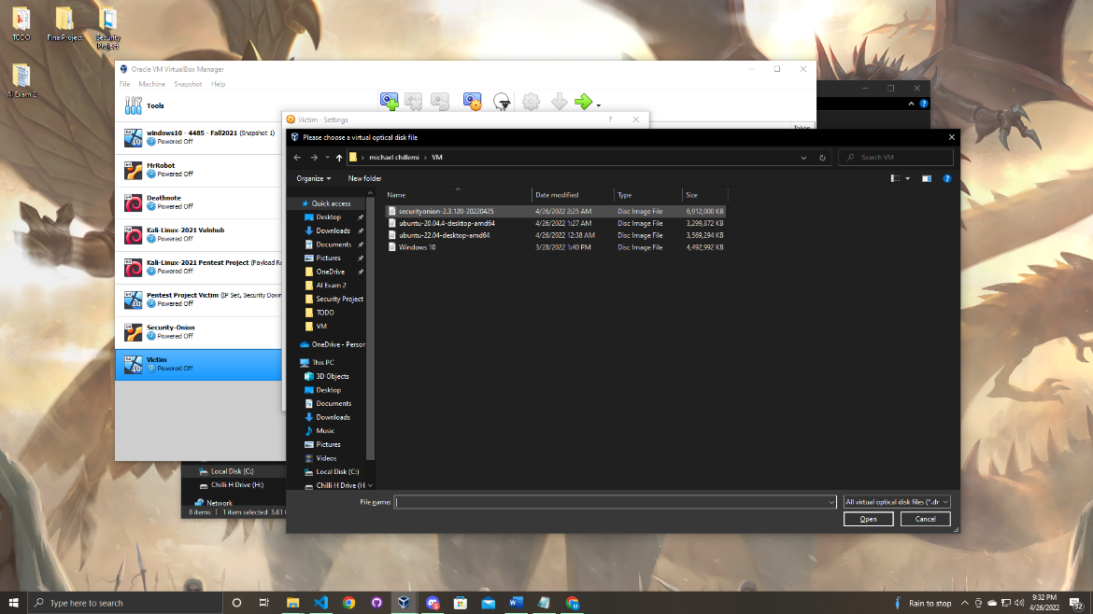

Once that is successful you will see the iso file has been added.

While we are in settings lets configure the network settings.

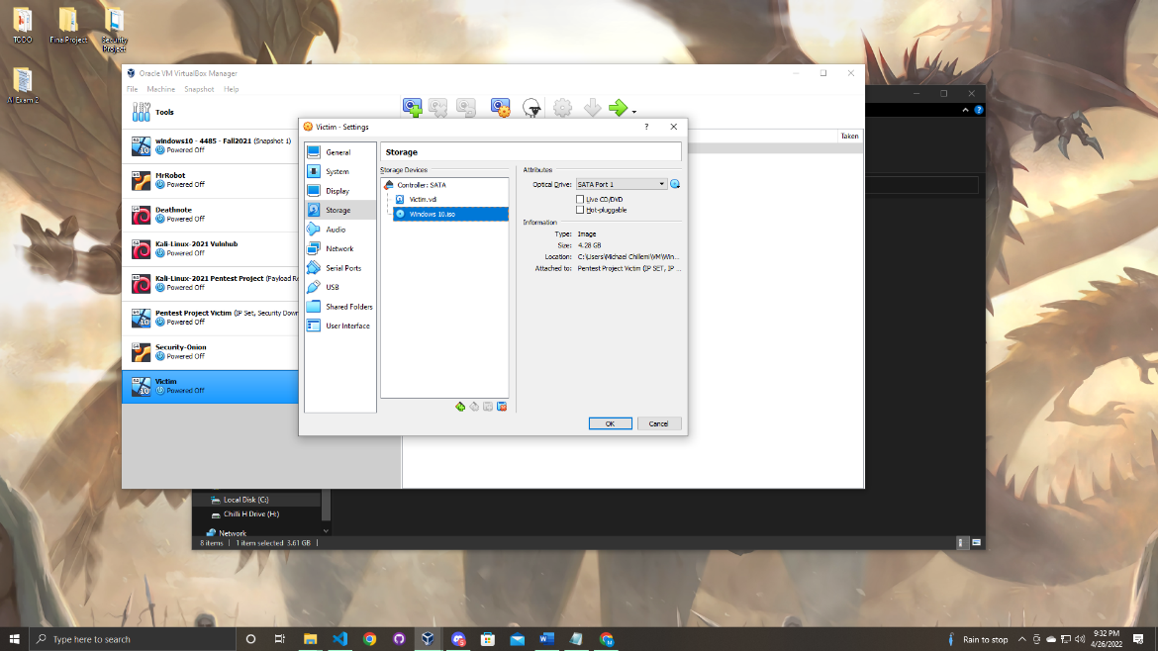

Click on the network tab and you should be prompted to a screen just like in the screenshot below.

You will see 4 adapters for the purpose of this project we will focus on adapter 1.

Go on the drop-down menu and change “NAT” to “Internal network”.

Next click the second drop down menus and click intent.

(The reason the network configurations need to be set up this way because you want your victim machine to not be able to connect to the internet)

Once that is complete click OK to close the settings.

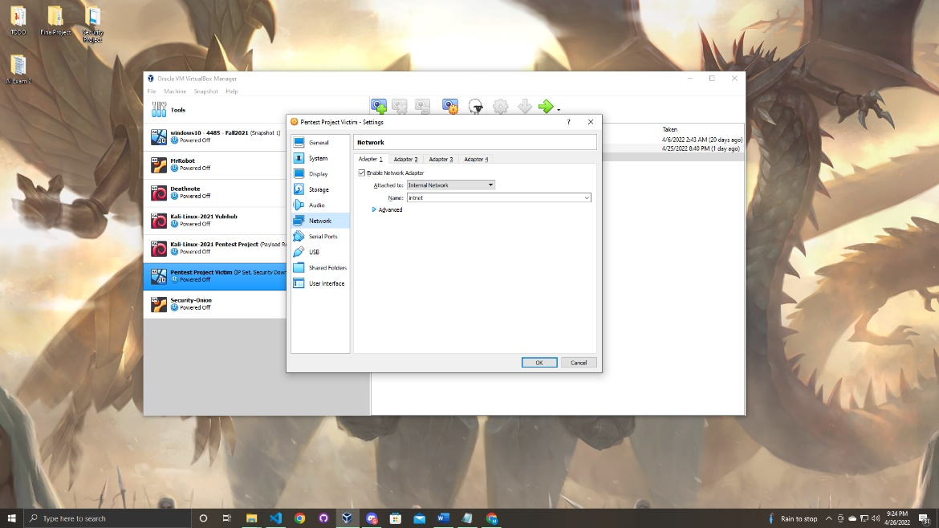

One of the last steps is we will need to configure the settings for the kali machine.

Replicate the same steps above dealing with the network configurations.

Now adapter 1 should be “NAT” which you will leave.

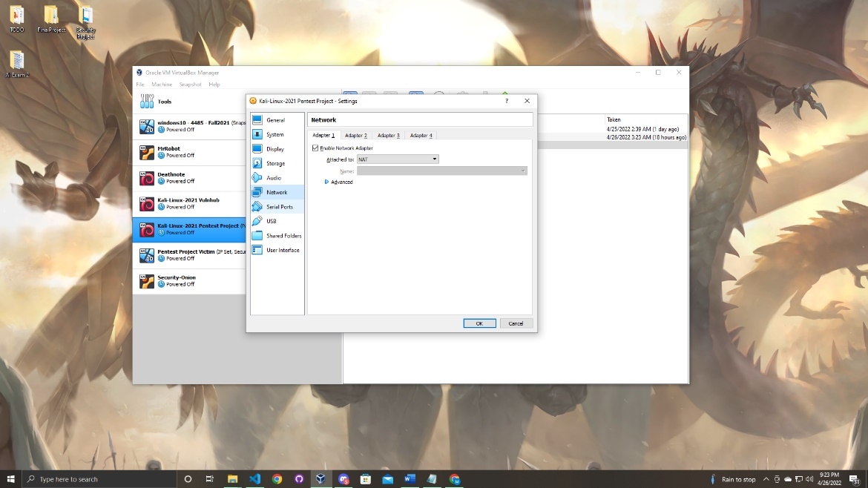

Next move on to adapter 2.

Once on adapter 2 set it up exactly as you did for your windows machine.

Then click OK to close the settings.

Now you are ready to start your machines!

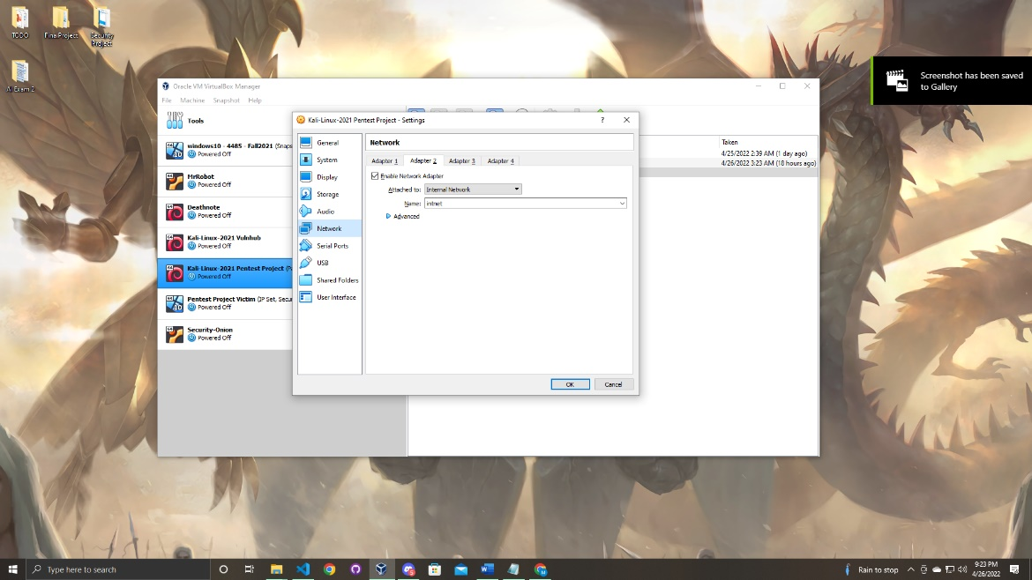

(The reason the network configurations need to be set up this way because you want your kali machine to be able to connect to the internet and have the ability to communicate with your victim machine)

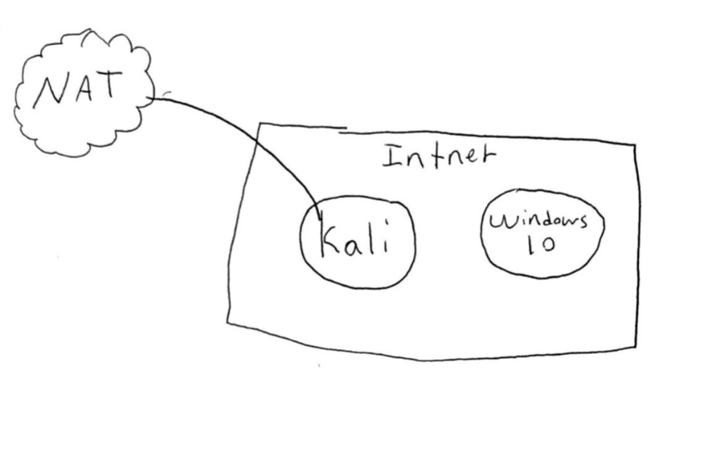

Section

3

Booting, Updating, and Network Configuration in Kali Linux

Now let’s set up the kali machine.

First start the Kali Linux virtual machine.

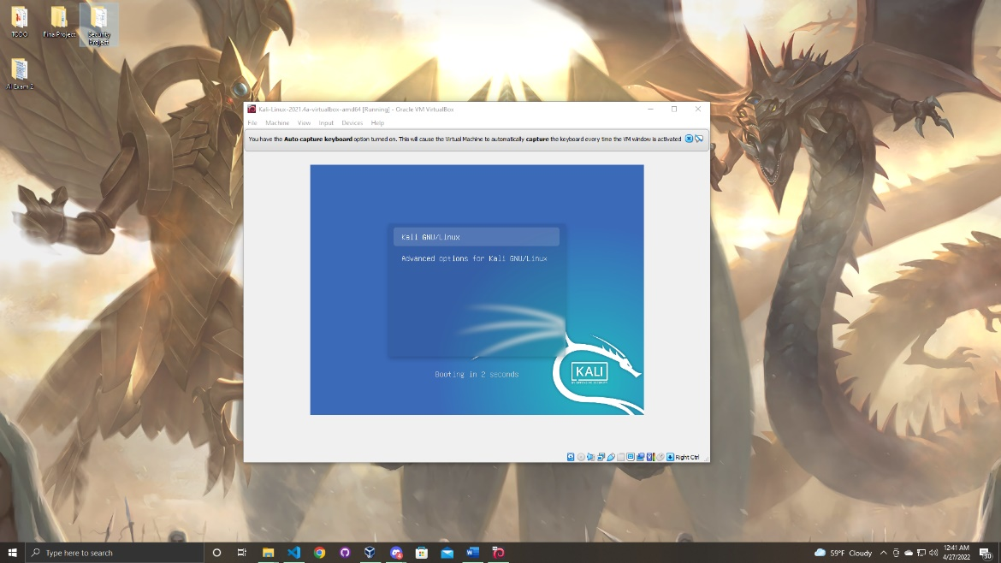

Once your system finishes booting up you will be presented with a log in screen.

The default log in will be:

User: kali

Password: kali

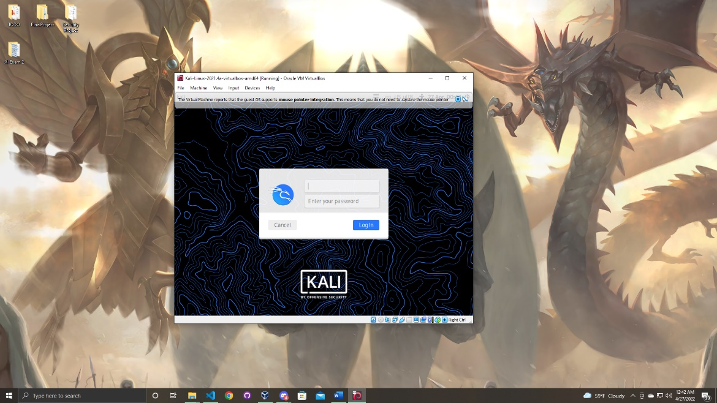

Once you log in you will be presented with the Kali home screen.

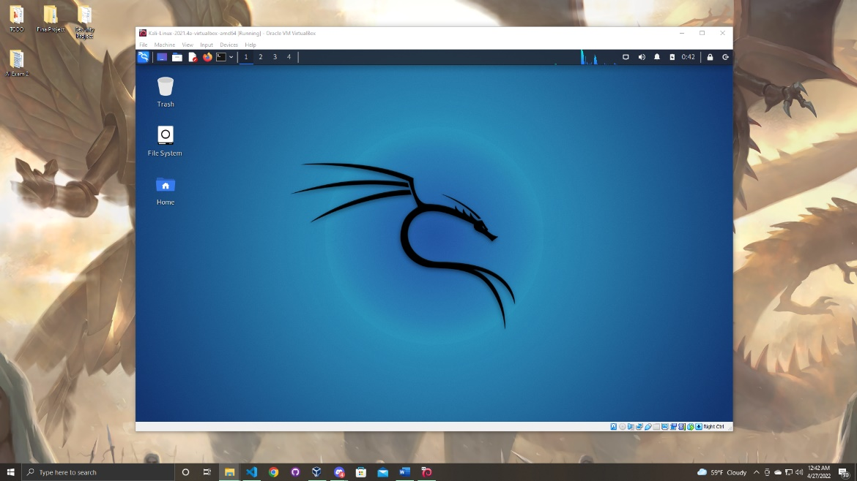

Once we are in Kali first, we will configure the network settings.

The first step will be to open up the terminal.

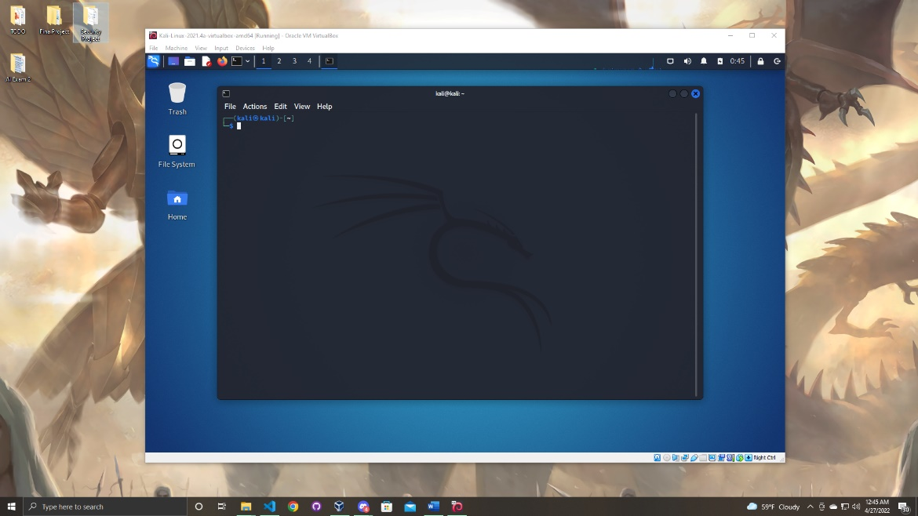Once in the terminal you must navigate to the interfaces file this is in the /etc/network/ directory. To get there enter the commands below.

Linux Commands:

cd /

cd etc/network/

Now as you can see in the interfaces file.

The next step will be to access and modify the file.

In order to complete this enter the command below and press enter.

Linux Commands:

sudo nano interfaces

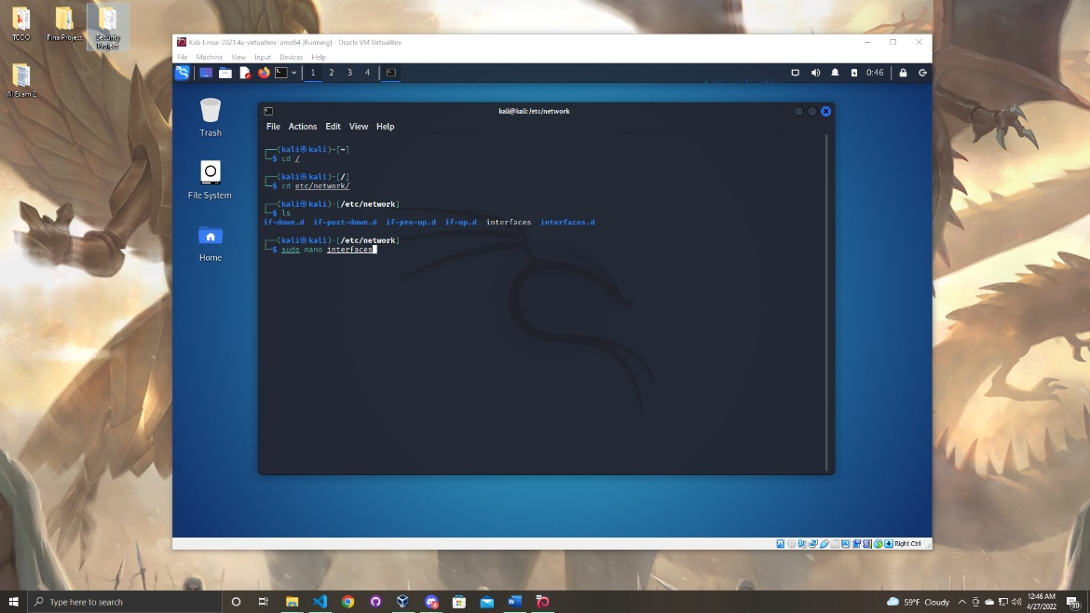

Before you can access the file you must enter the password to your machine. In this case it would be “kali”.

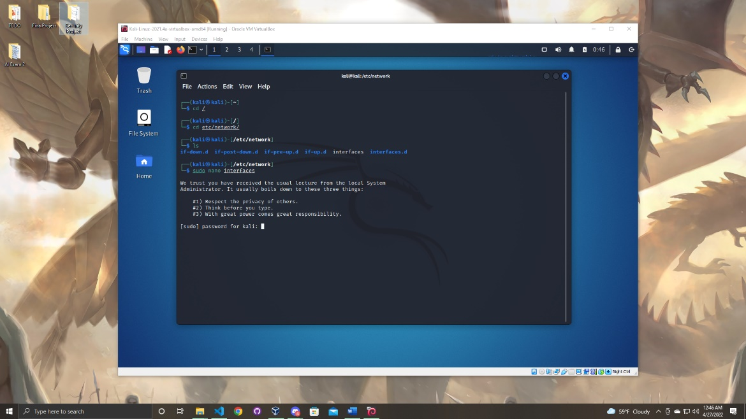

Then the interfaces file will open and you will presented with a screen just like in the screen shot below.

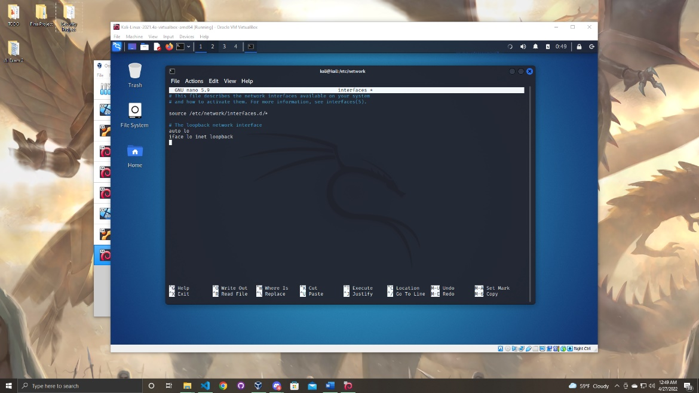

To get the network settings to be configured properly you must enter adapter 1 and adapter 2.

Copy the text as in the screen shot below. (Keep in mind which ever static IP you want your machine to have this is where you add it. You must also add the proper netmask and gateway for your IP address as well)

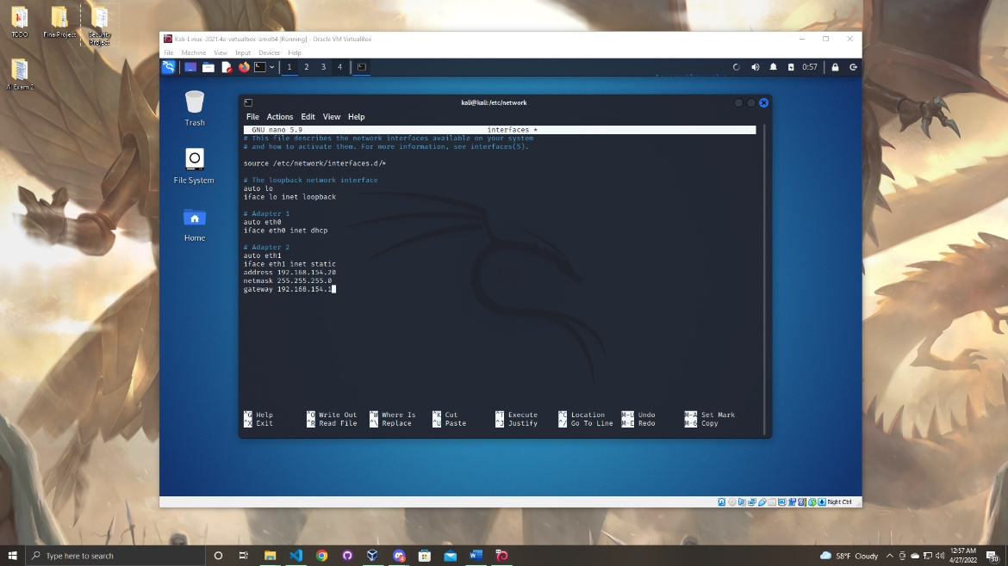

When you are finished with adding the network configurations to the interfaces file then you will press crtl + x on your keyboard to exit.

Next you will enter y and press enter twice to get back to the terminal.

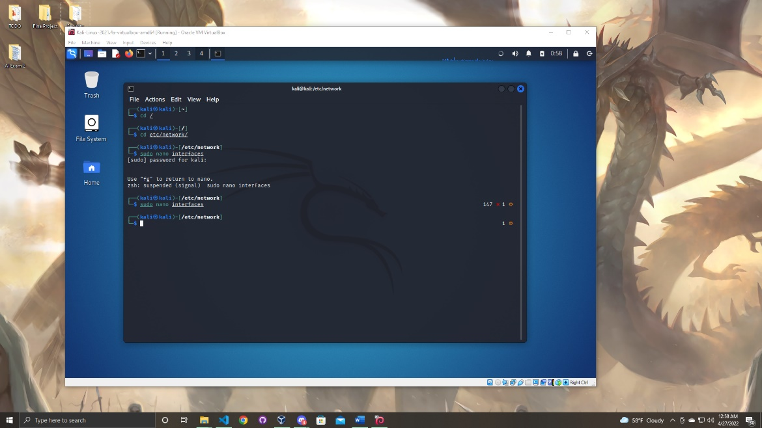

While we are in the terminal the next step will be to update Kali. You must enter two commands.

Linux Commands:

sudo apt-get update

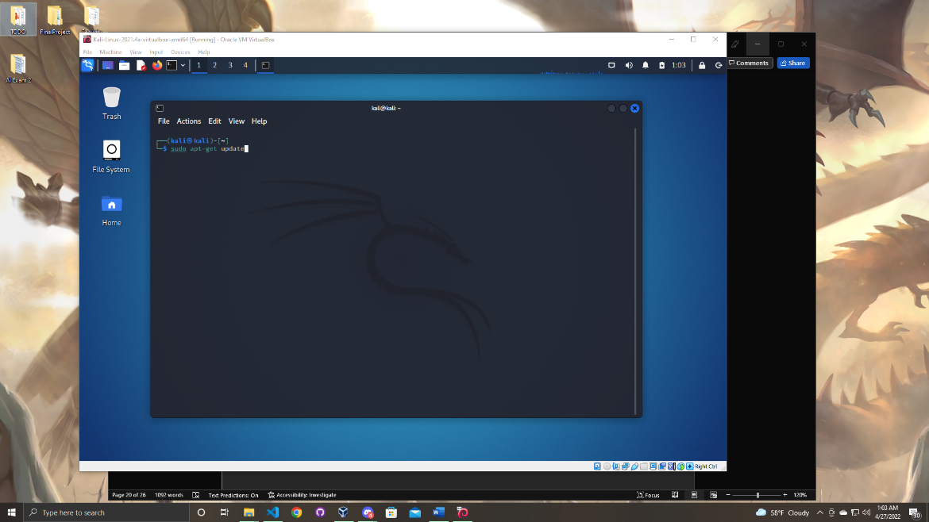

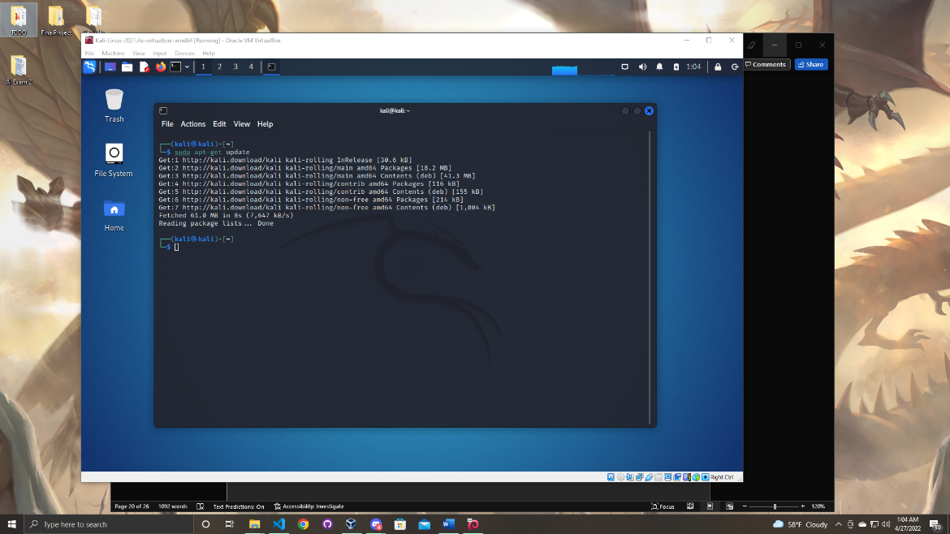

When the command is fully executed enter the last command to update the system.

Linux Command:

sudo apt-get upgrade

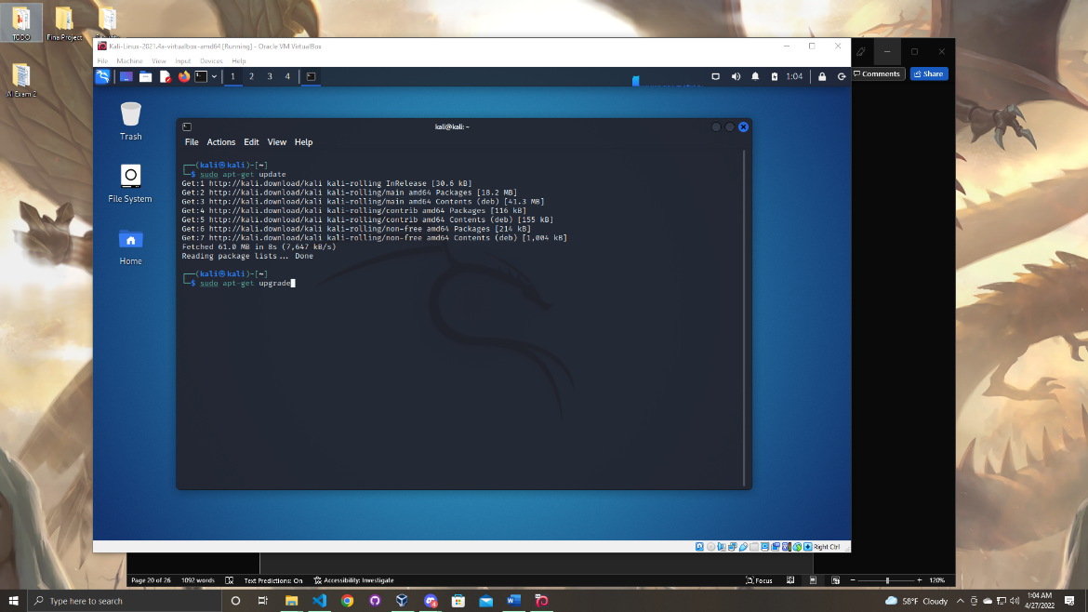

Let the command run you must enter Y and enter to procced through the update.

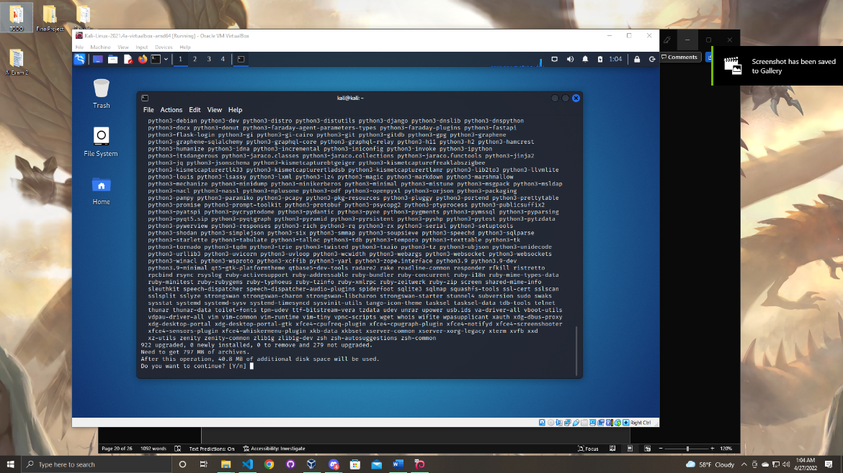

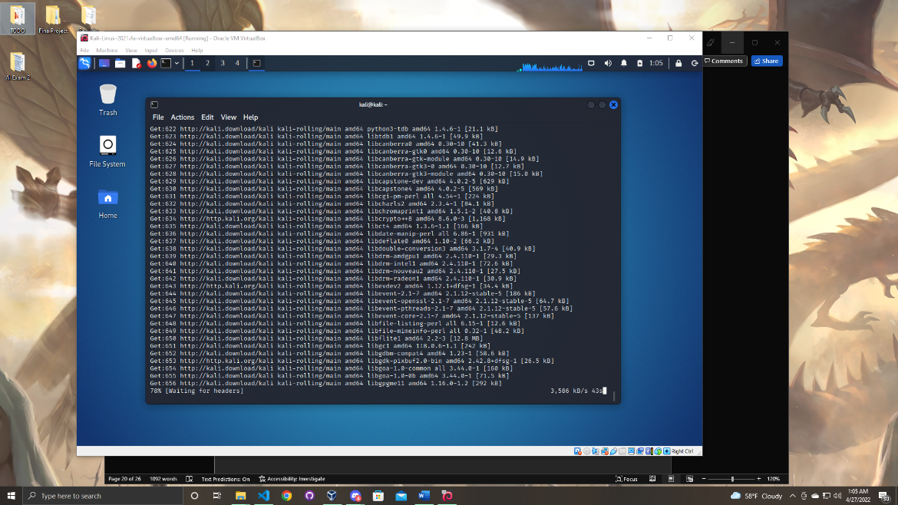

Towards the end of the update this screen will pop up. You must hit yes and click enter to finish the update.

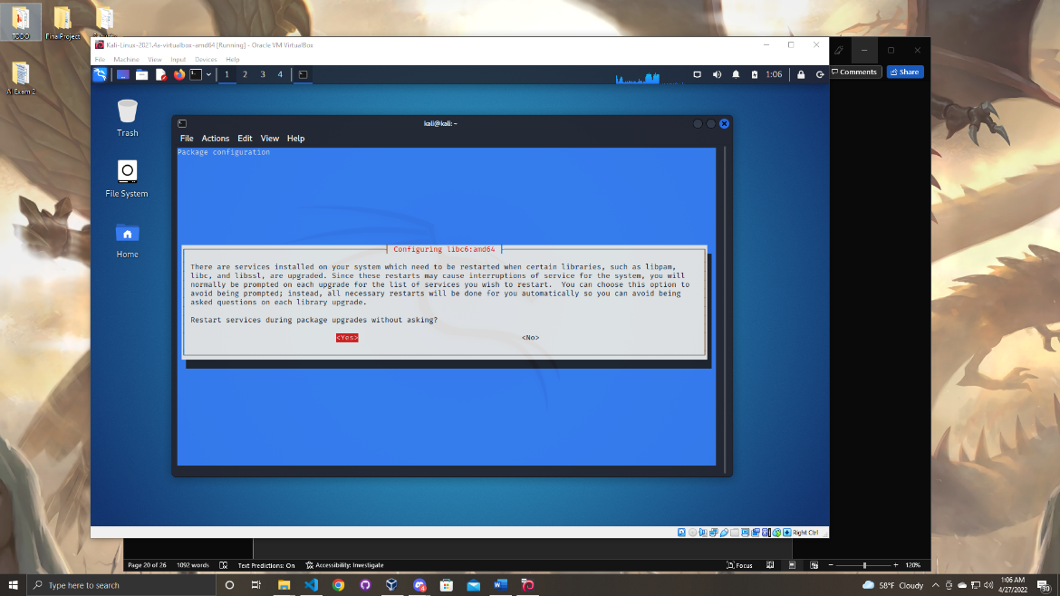

Now the system is fully updated.

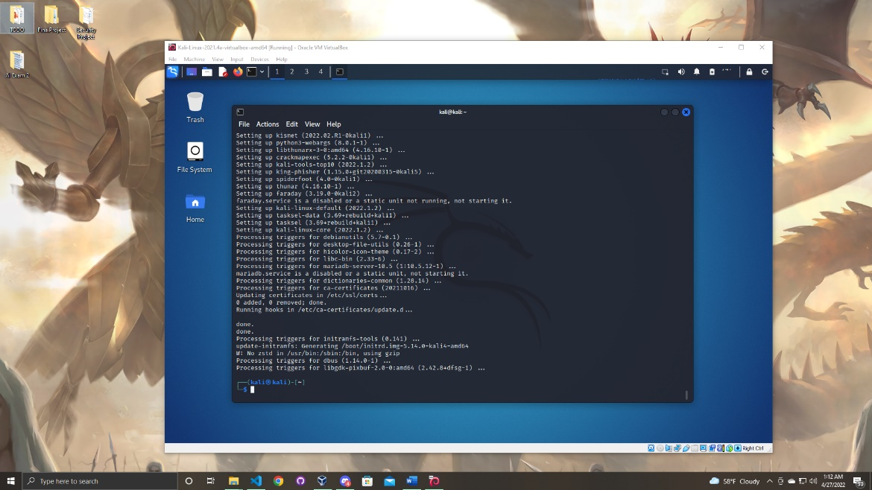

Next in this section we will install the application dradis. Dradis is an open-source framework for penetration testing. It allows you to maintain the information that can be shared among the participants of a pen-test. The information collected helps users understand what is completed and what needs to be completed. In order to download dradis enter the following command as before.

Linux Command:

sudo apt-get install dradis

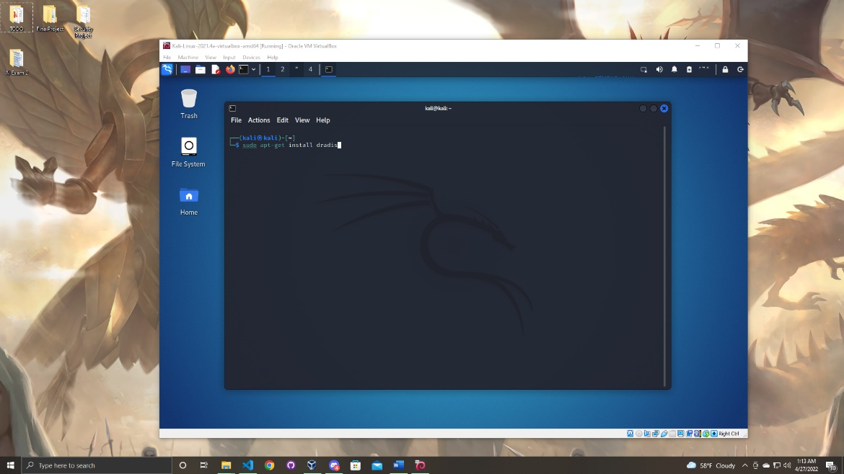

Very similar to the update enter “Y” and press enter to confirm the installation.

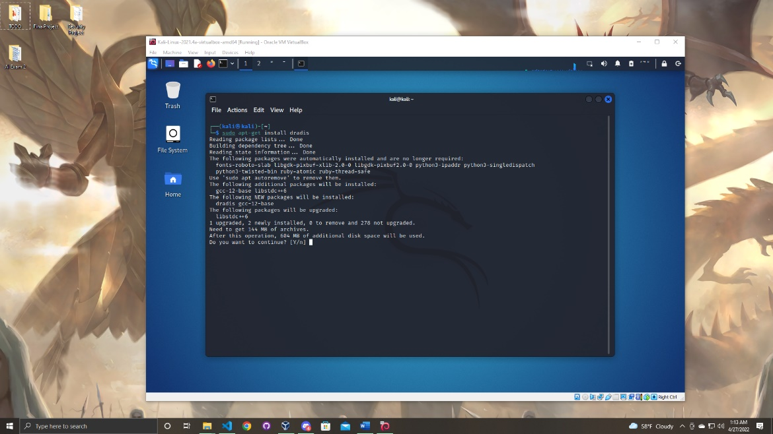

Give your system a couple minutes to download the application. Once it is complete you will be presented with the same screen as below.

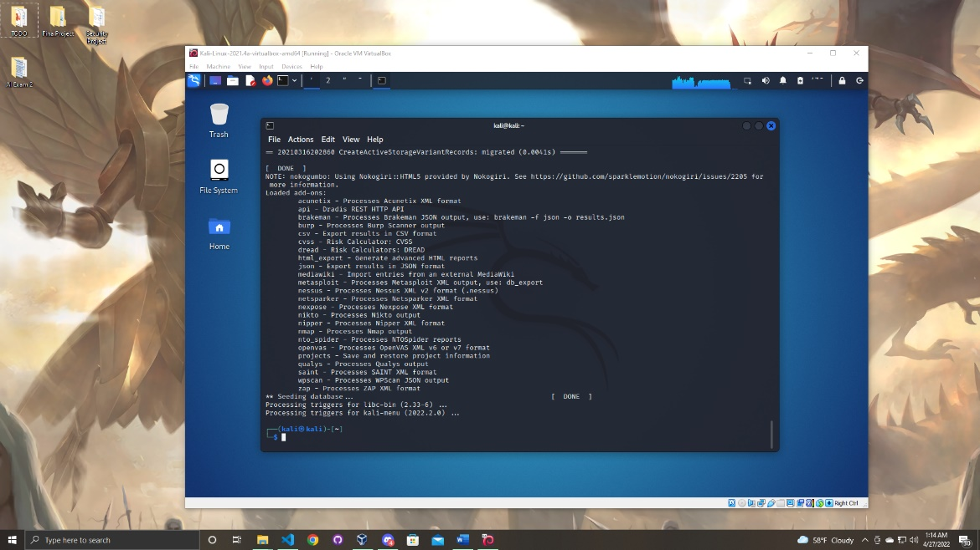

Now that the application is download lets start up dradis and set up the application.

First go to the application and type “dradis” you should be able to see dradis start double click on the application to start it.

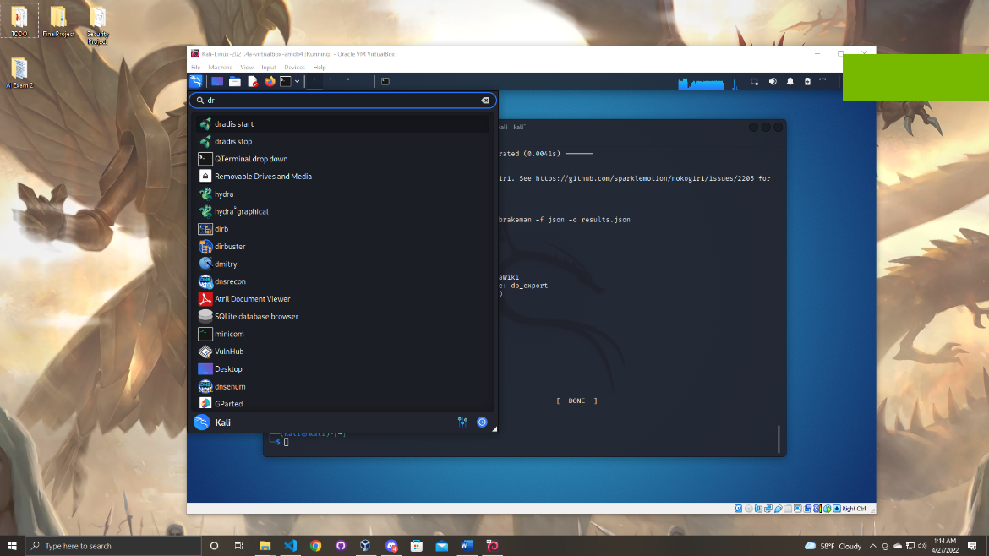

You can also do this from command line by typing the command listed below.

Linux Command:

sudo dradis

You must enter the password to your kali machine to procced. (Which is “kali”)

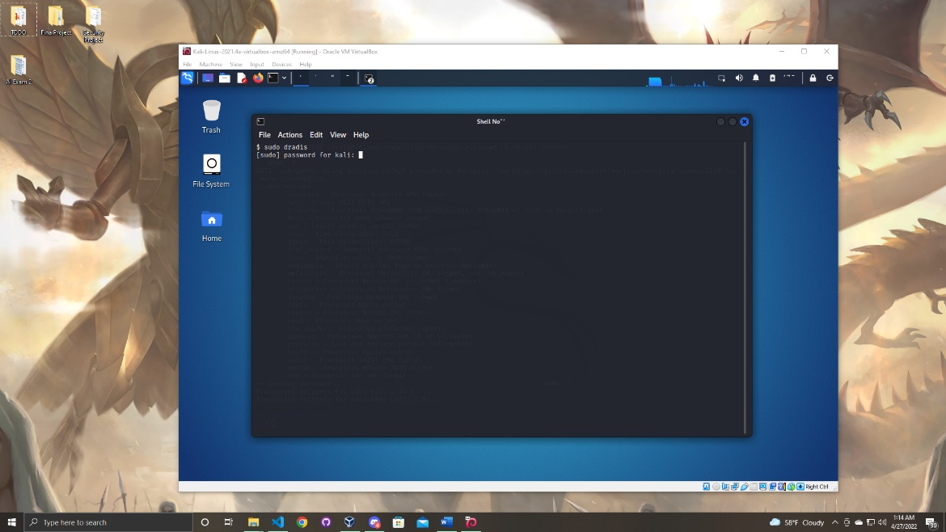

Once the password is entered the application will start up. Give the application a minute or two to start running and when it is complete your web browser should be opened to the start up screen.

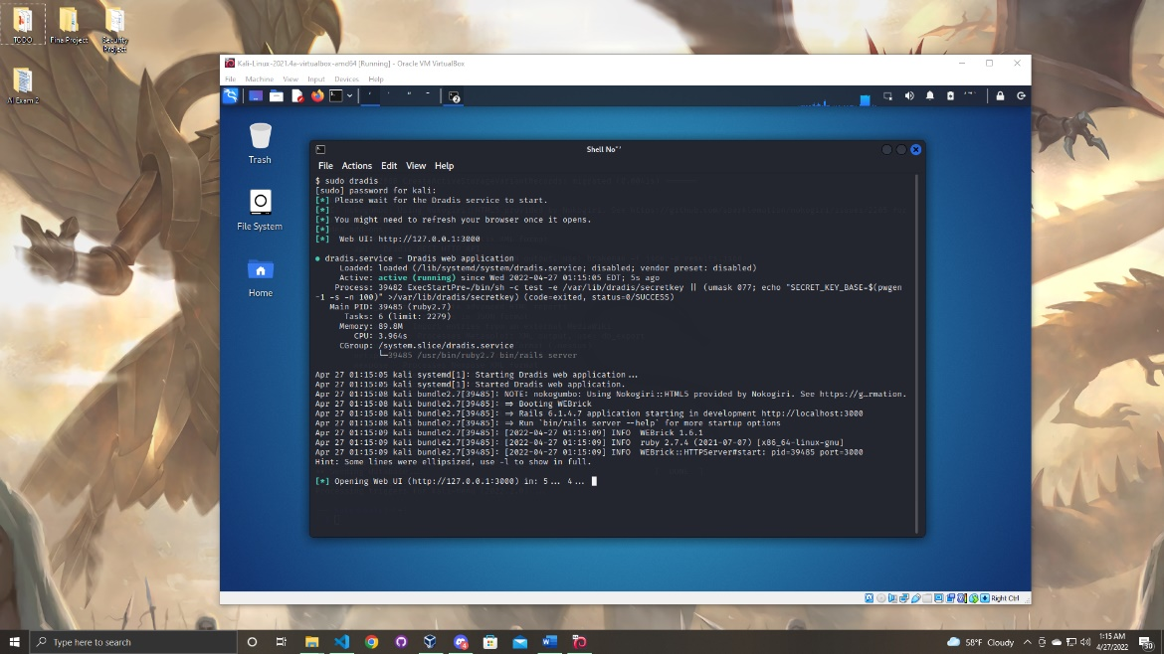

When dradis start up for the first time you will prompted to enter a password. Enter a password you will not forget. (Write down the password in a secure location because you will need it later to access dradis)

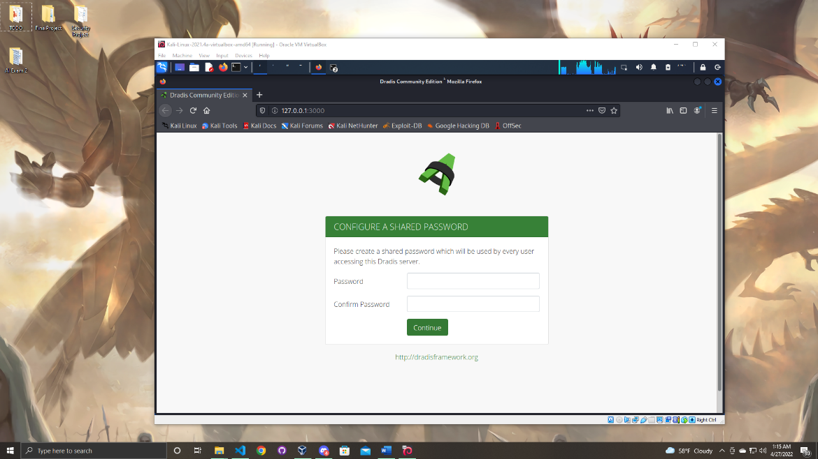

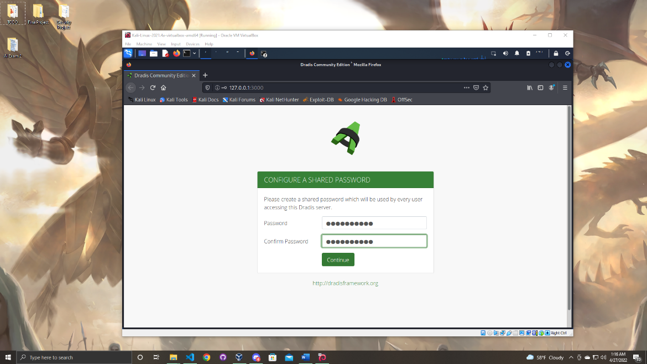

When the password is entered click continue and you will be brought to the screen as below. In this step you will need to add a username you can pick any user you want. (Save the username as well you will need it to log back into dradis later)

Once you create a username enter the password you created in the previous step and click the button that says “Let Me In”.

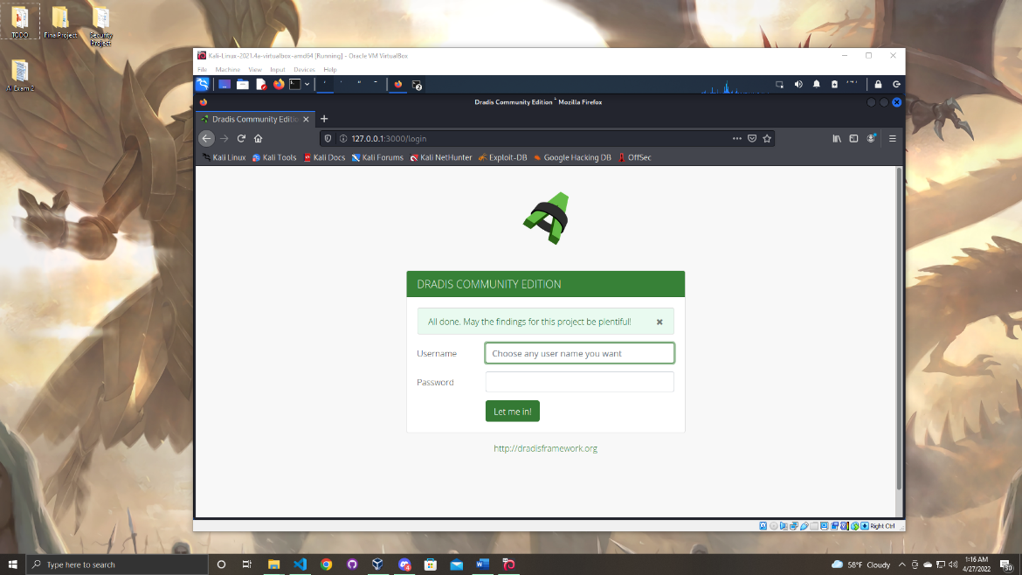

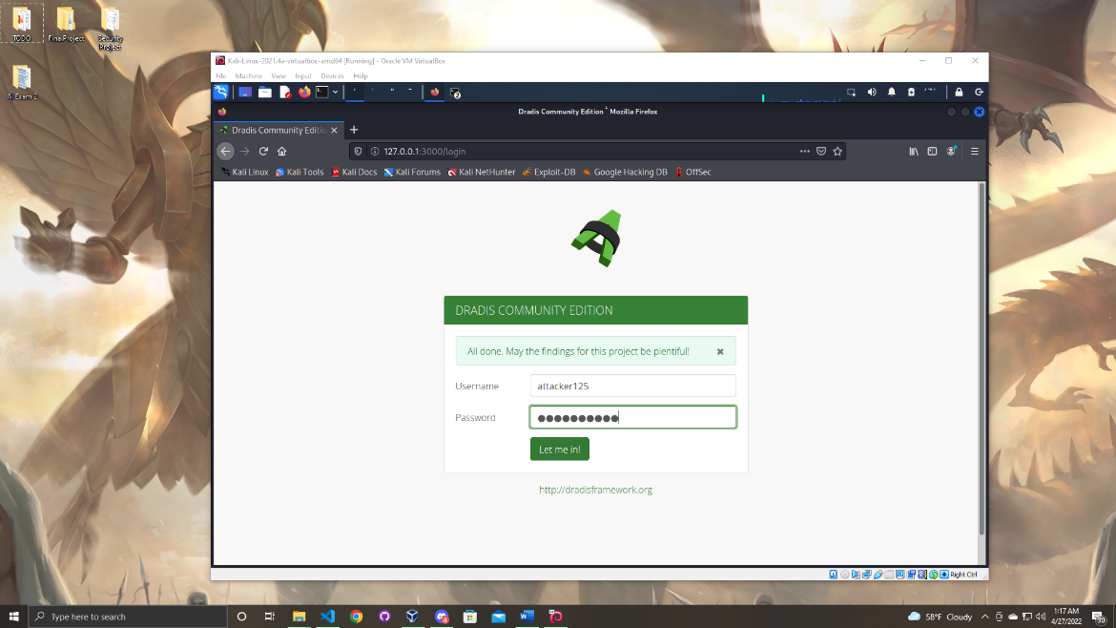

Once you click the button you are in the dradis menu. We will come back to this menu later in the manual. But for now you can log out of the application.

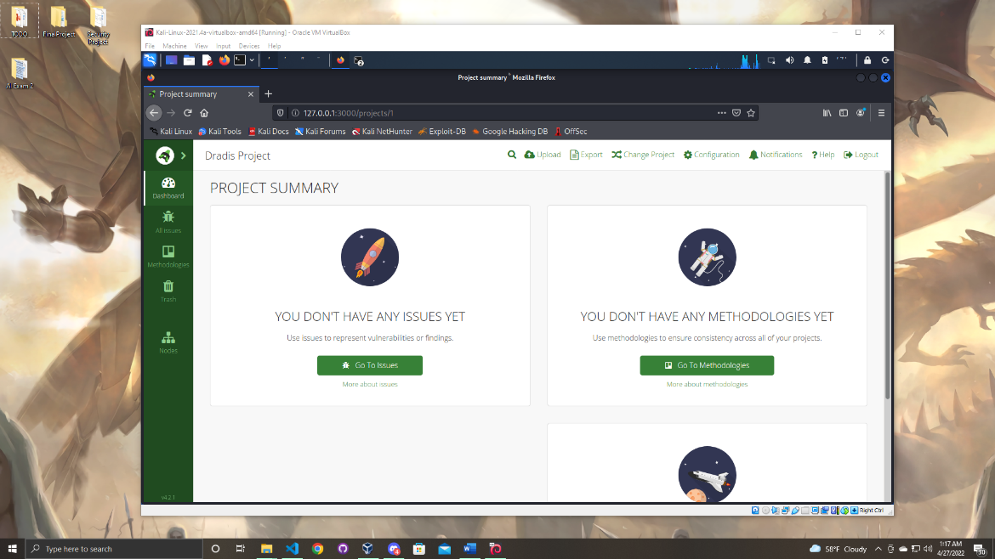

Once you are logged out of the application follow the screen below and stop the dradis service.

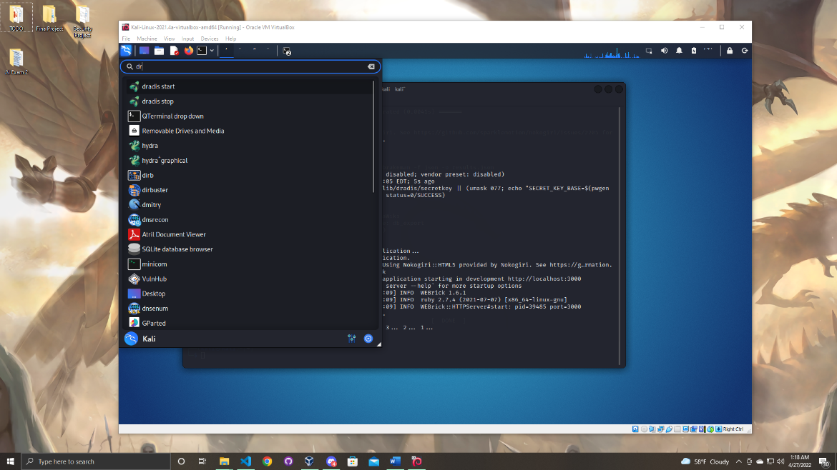

You must enter the kali machine password to stop the dradis service.

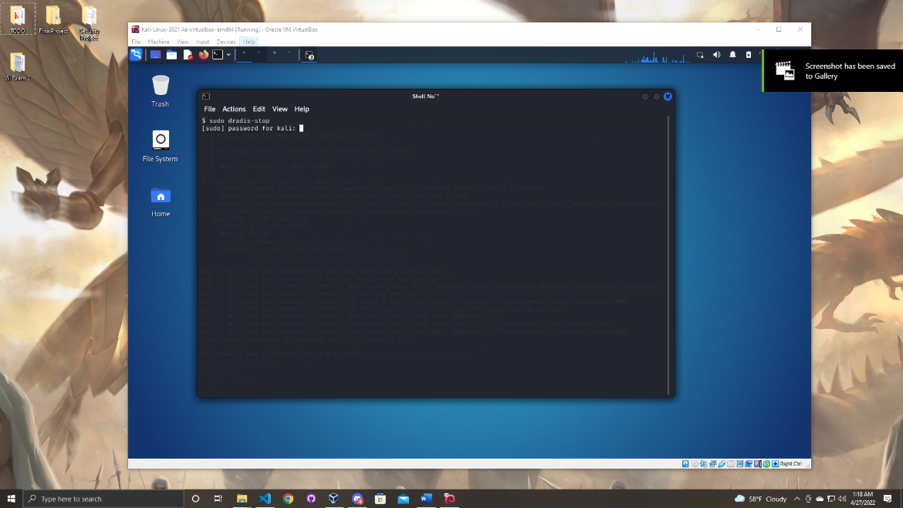

One of the final steps is to verify the network configurations were set up completely. To do this reboot the Kali virtual machine and reenter the username and password. ( User: kali Password: kali)

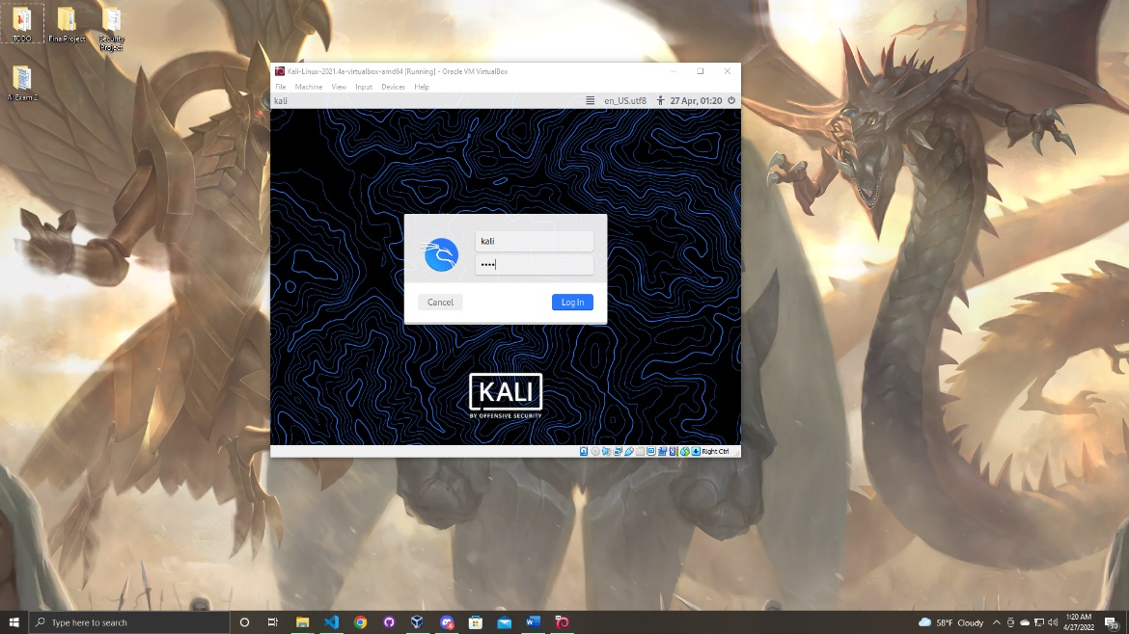

Once you are logged into the machine open up the terminal and type the command to see the network configurations for the device.

Linux Command:

ifconfig

As you can see below the static IP has been set correctly!

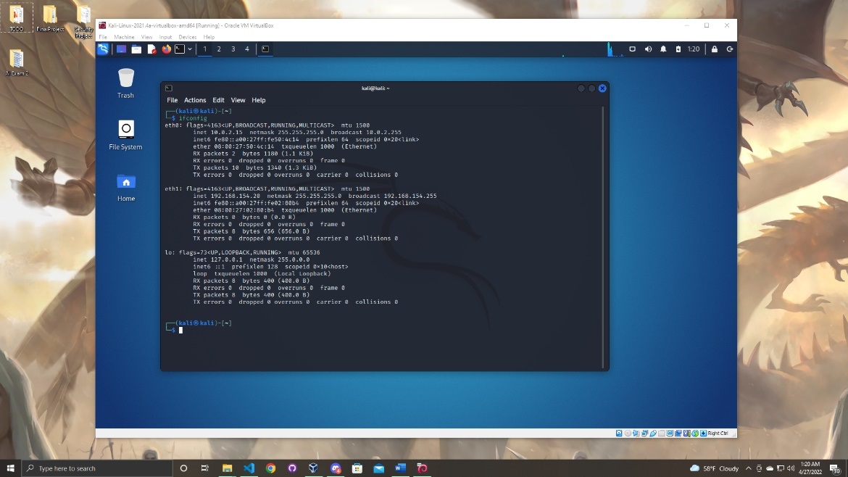

Now you can close down the virtual machine and proceed to setting up the Windows device. (This is a great time to take a snapshot of the Kali machine. Just to have a save ready in case something happens in the future. This will save you time so you do not have to repeat the steps above)

Section

4

Booting and Network Configuration in Windows 10

In this next section we will start the virtual machine of the Windows 10 device and configure the network settings.

First click on the windows 10 machine a click the green start arrow on the top of the virtual box menu.

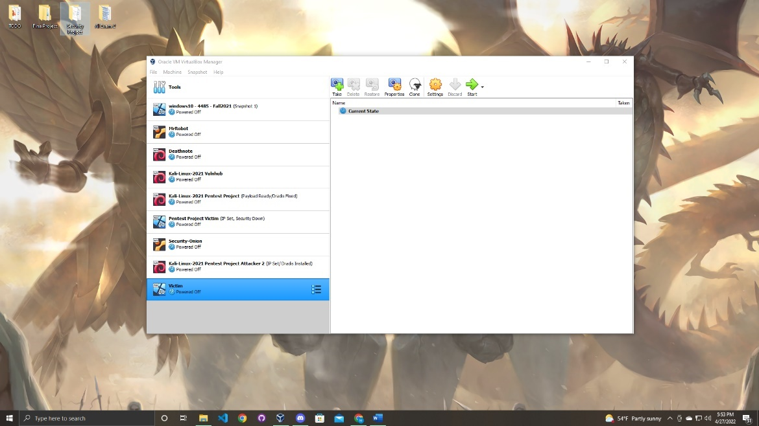

Give the machine a minute to load and you should be presented with a screen that looks identical to the screenshot below.

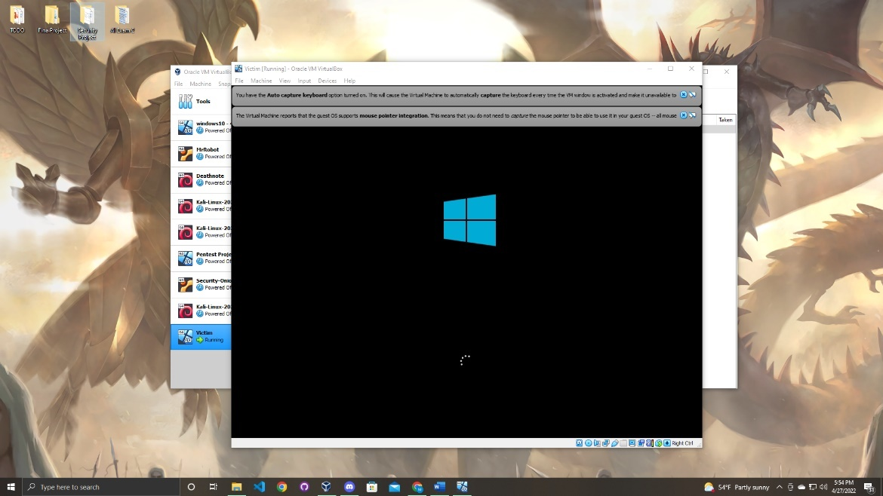

Once it finishes loading you will be presented with the screen below click “next” to proceed to the next step.

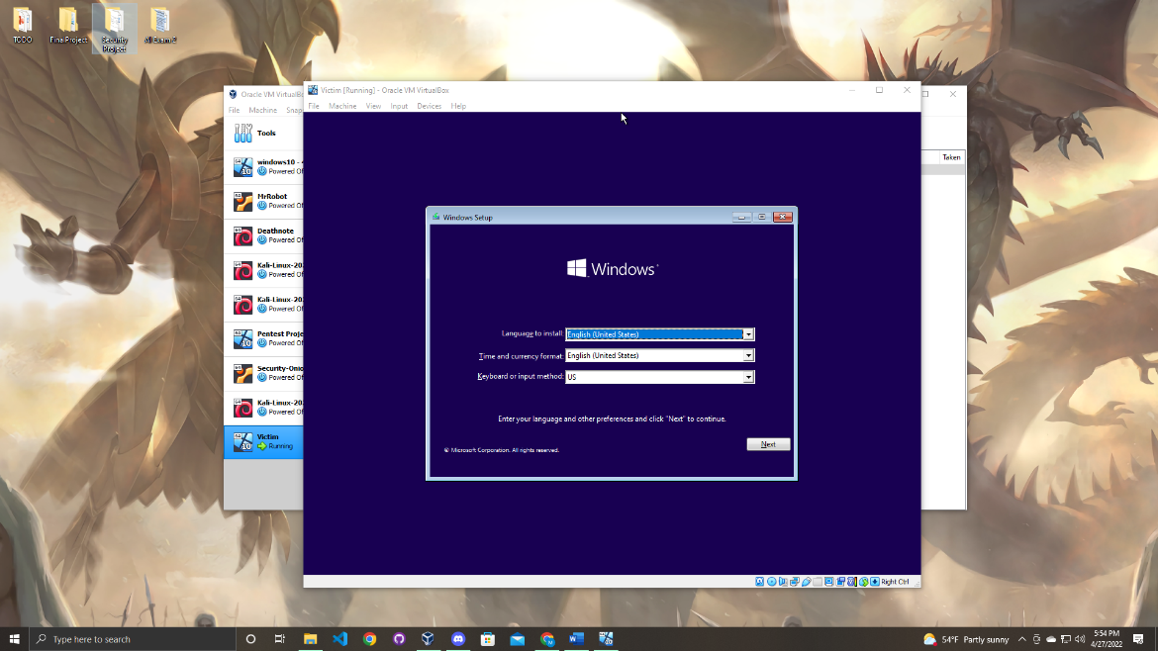

The next page will ask for a product key. There is no need for a product key so you can click “I don’t have a product key” in the bar below.

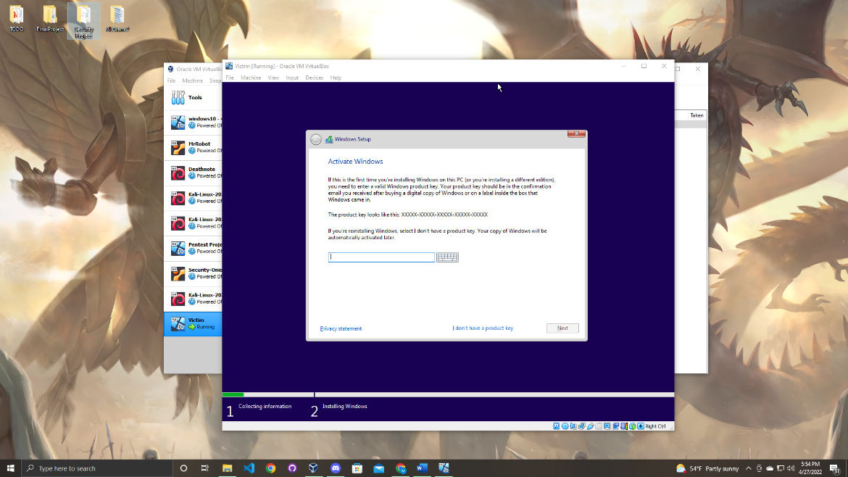

In this step you can select the type of Windows you desire but for this project Windows 10 home.

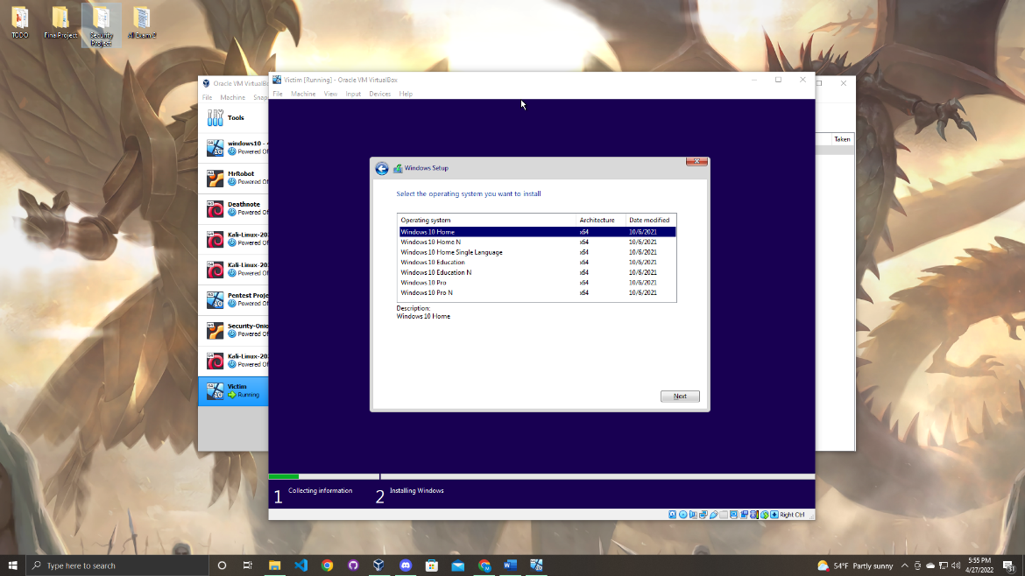Next agree to the to the terms and conditions and click next.

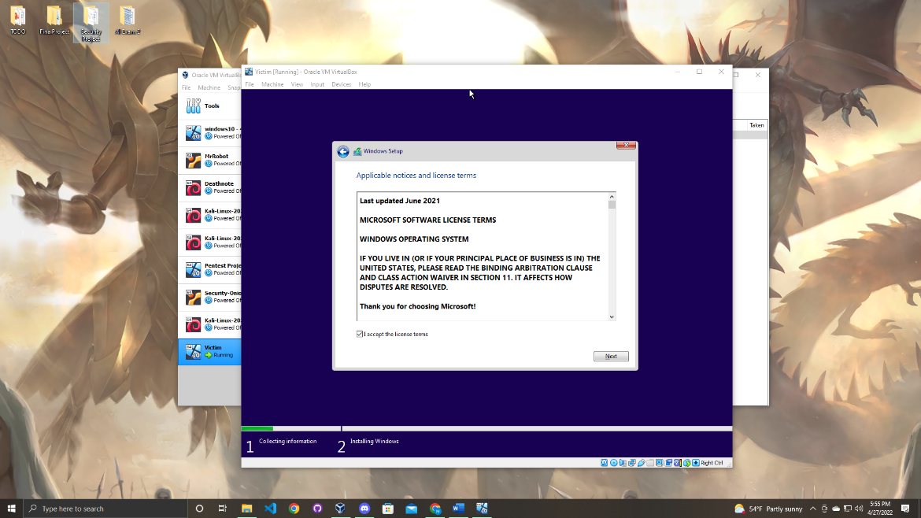

For the next step it is crucial you select the custom installation option in order to proceed to the next step double click to select the option. (If you click on the upgrade install option you will not proceed in the download and would have to repeat the steps above)

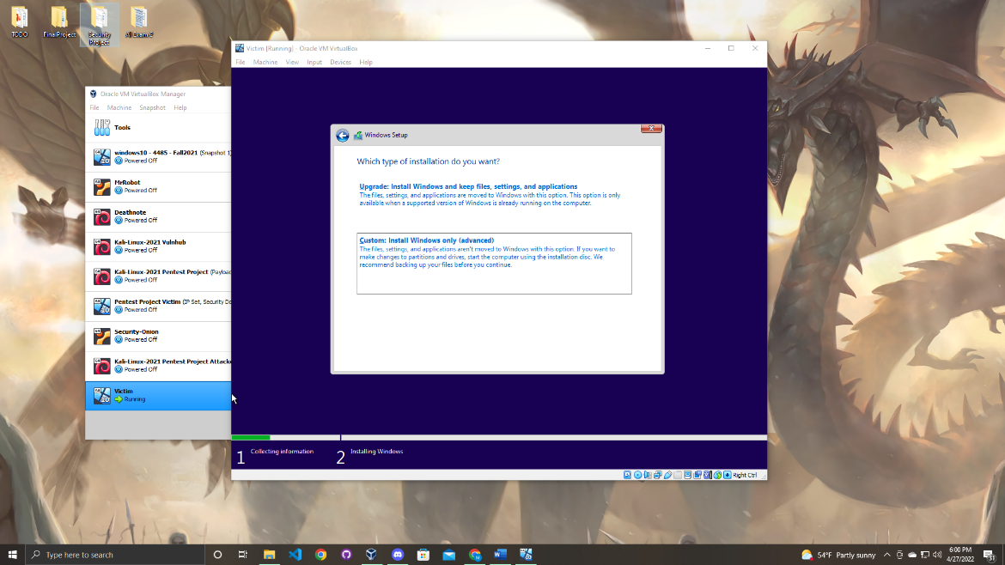

Now the installation process will begin wait until it is complete.

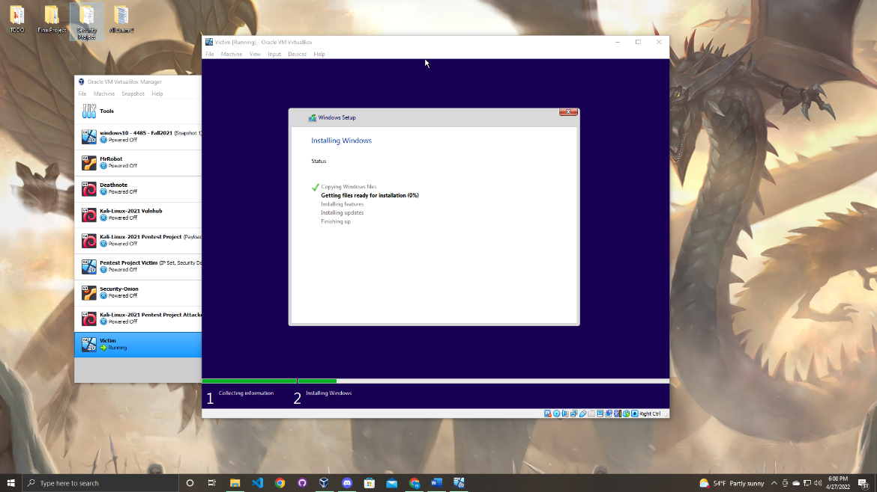

This installation will take a couple of minutes.

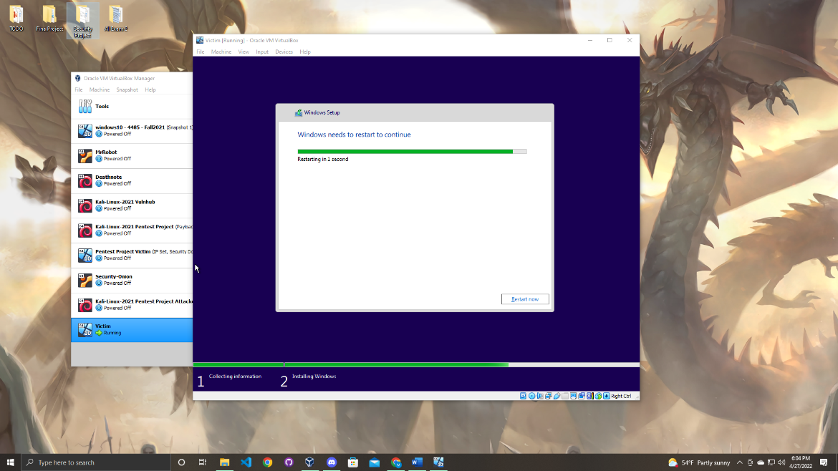

Once the installation is complete click the restart now button on the bottom of the screen.

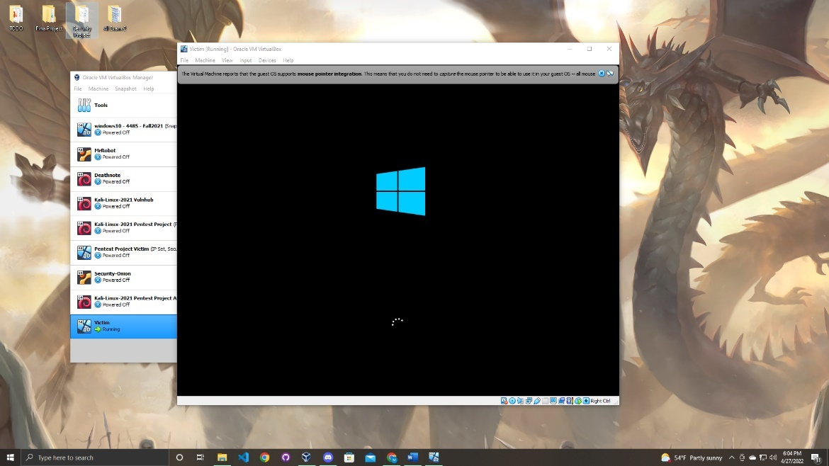

Give the system a minute or two to boot up.

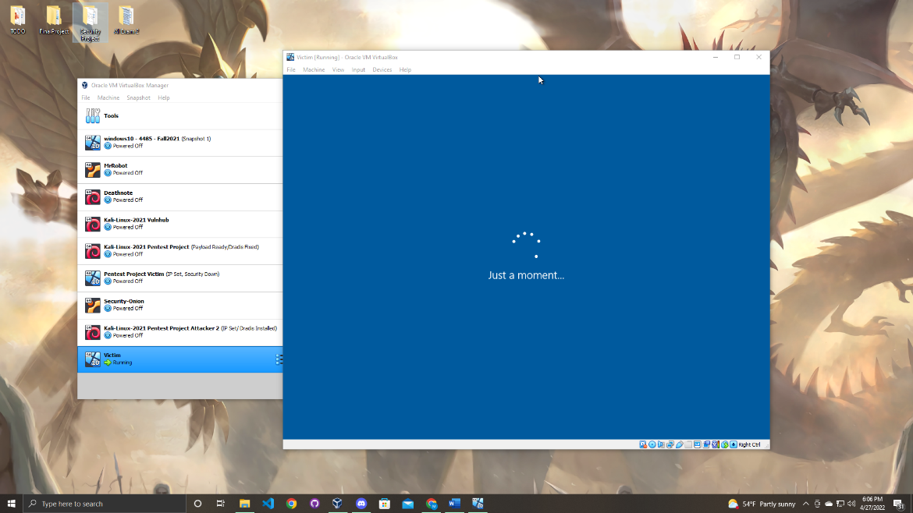

Once the device has started up go through the set-up process as below. Select a region and click yes on the bottom right of the screen as shown below.

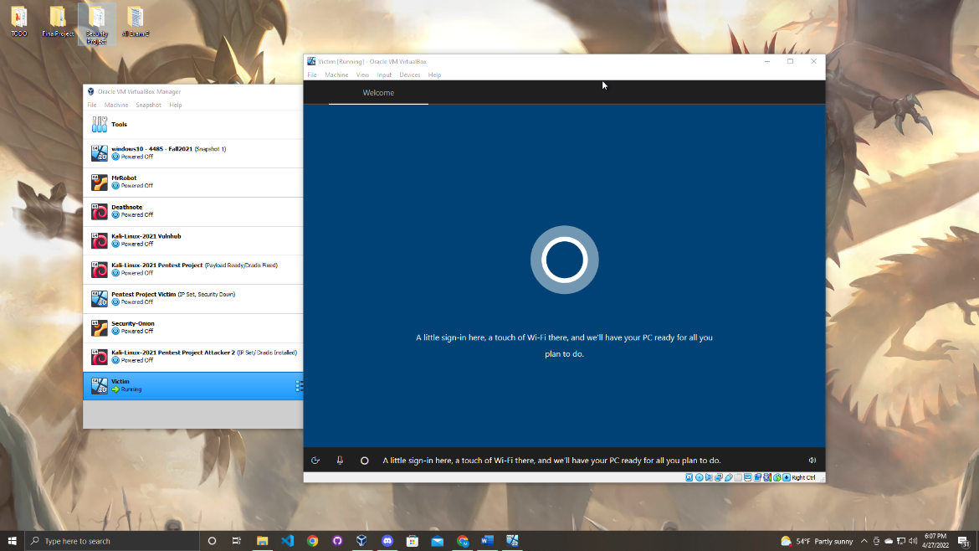

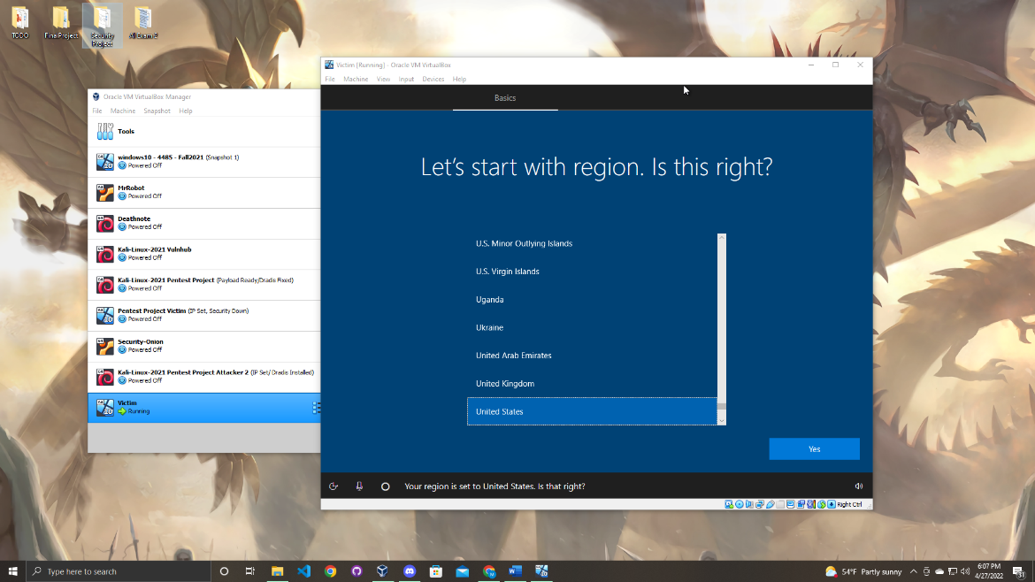

Select the proper keyboard you use.

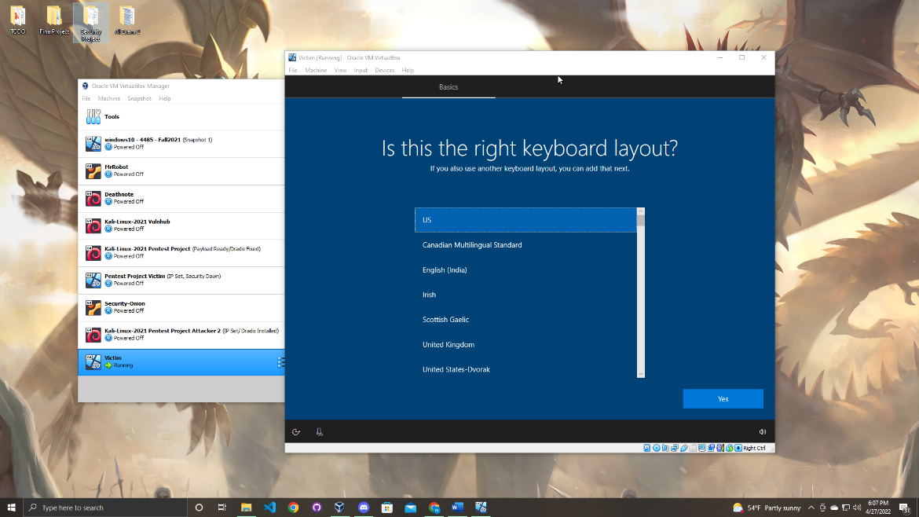

For this project the second keyboard option was skipped.

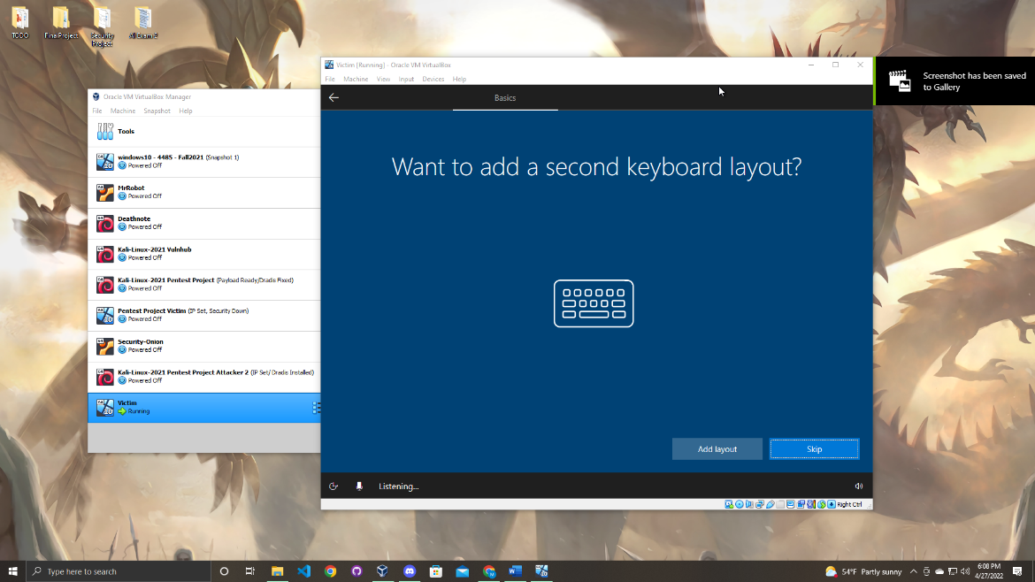

Next it will ask you to connect to a network. For this project you do not want to connect the Windows device to connect to internet. Next click the “I don’t have internet” option on the bottom left option.

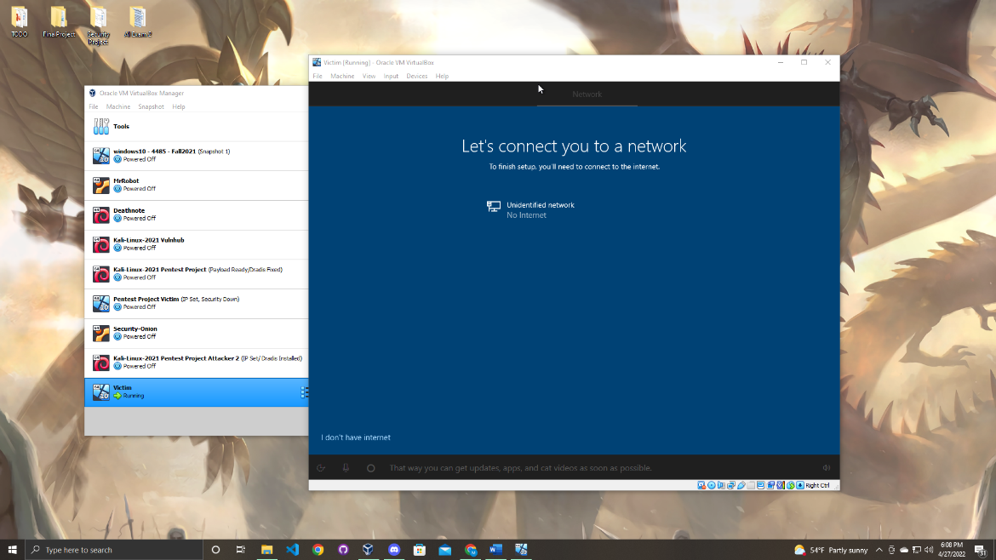

The next step go to the same place as the previous step and click the “continue with limited setup” option.

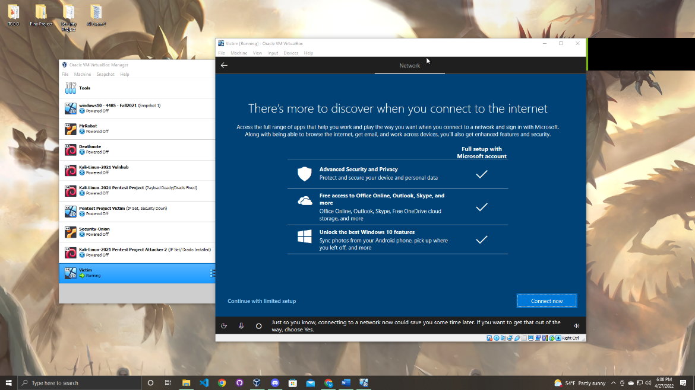

Now you will be able to add the a name to the Windows device for the project the name “victim” was chosen to give a clear representation of who will be attacked later in the project.

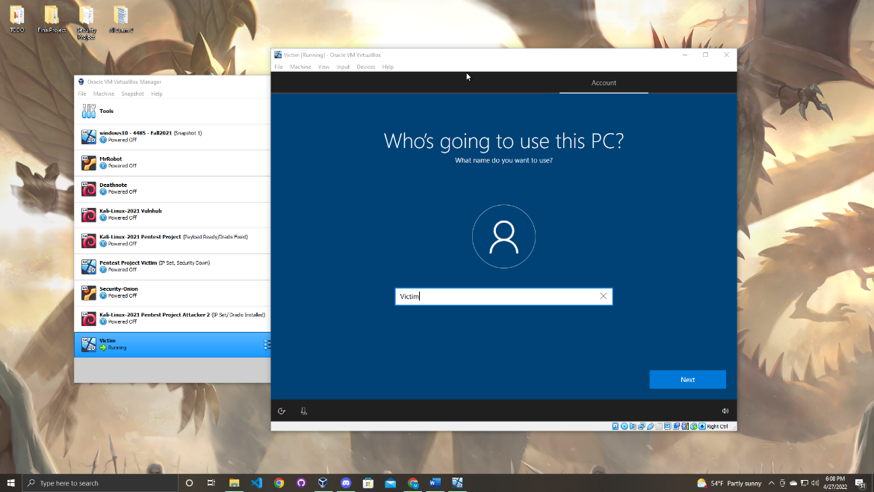

Create a password that you will remember later. (recommendation is to write down the password after you create it)

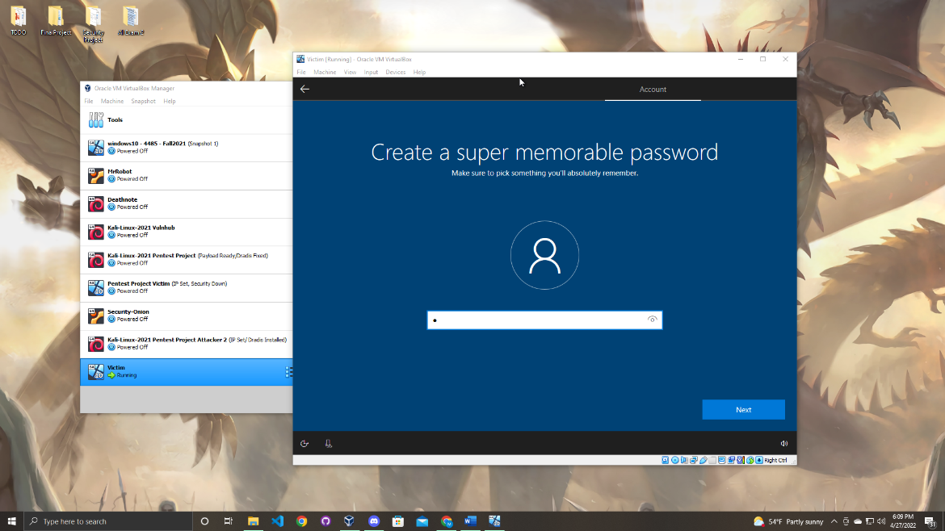

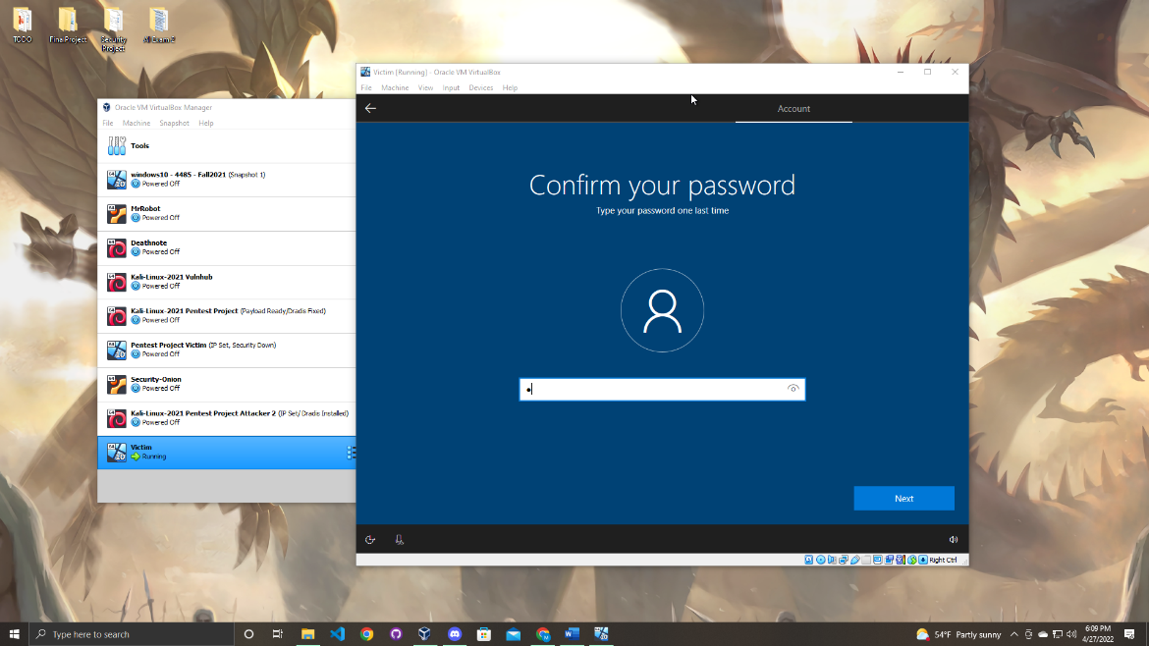

You must also add security questions to advance in the initial setup.

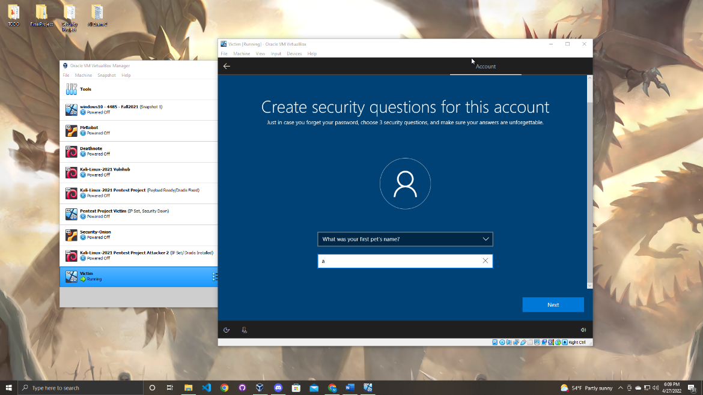

Next accept the privacy settings.

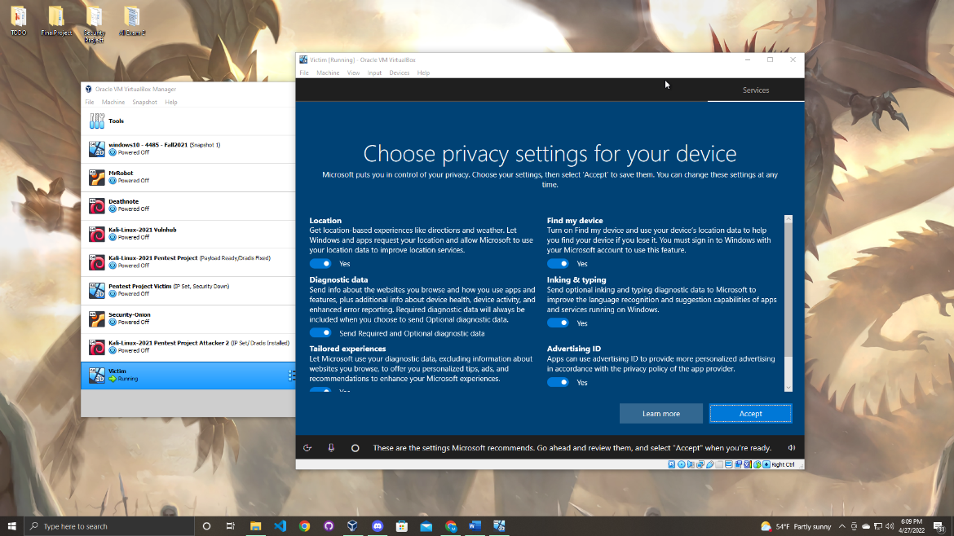

Wait for the machine to load up the desktop.

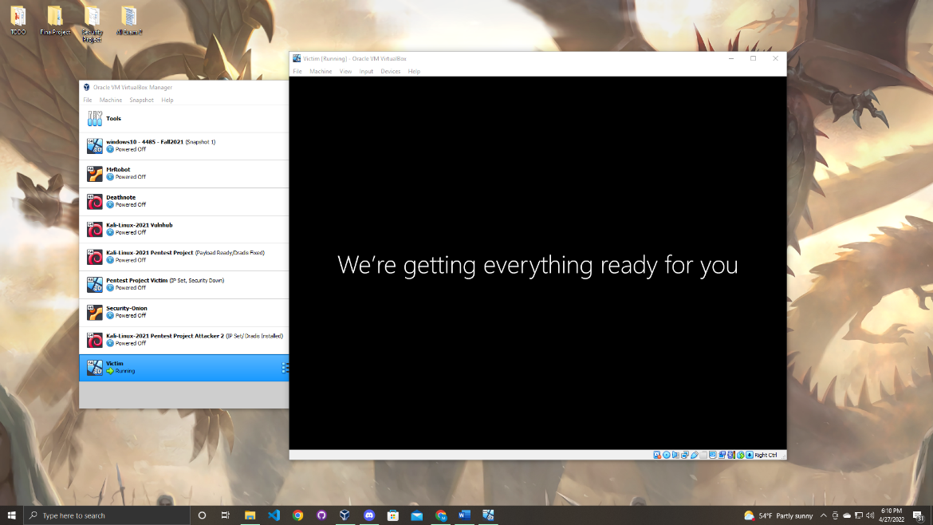

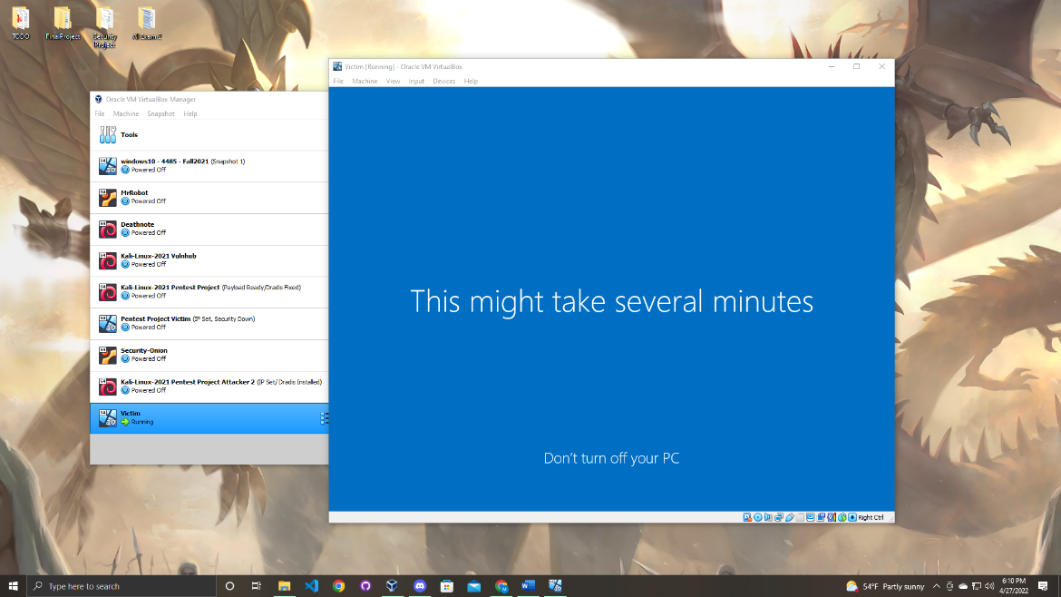

Now the Windows machine will be successfully set up. The next step while the windows machine is open is to set up the static IP address.

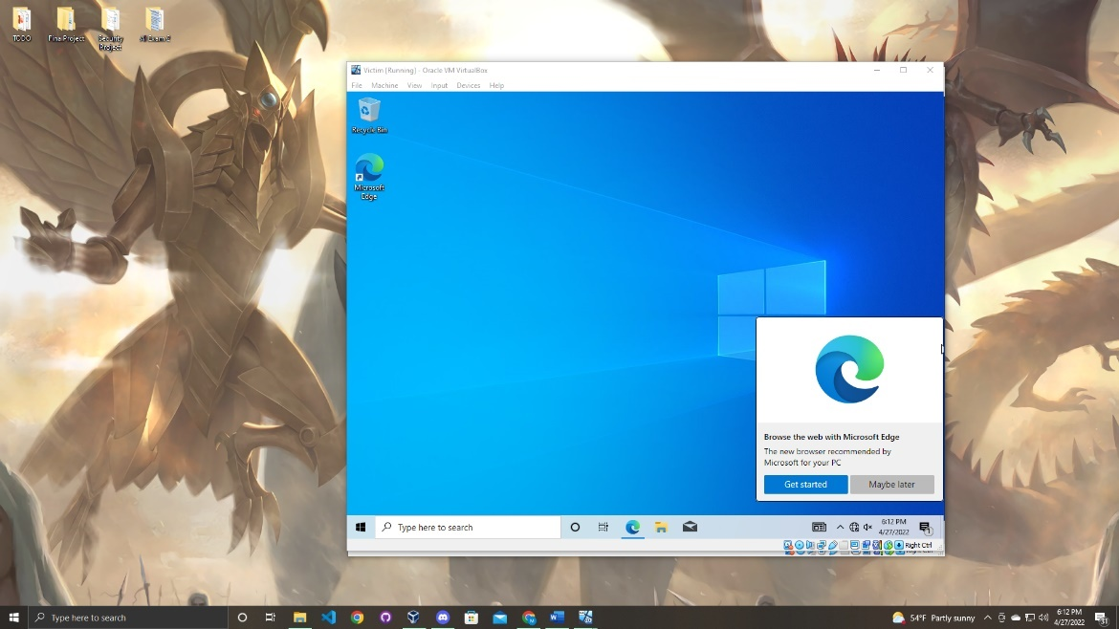

Go into the search bar below and search for the control panel. Once you see control panel double click to open the program.

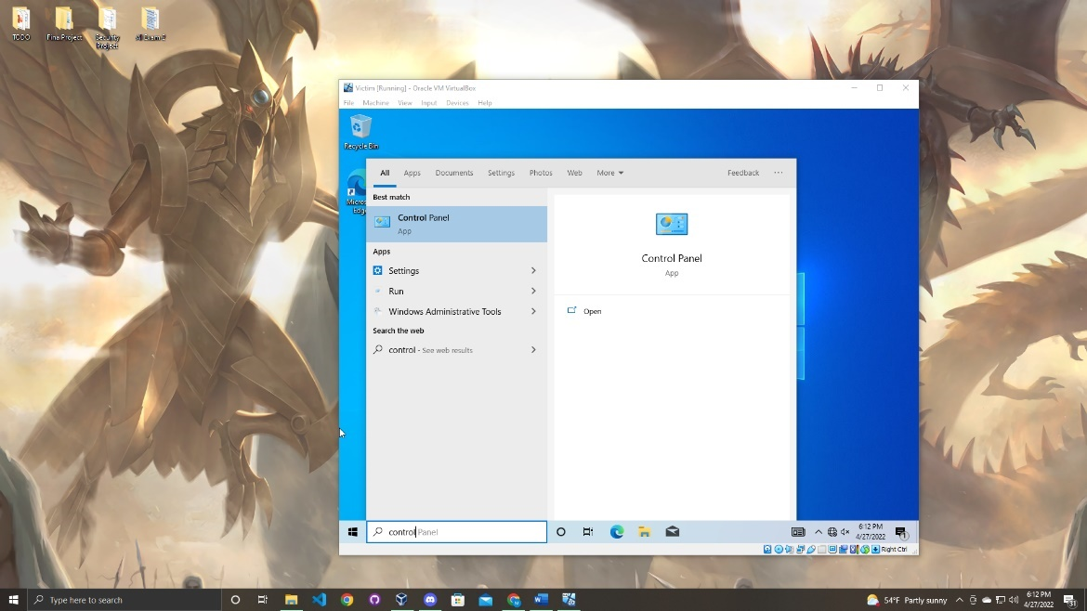

Once the program open go to the top right to the drop down menu and select it to “small icons”.

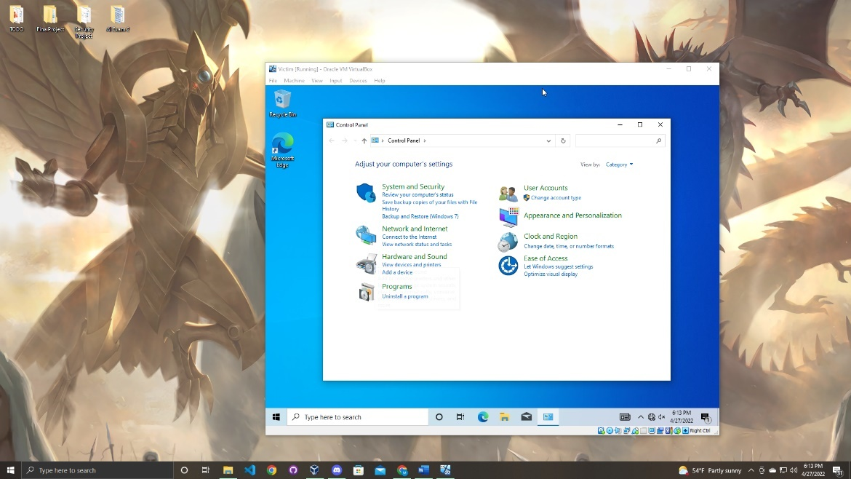

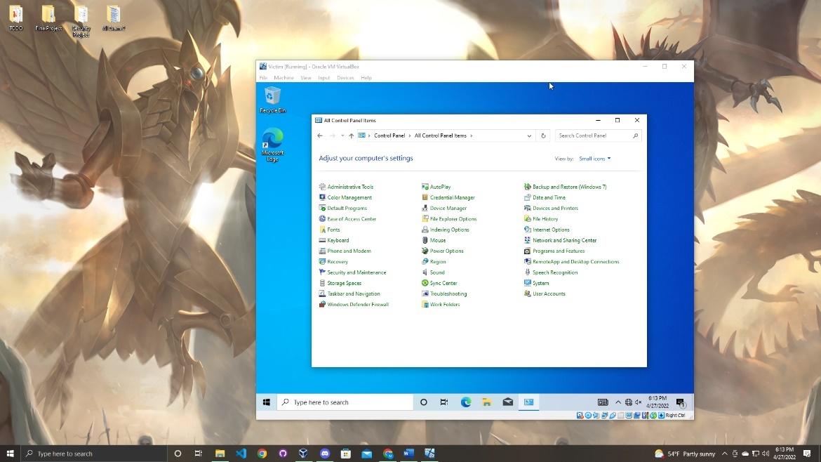

Next select the Network and Sharing Center option.

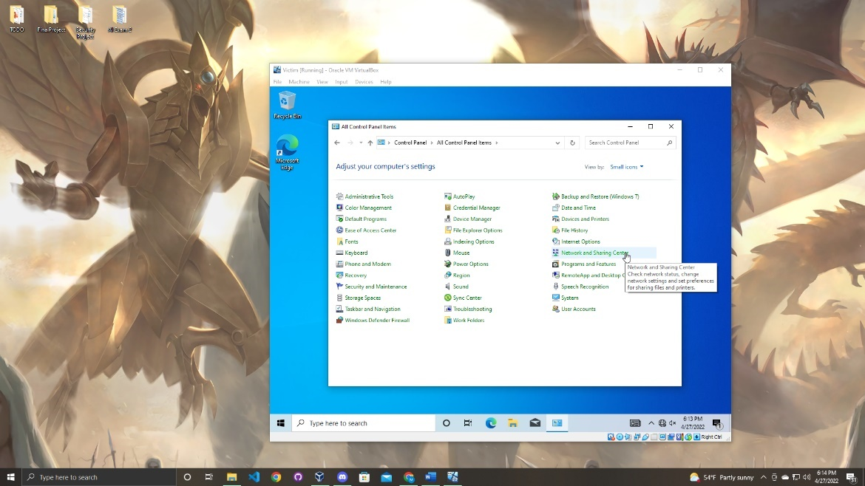

Next it will open another menu.

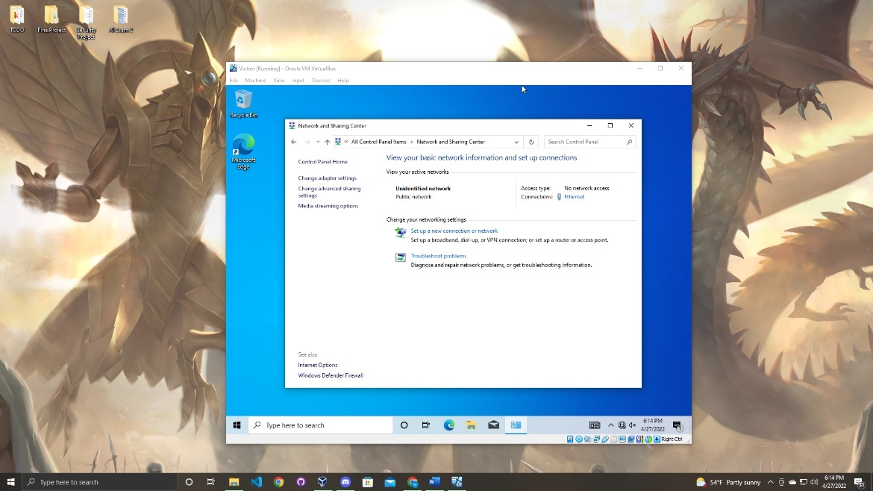

Once you are on this page go to the left side of the window and select the change advanced sharing settings.

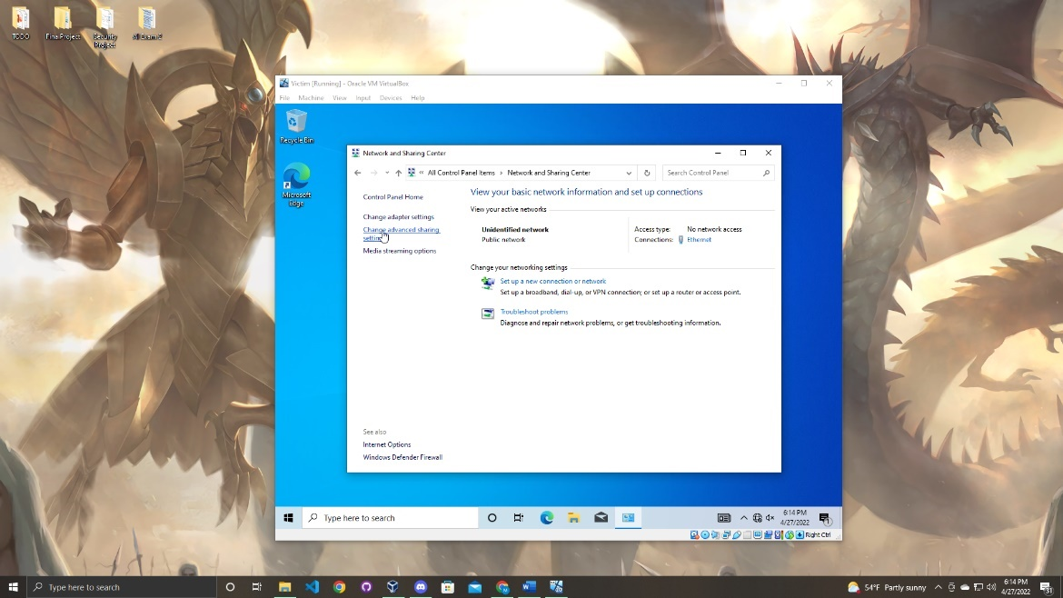

When you are on this page you must turn on the network discovery and file sharing option.

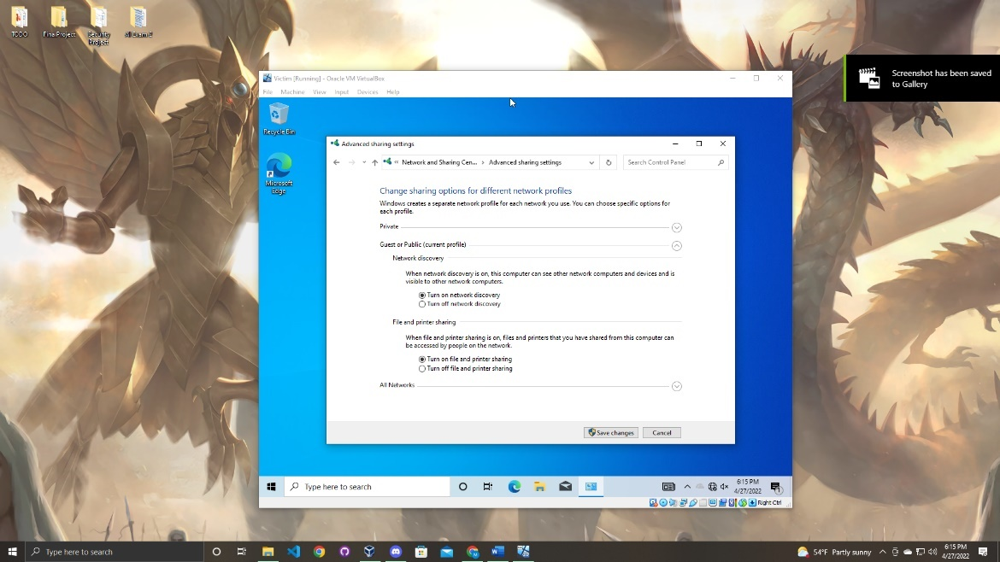

After both settings have been turned on save the changes and click the back arrow to bring you to the previous page.

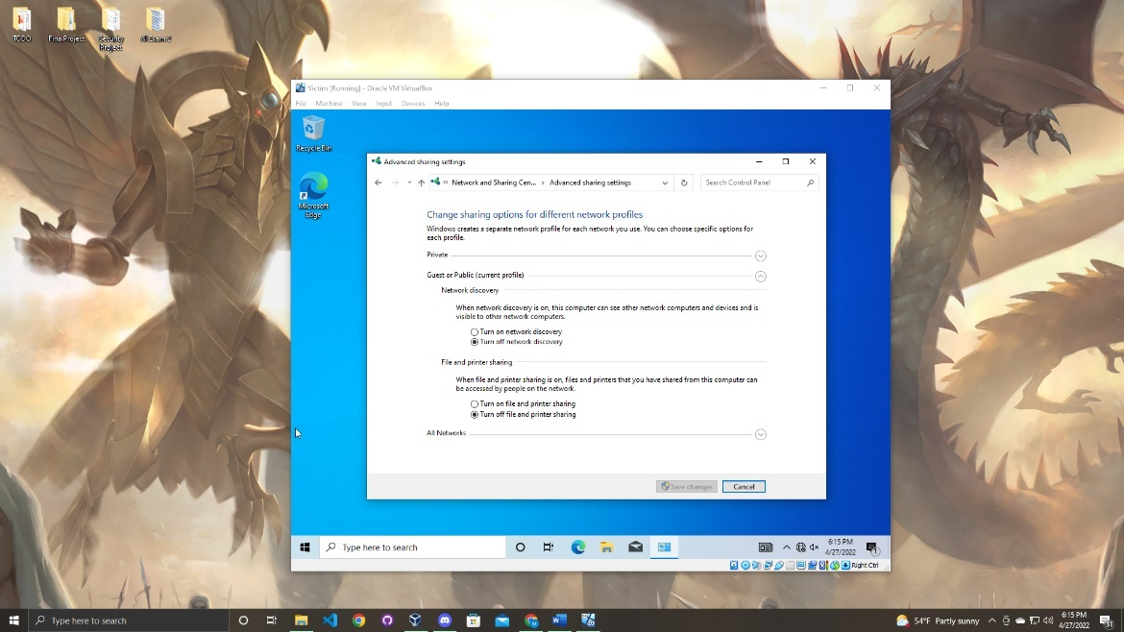

Now click the chapter advanced adapter settings as shown in the screenshot below. This step is very crucial because this is where you set up the static IP address for the Windows machine.

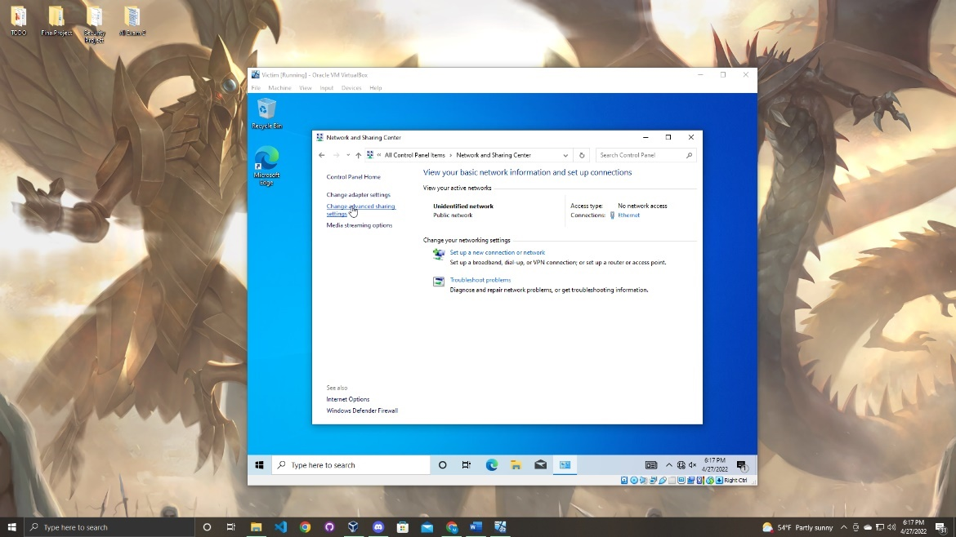

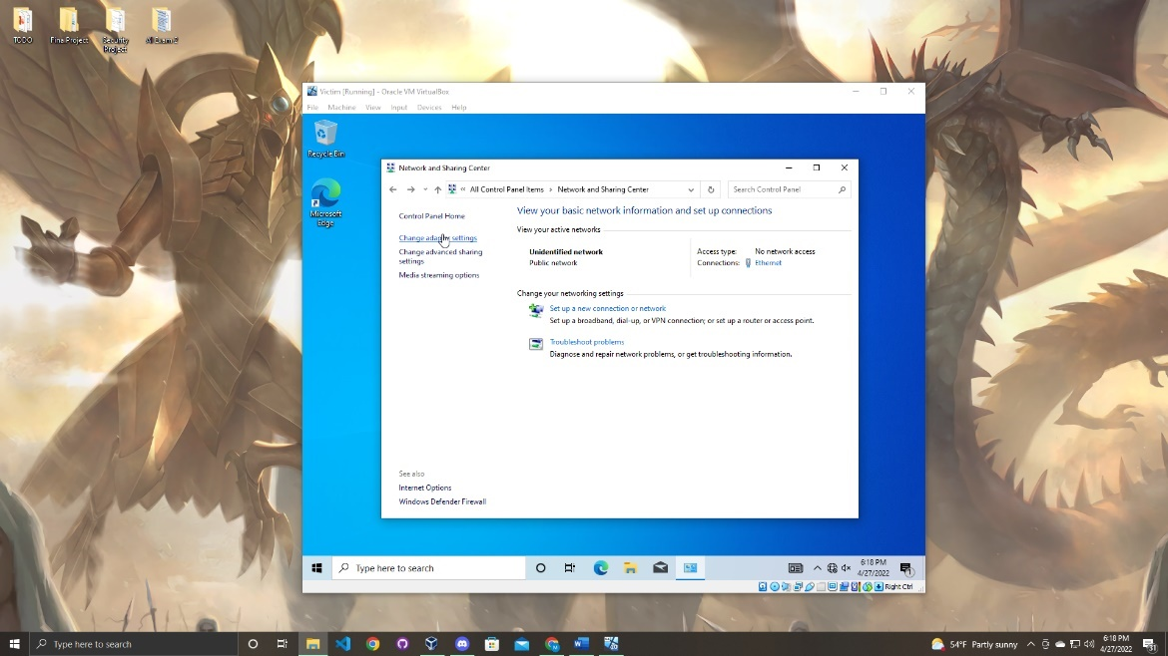

Now click the ethernet option and right click it to bring up a small menu.

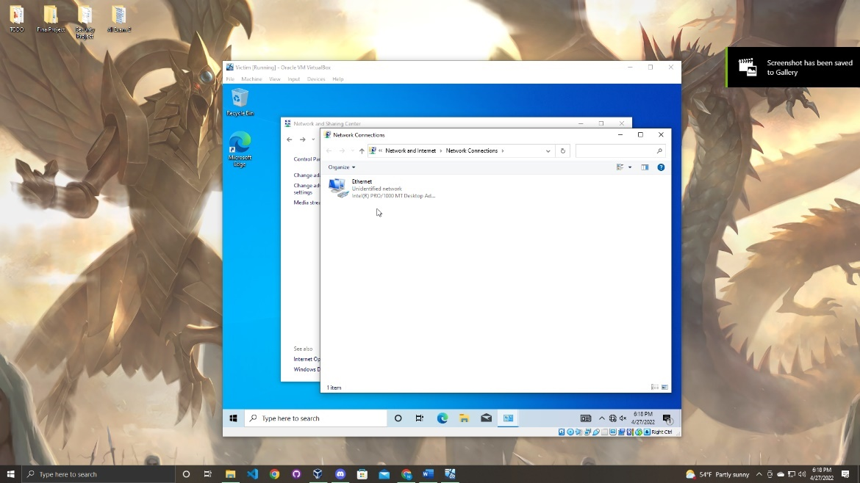

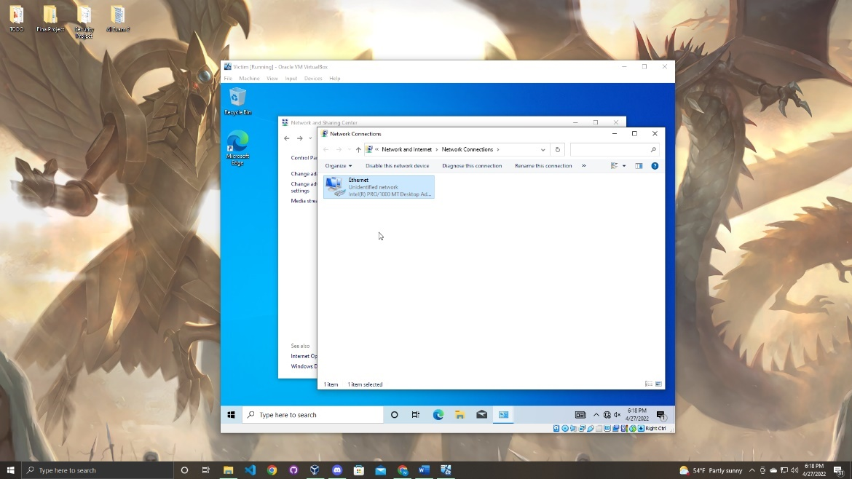

Once the menu is open go down to properties at the bottom.

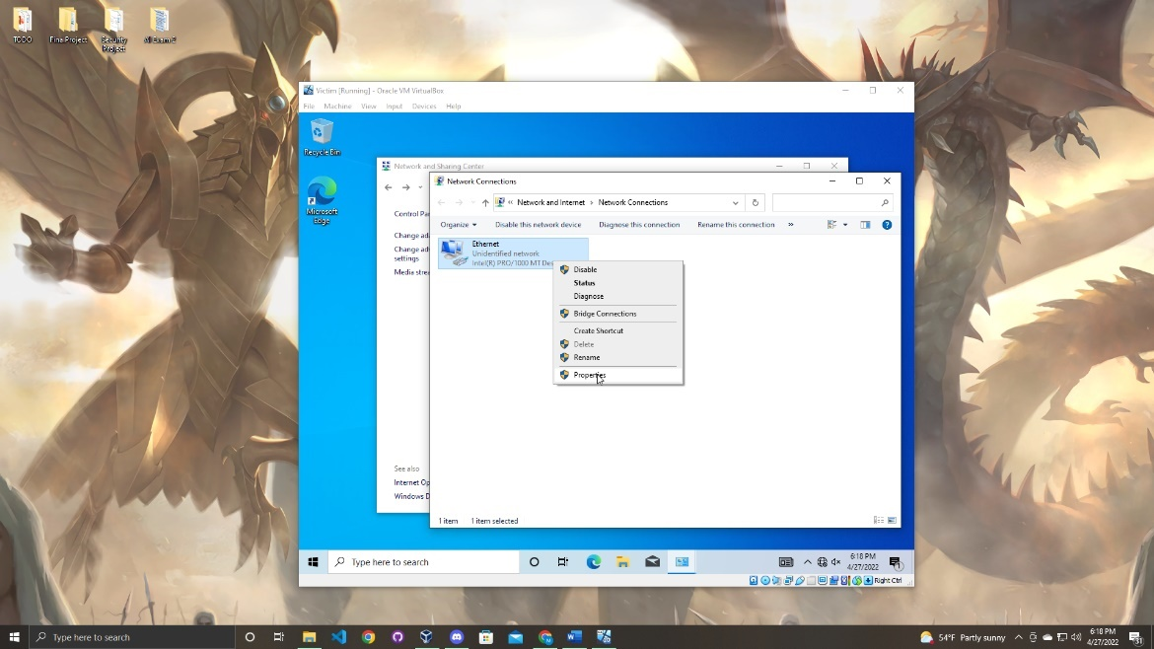

You will be brought to

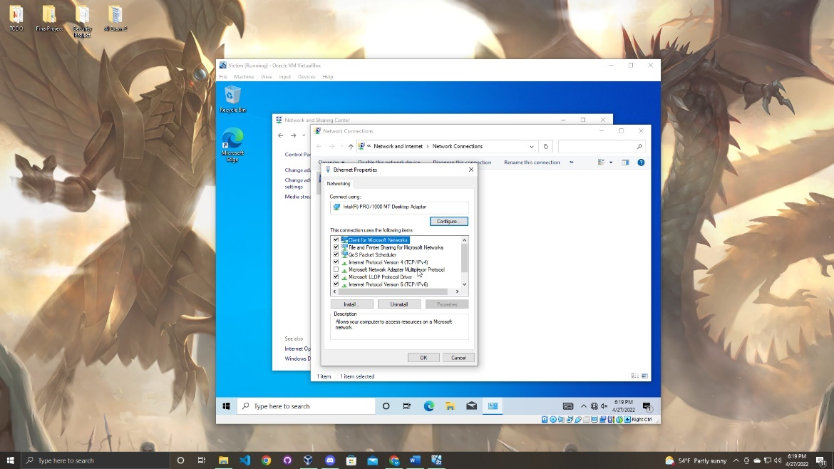

Scroll down until you see the internet protocol version 4 (TCP/IPv4). Click on the option to highlight it and then select the properties option.

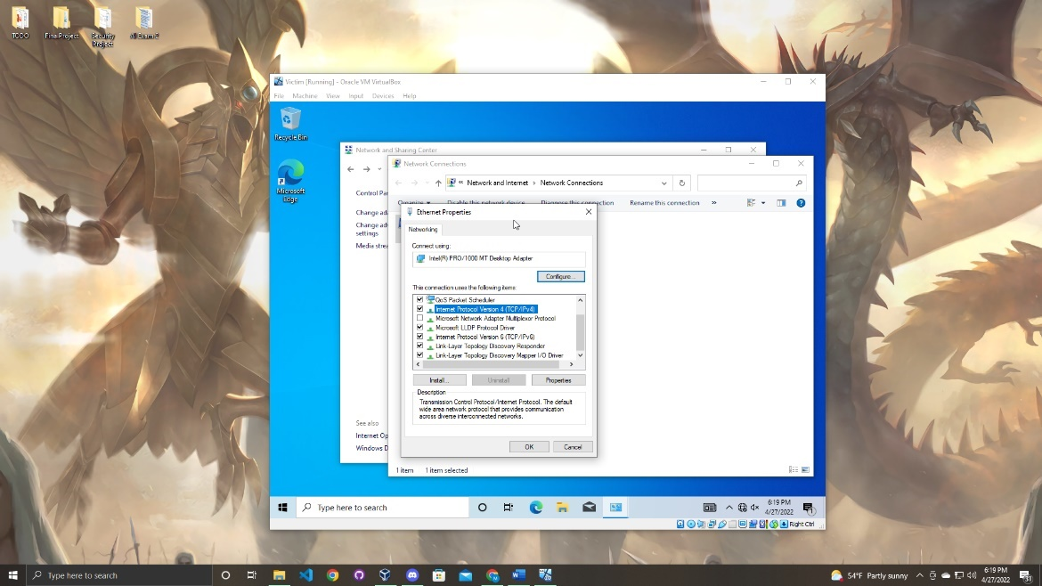

Now this is where you set up the static IP address.

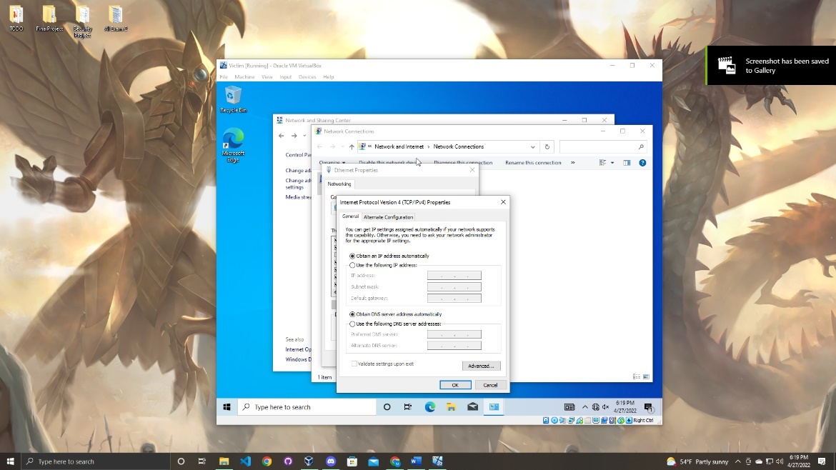

Click the “use the following IP address” option and enter the static IP address you want for your device. Also you must add the proper netmask and gateway for your static IP address.

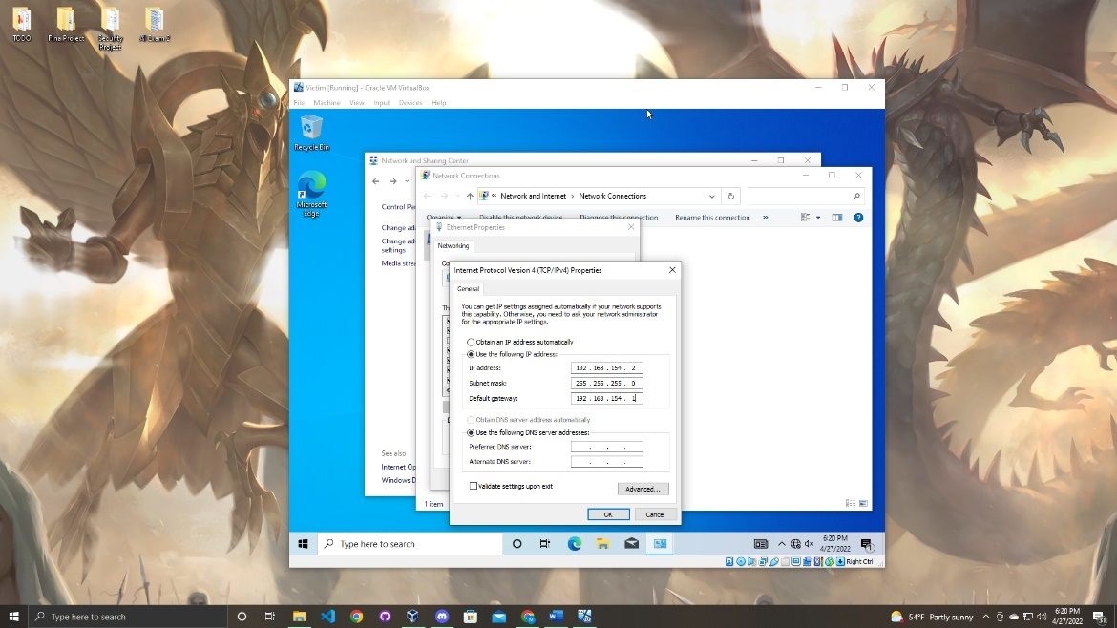

Once the options are filled out click the “Ok” option. Now you must test to make sure the IP address was successfully changed to do this open command prompt. When you are in the command prompt type the command to see the network configuration. To do this follow the command below.

Windows Command:

ipconfig

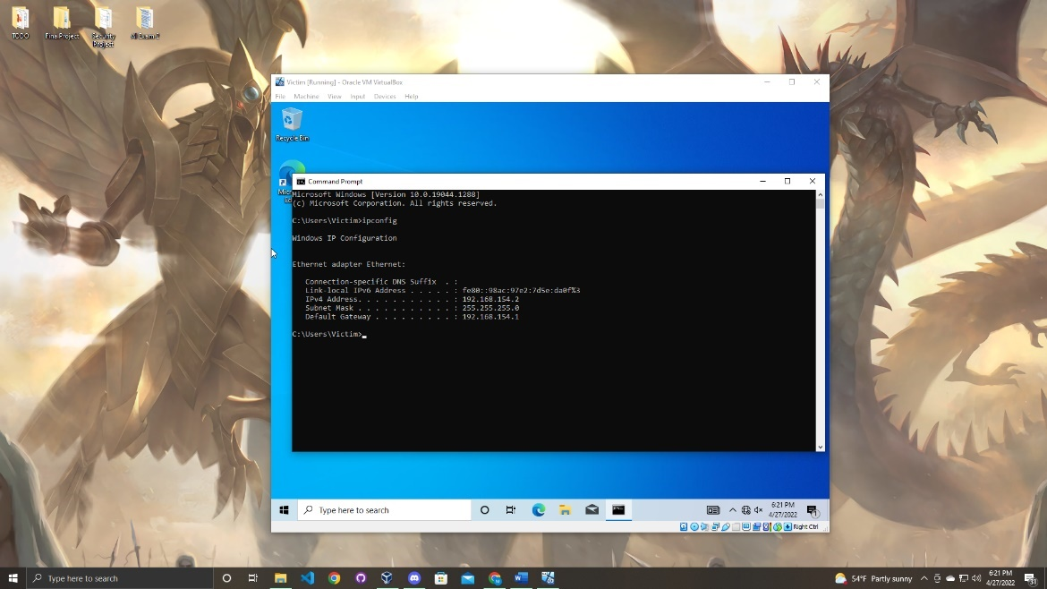

As you can see the IP address has been successfully changed to the static IP address.

Section

5

Verify Connection Between Kali and Victim

In section 5 of the user manual, you will follow the steps to verify your machines can ping each other. If they can ping each other this means that we can conduct an attack on the victim machine. First open both machines.

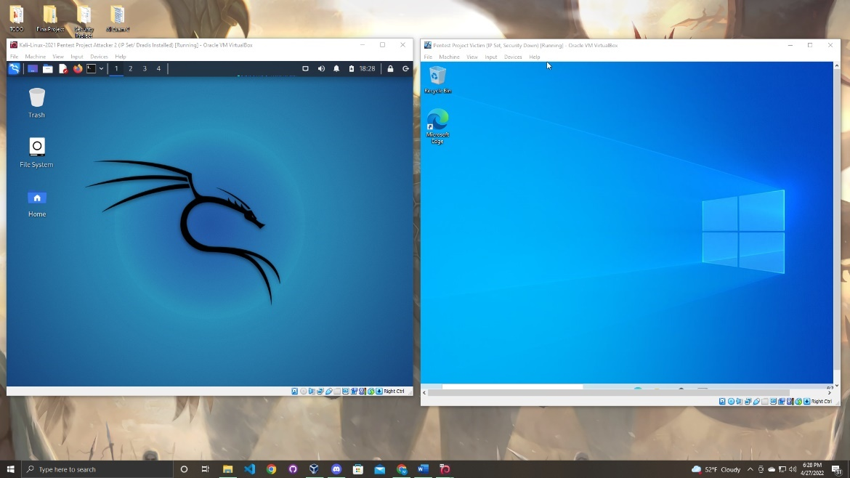

Next open command prompt on both devices as shown below.

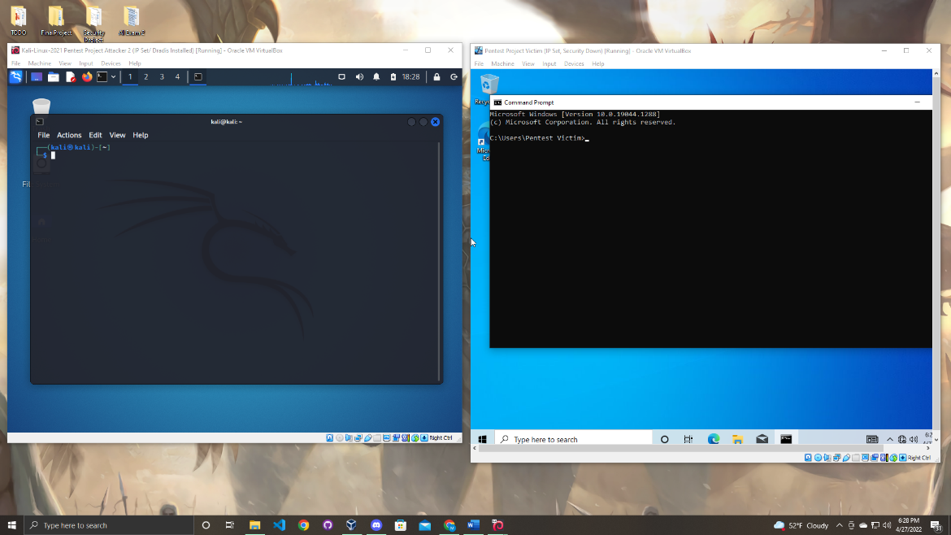

Next you will run a ping command to google on both machines to verify that the Kali machine can connect to the internet and the Windows machine cannot.

Command:

ping 8.8.8.8

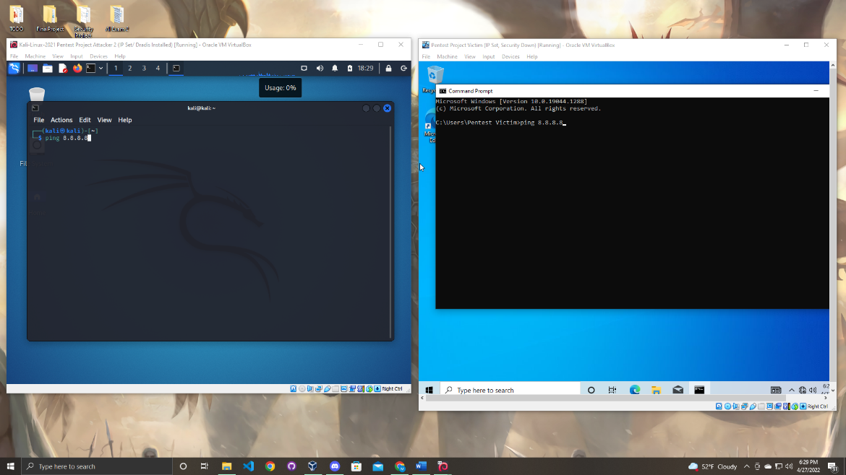

As you can see in the image below the Kali machine is successfully sending pings while the Windows machine is not. Which is exactly what we want.

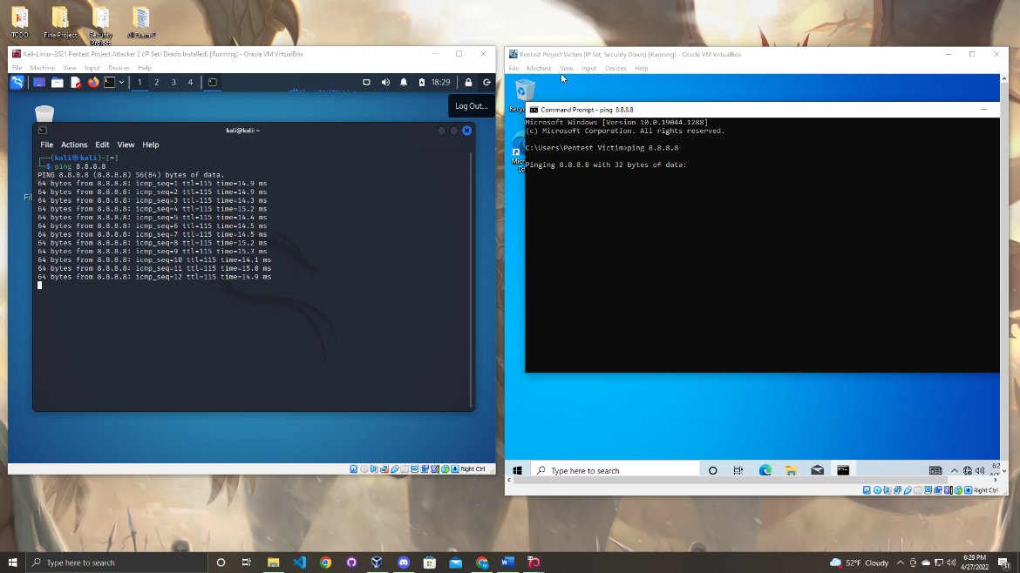

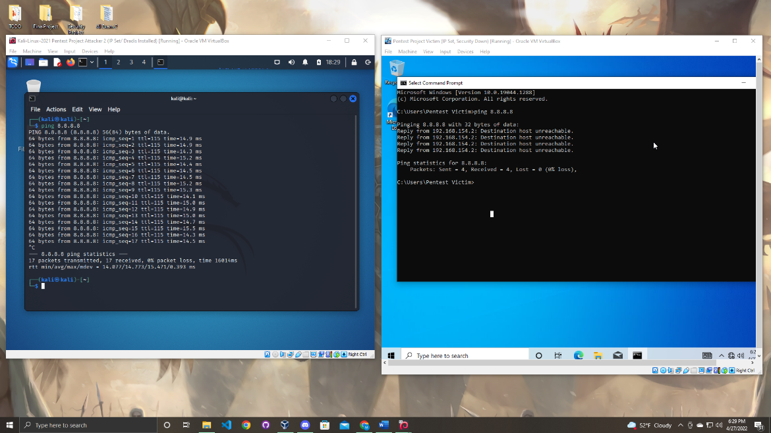

Next you will want to use ifconfig on Kali and ipconfig on Windows to display the IP address of both machines. Now once you see the IP address call the ping command and ping the other machine as shown below.

Kali:

ifconfig

ping 192.168.154.2

Windows:

ipconfig

ping 192.168.154.20

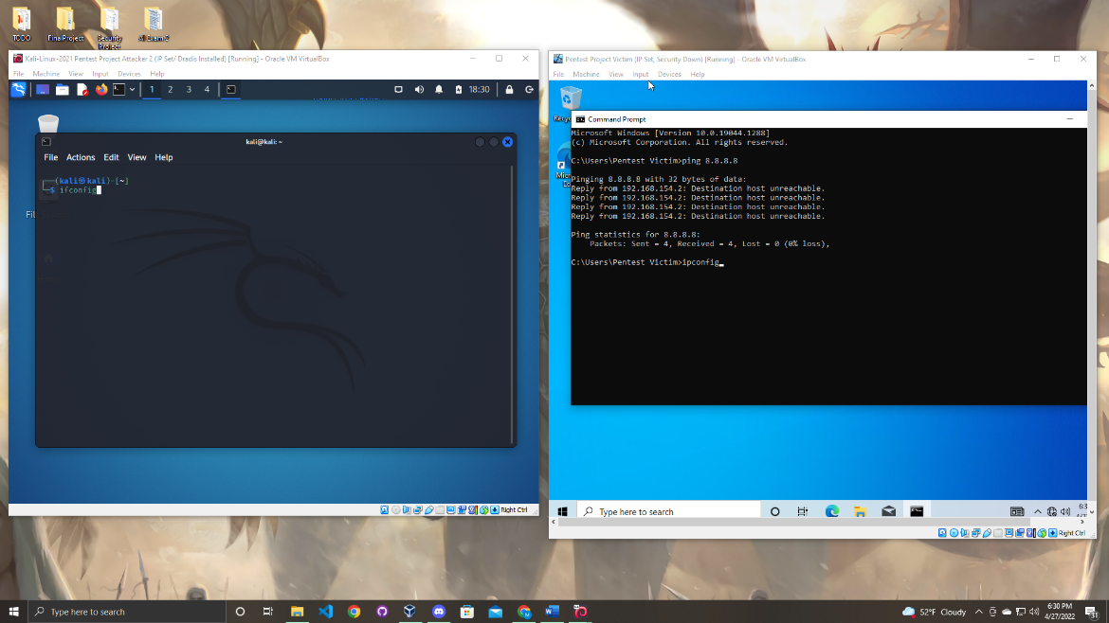

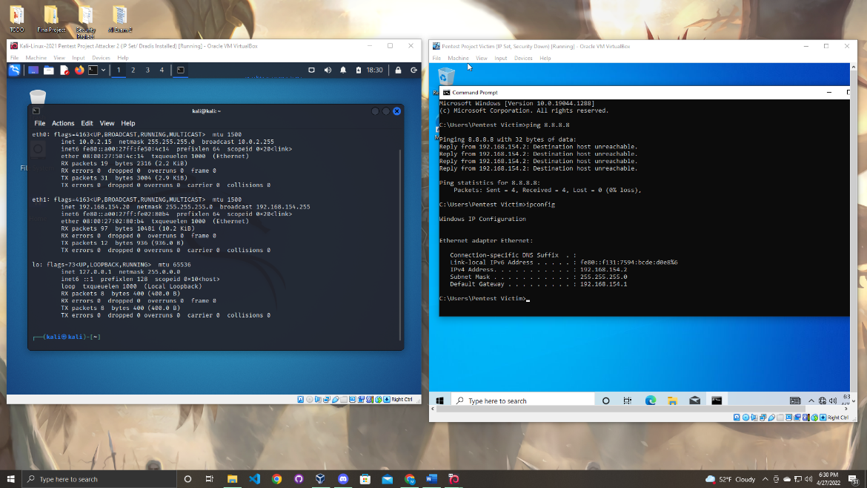

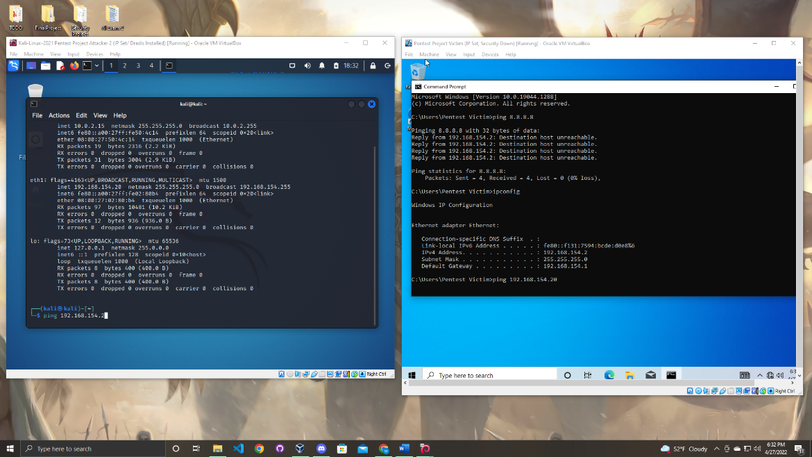

As you can see below both machines are able to send pings to each other.

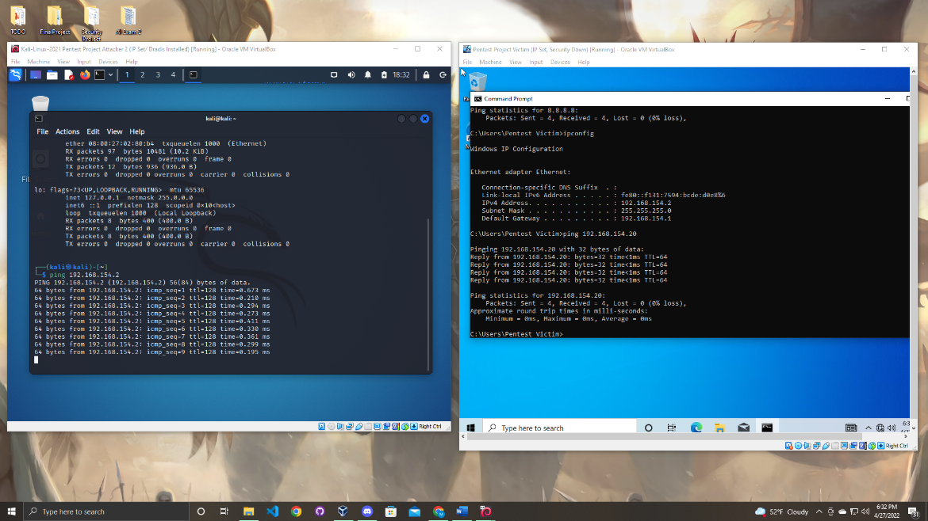

Now both machines can communicate with each other. Now the devices are configured to replicate an attack.

Section

6

Attacking Windows Machine

Now since all the devices are set up, we can have the Kali machine attack the windows machine.

Open Kali Linux and log in the same way as you did in the previous step.

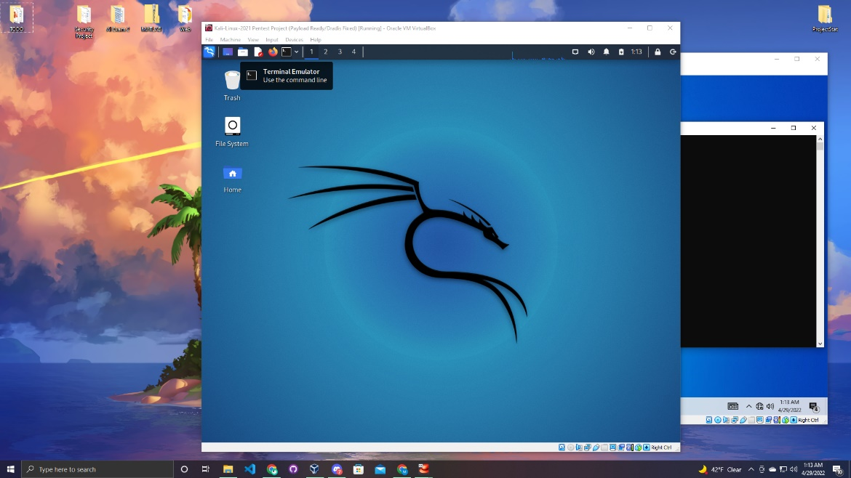

Once in Kali open up the terminal.

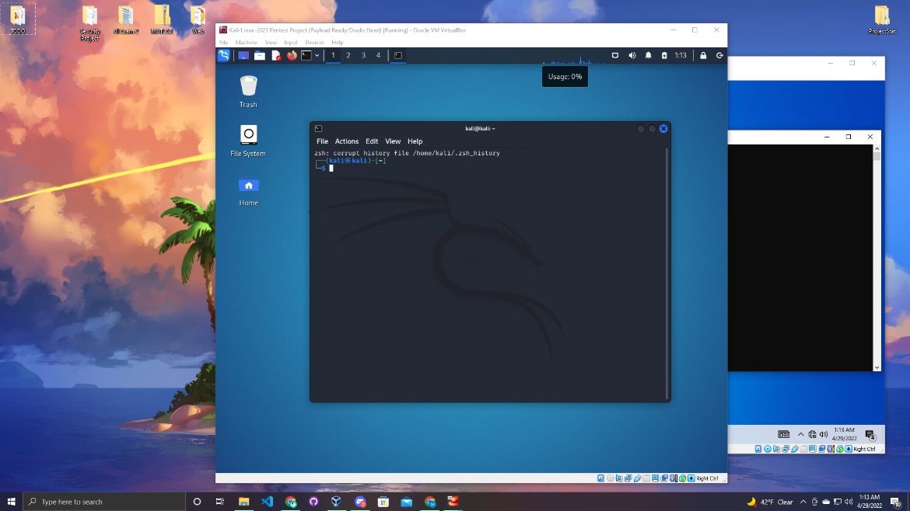

Now in this next step follow the command below. Msfvenom is used to create a payload for the attack. A payload is a the carrying capacity of a pack or another kind of transmission data. (It is important to properly set the LHOST, and LPORT correctly)

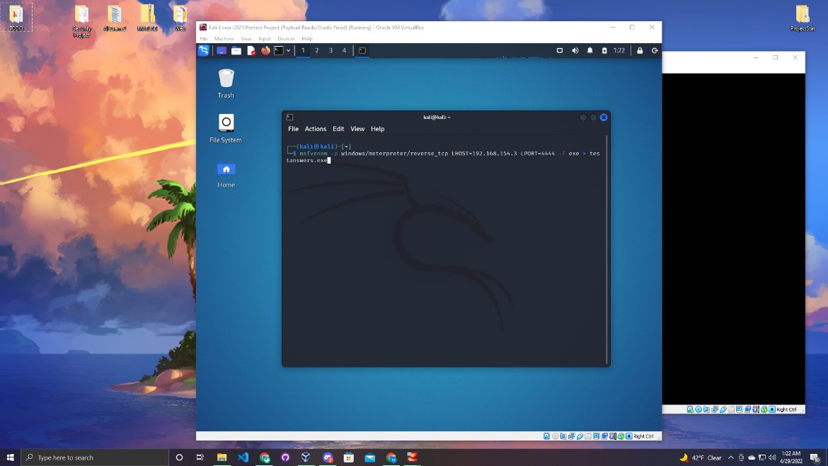

Give the command a minute or so to execute but the output should be very similar to the image below.

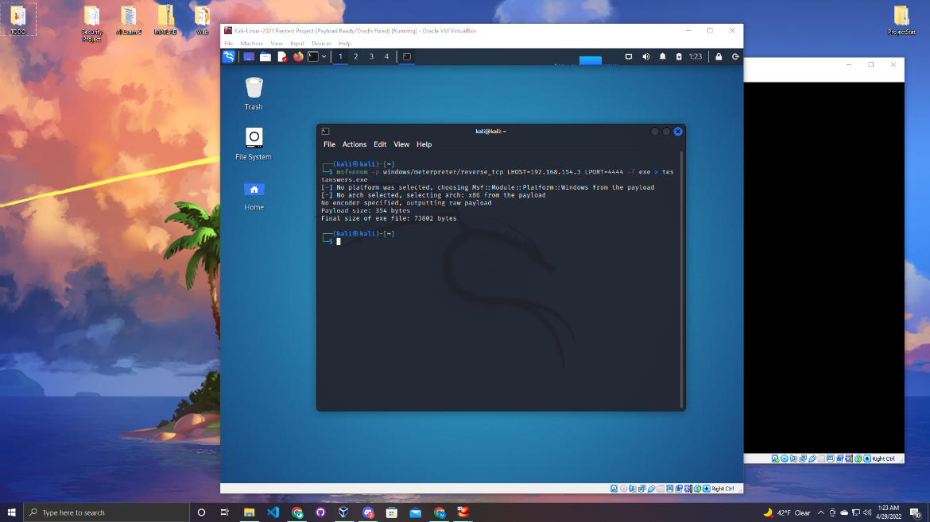

You can go into the file explorer and physically see that the payload is created. Now that the payload is created you can be a little sneaky and hide the payload into an image. The following steps will show how to hide a payload into a image.

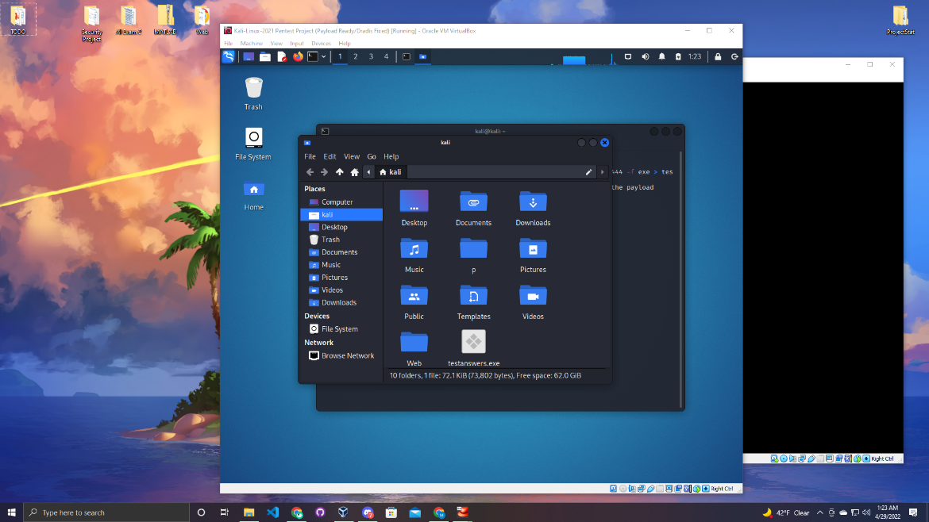

Select any image you want to use and save in a know location on your device.

Open up your web browser and go to ICO Convert. ICO Convert is a website that takes images and creates icon files with those images. Later in the section we will explain why the ico file is important.

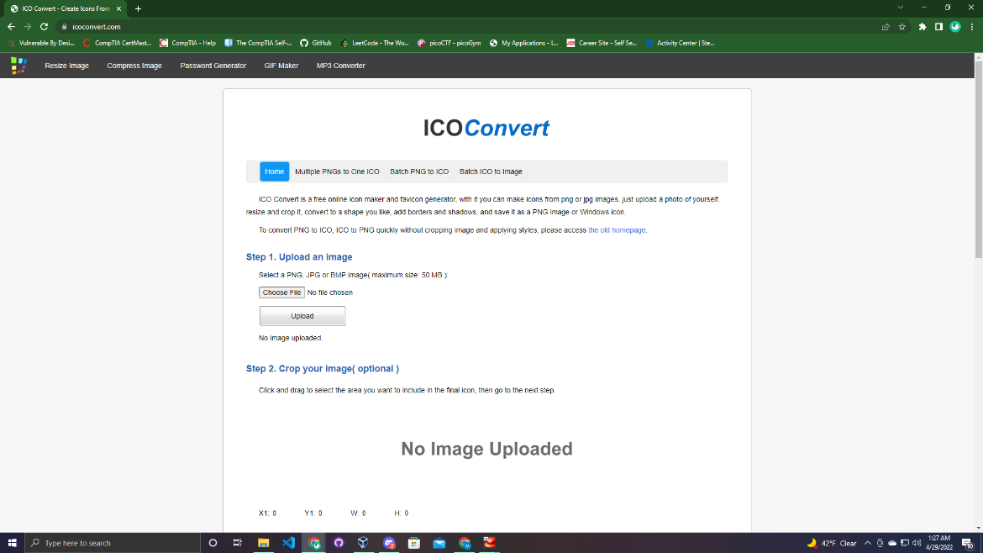

Follow the steps on the page. Upload the image you want to convert. For this simulation the best fit for the scenario is a random answer key image that was found on google images.

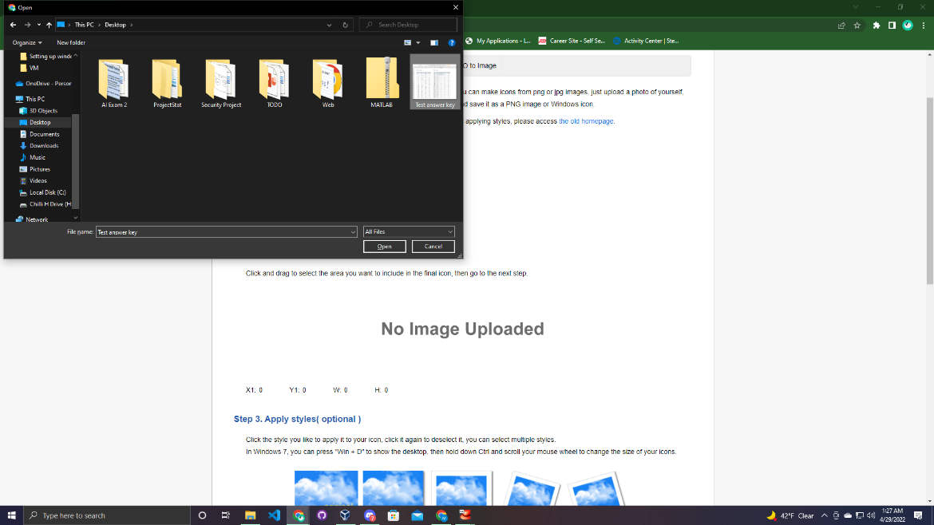

After you select your image click the upload button. Once it has been successful you will get a message under the button saying “Successfully uploaded”. Next you can skip step two and skip step 3.

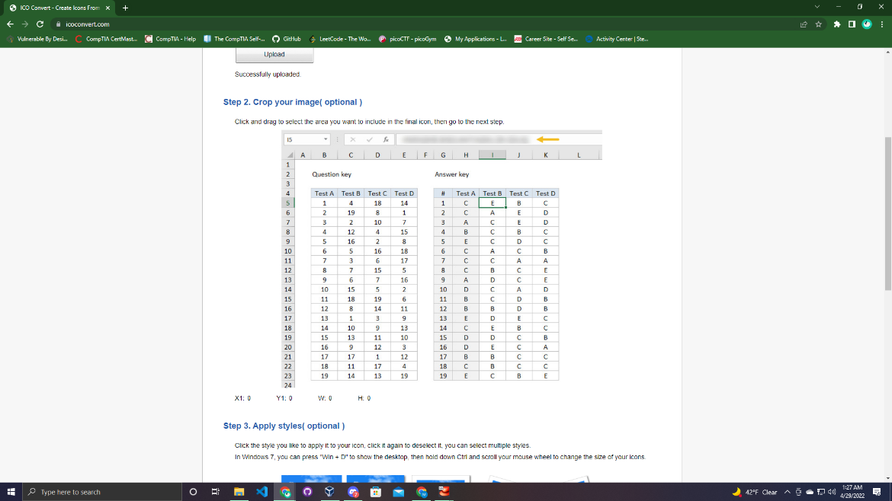

Select the ICO for windows 7,8,Vista, and XP option.

After click the “Convert ICO” button at the bottom and you icon file will be made.

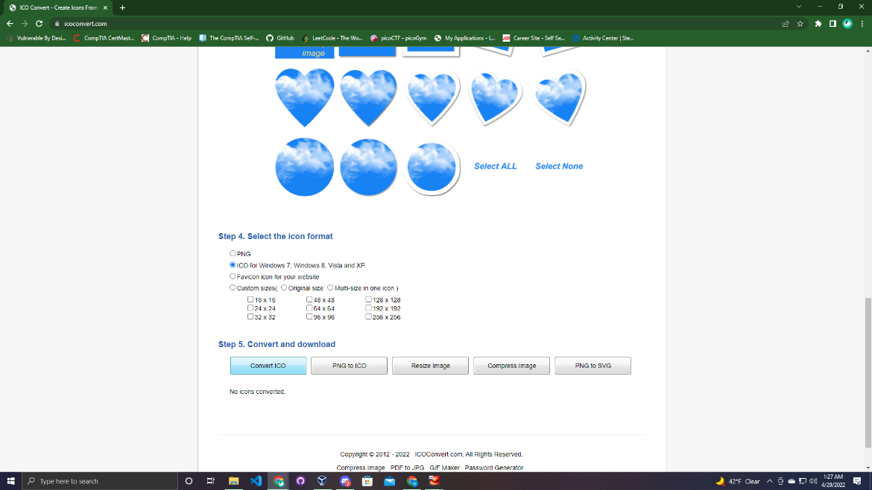

Now you need to bring the payload on to your device. The machine used during the project was a Windows machine. On windows you can download “WinRAR” which is what we will use in the demonstration.

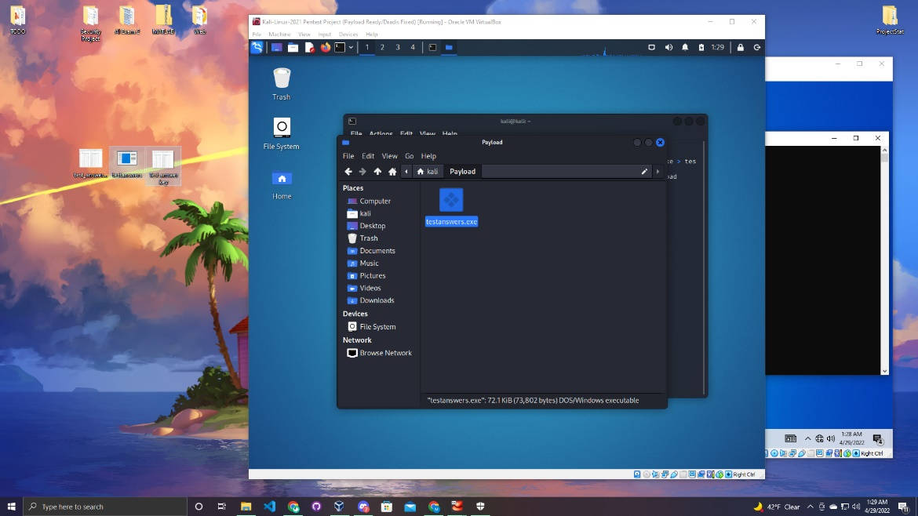

Now highlight the payload and the image. Once both are highlighted right click your mouse and select add archive. Then this window should appear as in the screen shot below.

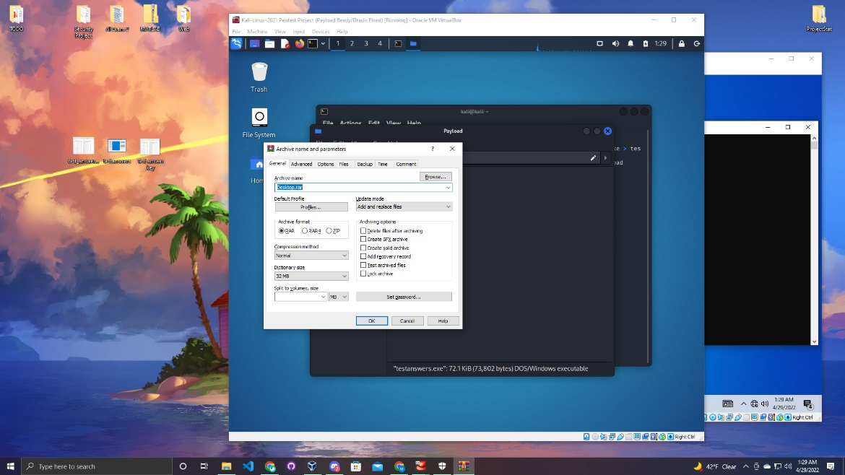

In this menu you can change the name of the file. For the specific scenario “TestAnswers.jpg ” was chosen.

Change the compression method to best.

Change the dictionary size to 256 MB.

Click the “Create SFX Archive” option.(Make sure the check mark is shown once you click it)

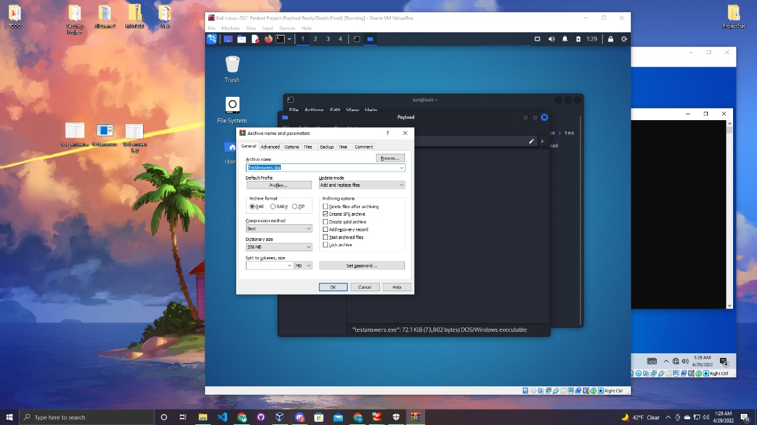

Next select the advanced tab and select the SFX options button.

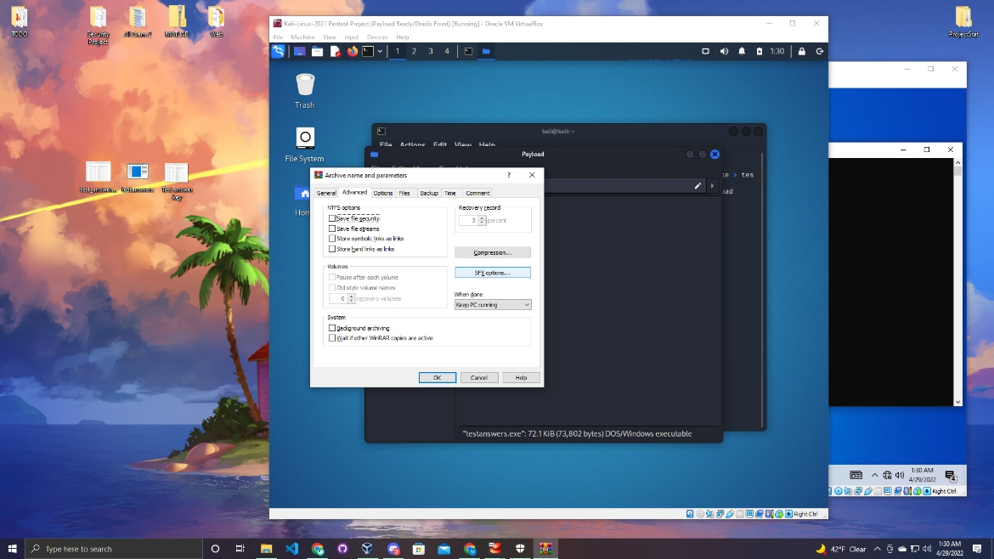

Once the window appears select the text and icon tab. The important reason for creating the icon file was to use in as the icon for the new file that is being created. WinRAR is being used to a create a new file with the payload and the image. Go to the last option to load the SFX icon from the file and click browse. Locate your icon file and select it.

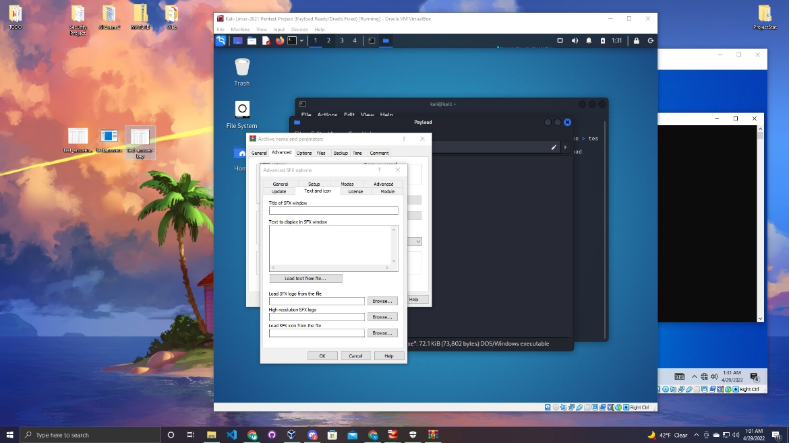

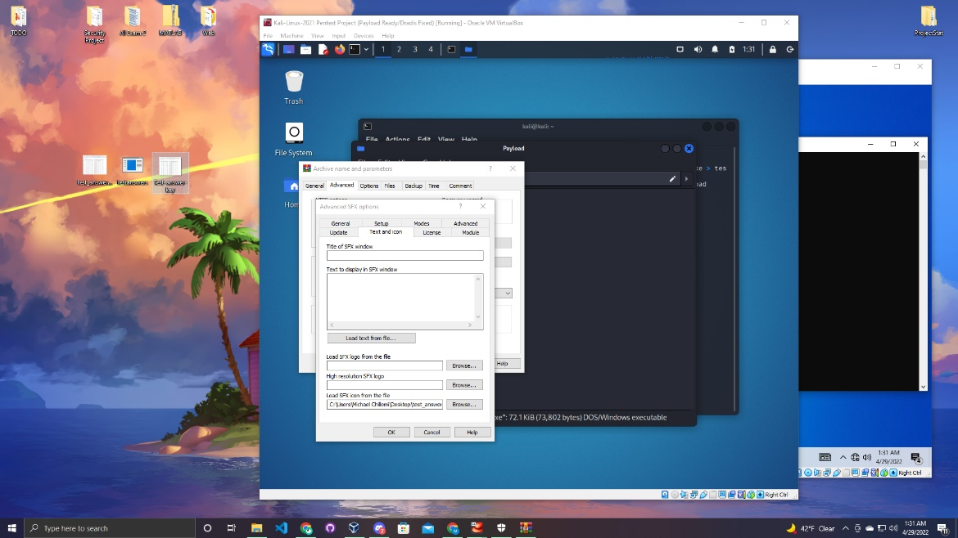

Now you can move to the update tab and select the overwrite all files option.

After navigate over to the setup tab. There will be a big text box this is where you tell the application what programs you want to run first when this file is opened. Enter the name of the payload with the correct extension. Then on the next line enter the image name and proper file extension.

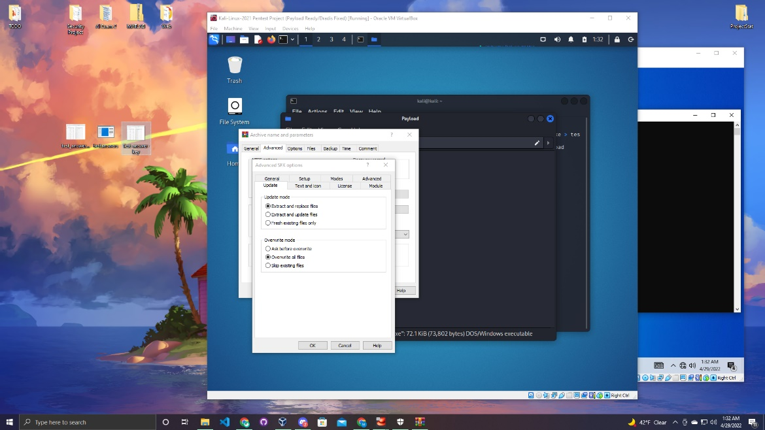

The last step will be to go to the modes tab in that menu select the hide all option in silent mode. Last select “OK”.

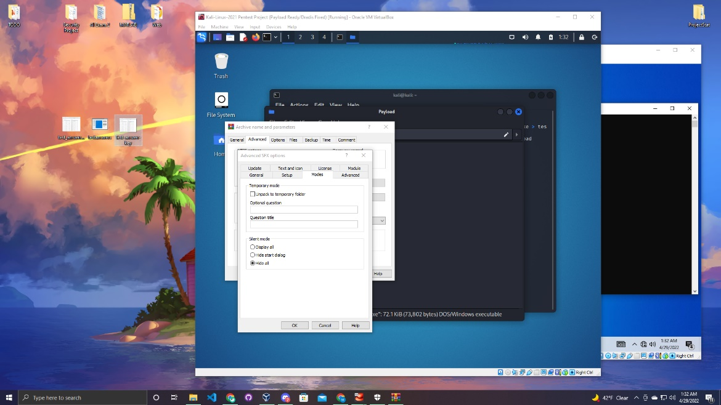

Now the new file should be created move all the files back on the Kali device.

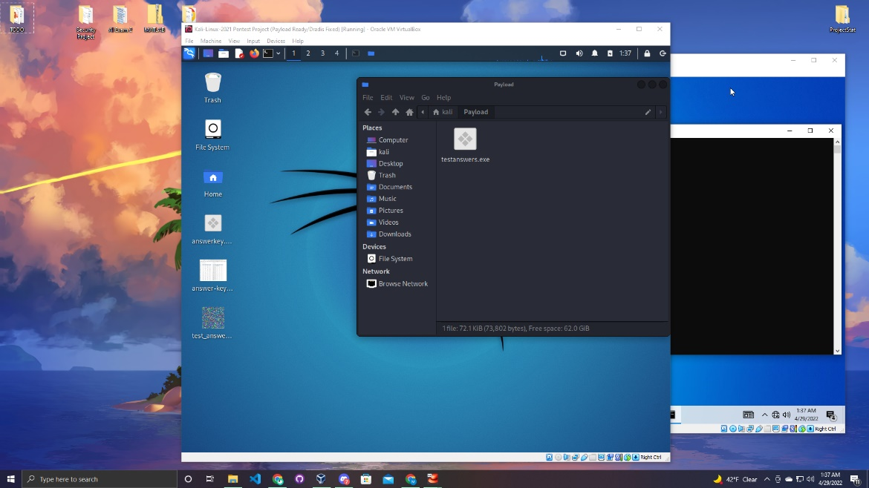

Once they are on the Kali move all the files into a folder. For this project I created a very basic web page to be the way of transmission to the victims device.

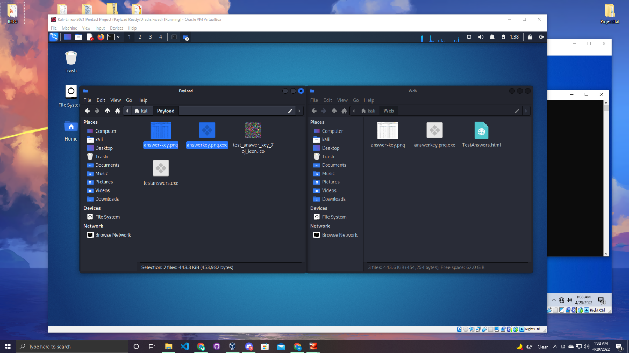

Scenario

So in this scenario a big test is coming up in Dr. Aakash’s class. The class is very nervous about the test. Joe Smith who will be the bad guy in the situation tells some of the classmates that he has the answers to the exam. All they have to do is go on this web url 192.168.154.3:9000/TestAnswers.html.

Joe will be the user on Kali and Paul will be one of his classmates who went on the website.

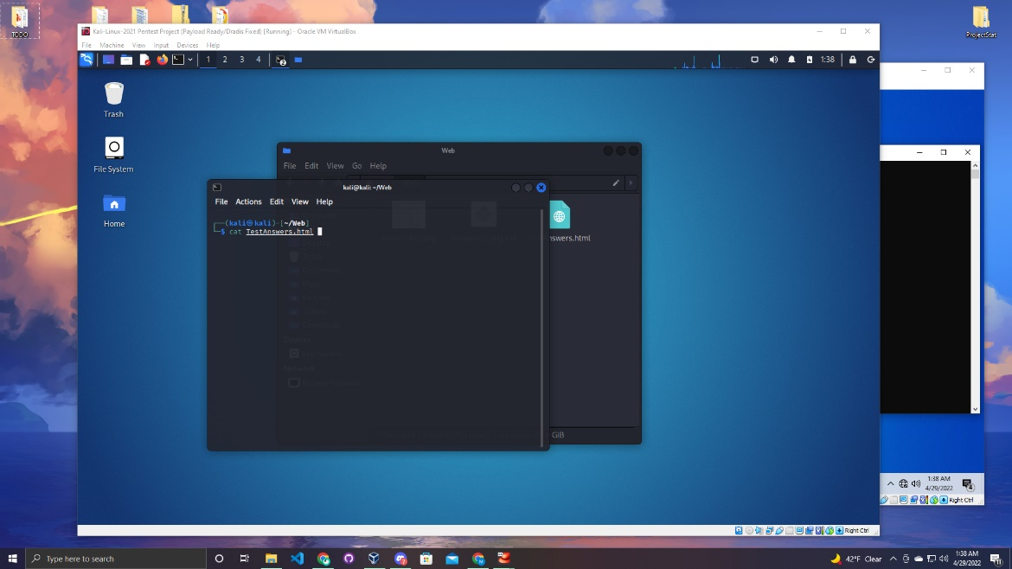

You can copy the html file as in the below image. Be sure to add the name of your payload and image file. In this html file when a user clicks on the image it will download the payload on the users device.

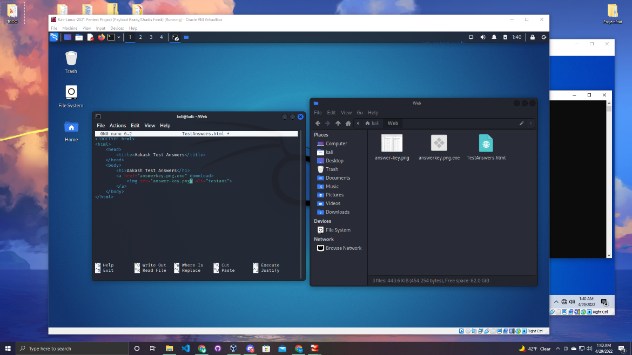

Make sure you are in the folder that has the html file and run the python simple http server to run the web page.

Linux Command:

python3 -m http.server –bind (add the desired ip and port number)

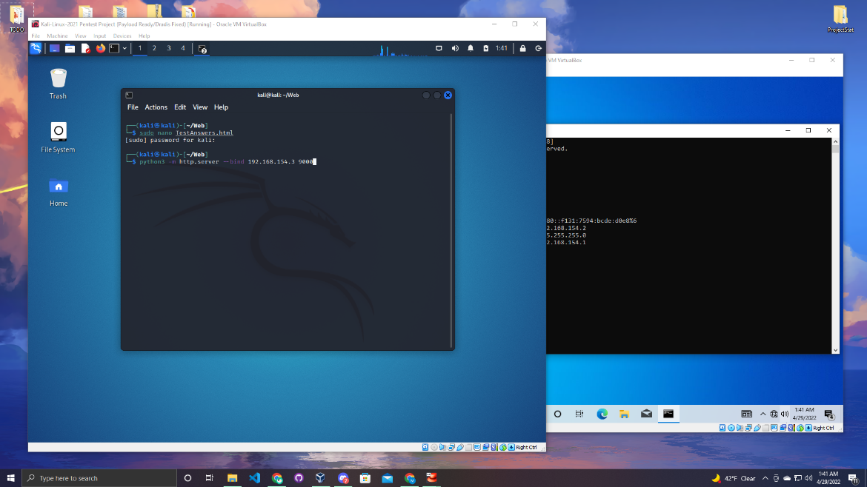

As you can see on the kali machine the web server is up and running.

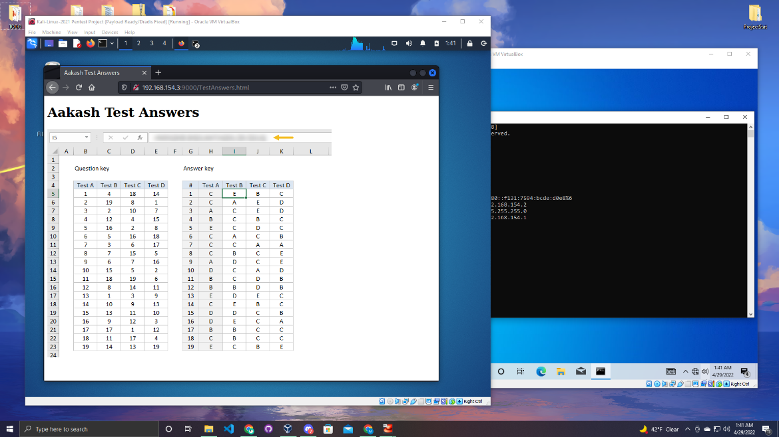

Now on another tab in the terminal load Metasploit.

Linux Command:

msfconsole

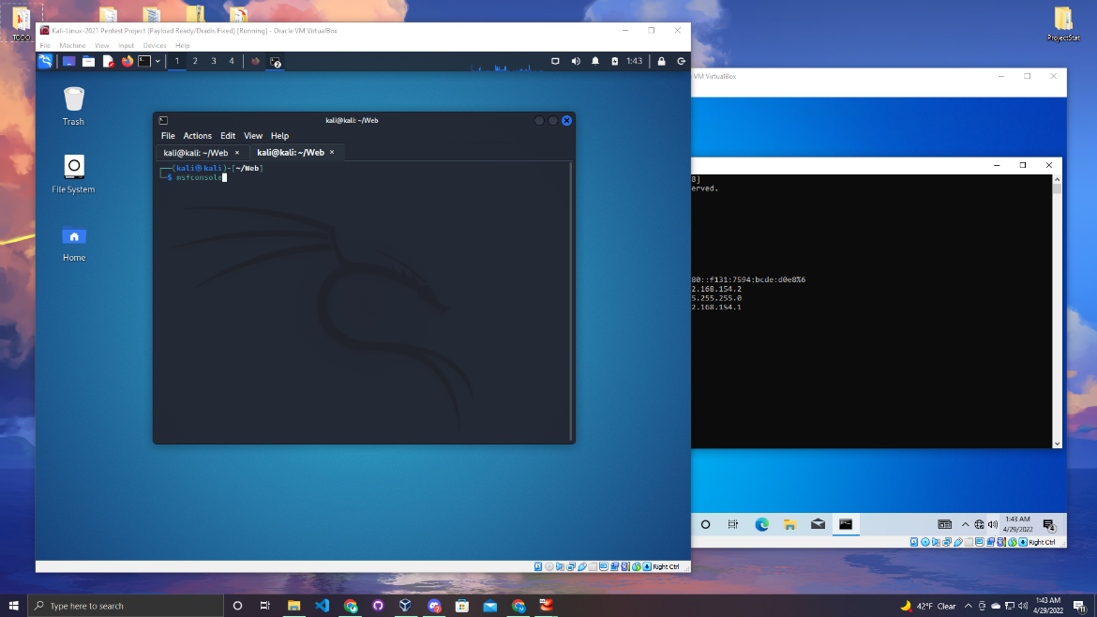

Give the application a minute to load up.

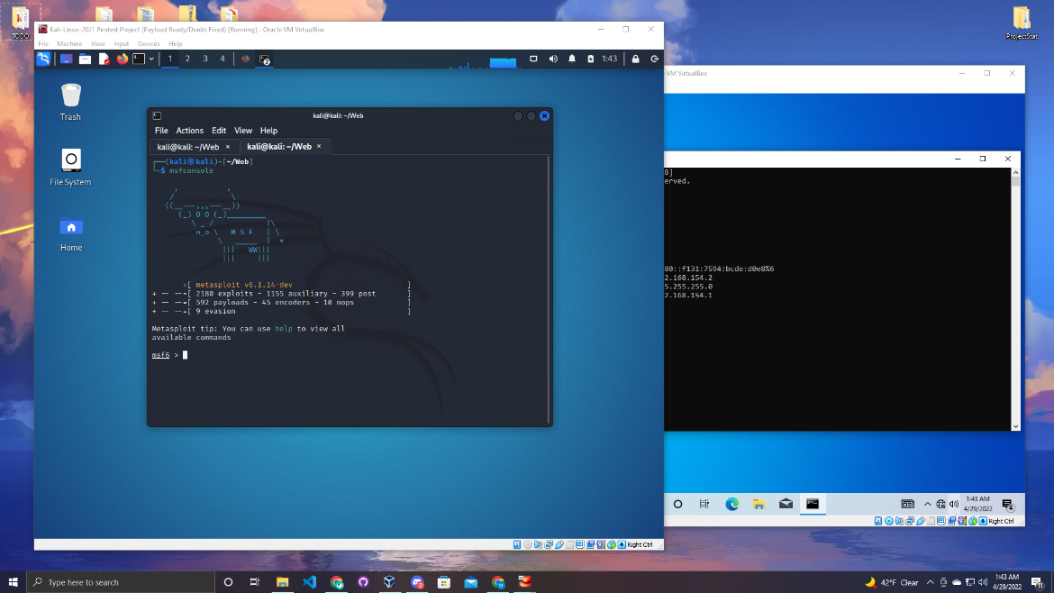

Once it is up and running enter the command to use the multi handler.

Linux Command:

Use multi/handler

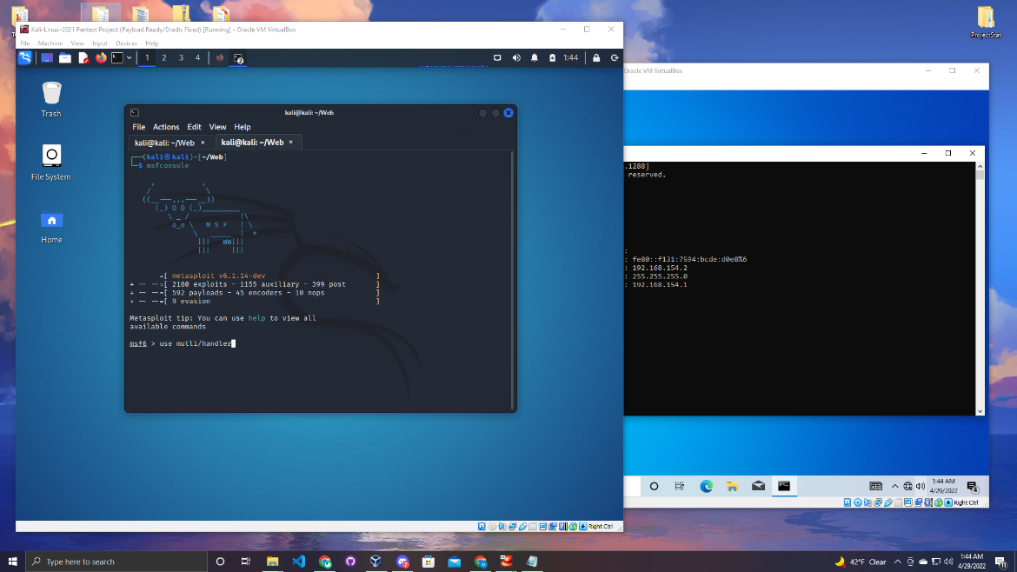

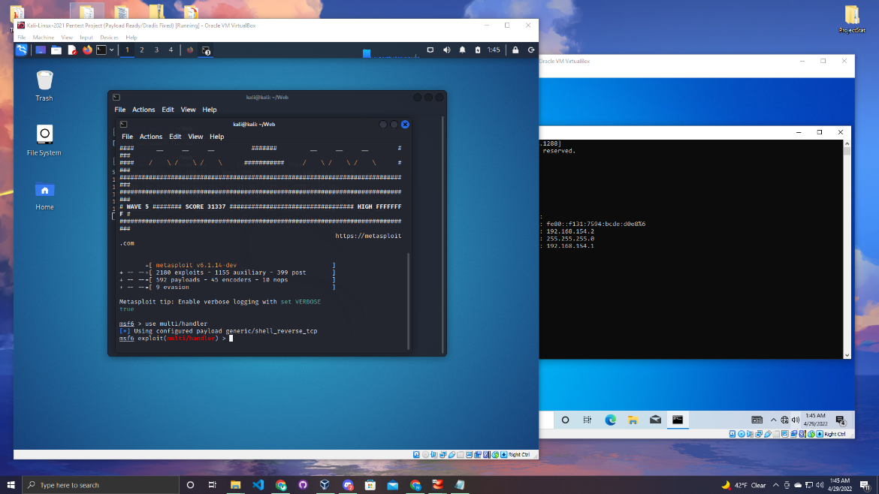

Once that command goes through you will set the payload it will be the same as you used when you created your payload. Enter the command below.

Linux Command:

set payload windows/meterpreter/reverse_tcp

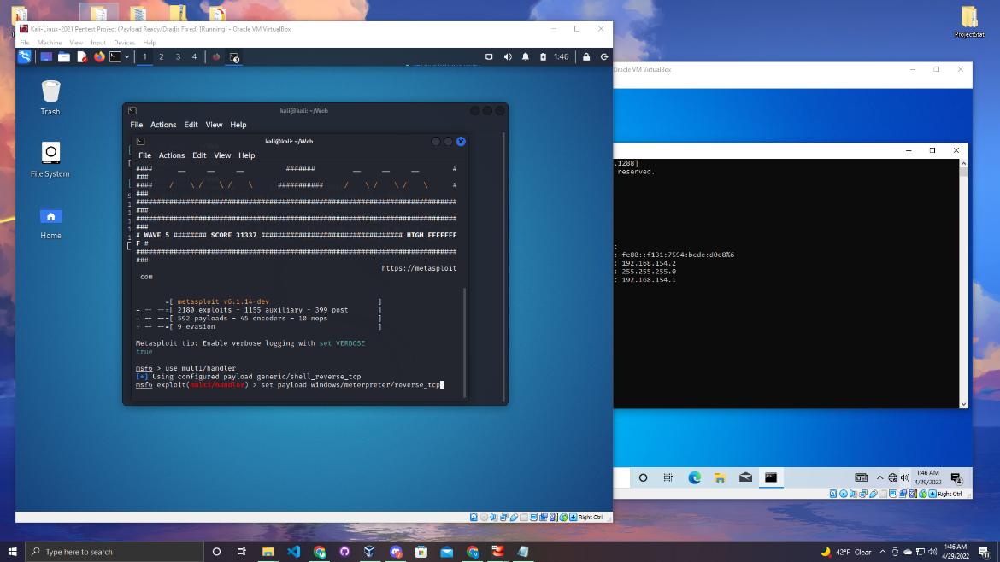

Once the payload is set you need to set the LHOST and LPORT. Follow the images below and set it to the proper IP address and port number.

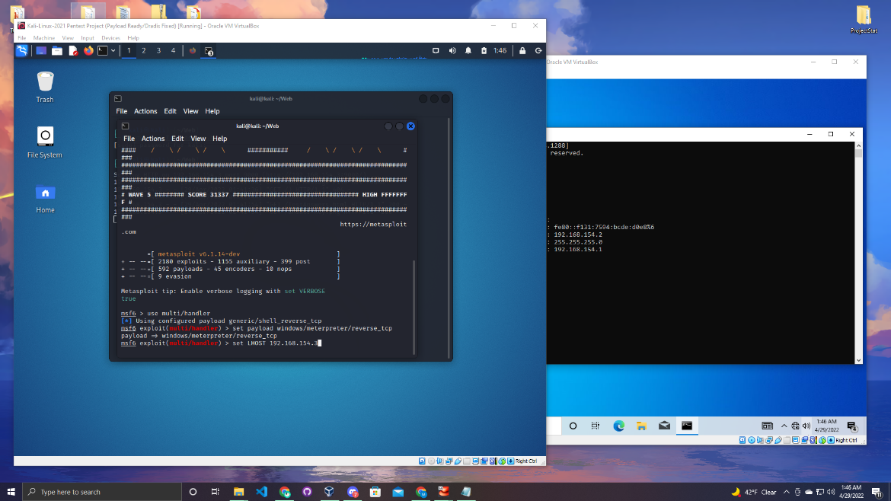

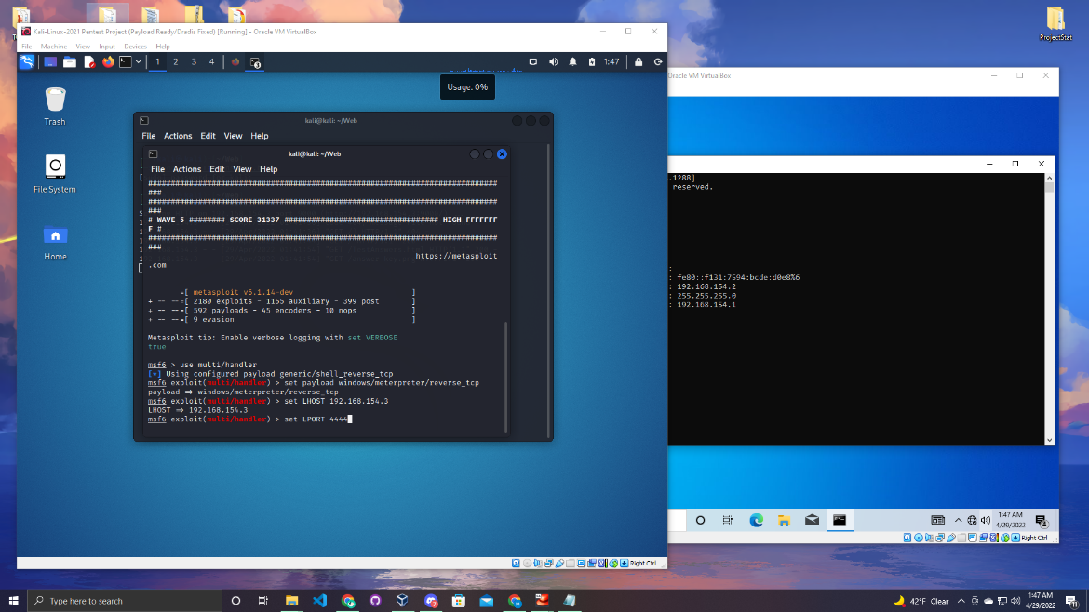

Now enter run to start the exploit. Wait until the user opens the file.

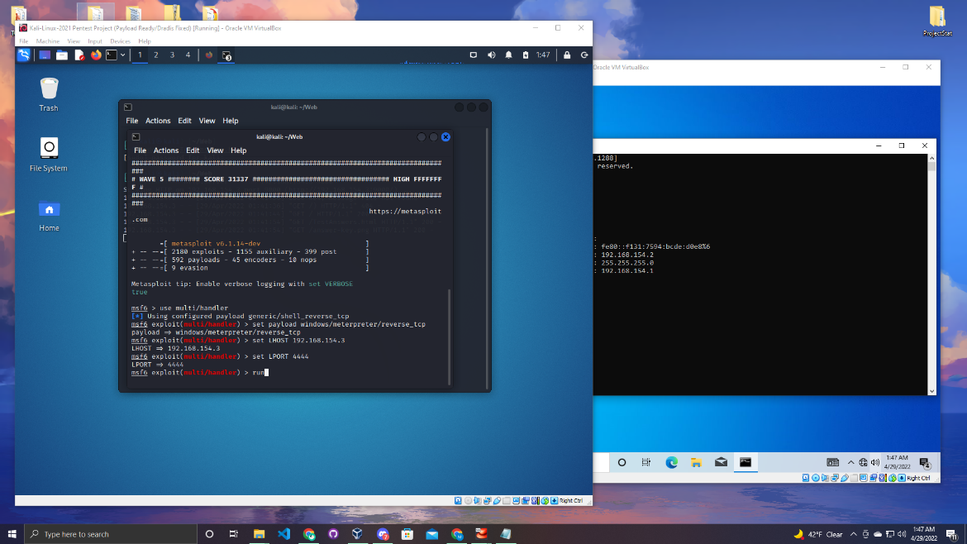

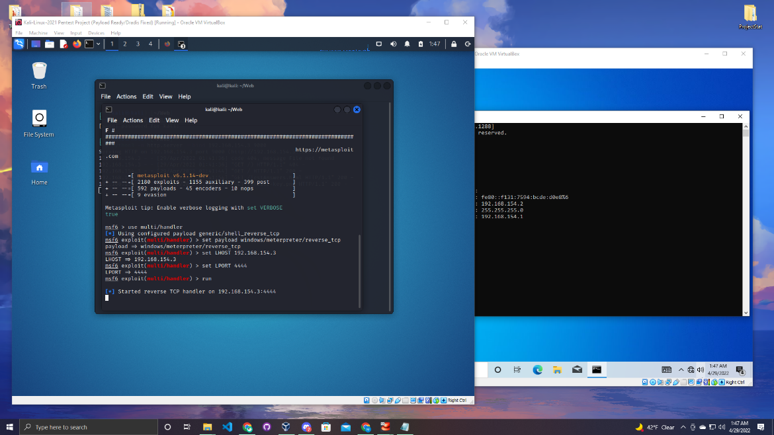

Now if you want the attack to run smoothly for this project turn off the firewall and virus and threat protection. Go to Windows security and turn them off.

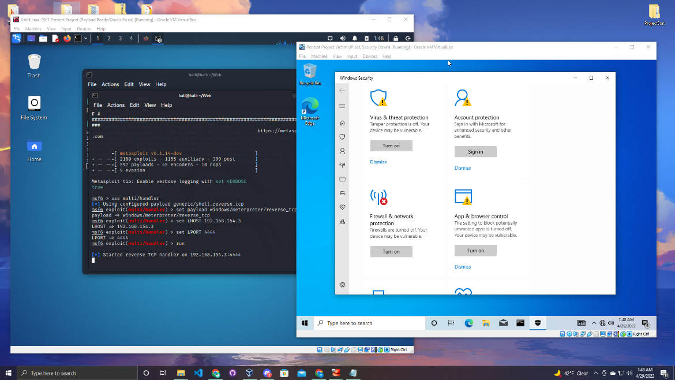

Now enter the address in the url bar and press enter. This is simulating Paul going to the web site because he listened to Joe.

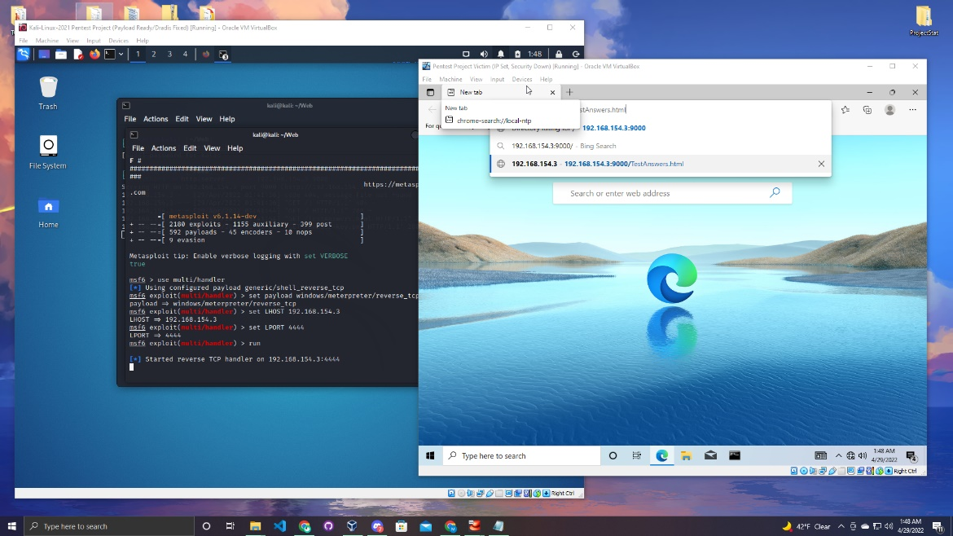

Once click enter the web server should appear. On the Windows machine click on the image and it will start to download on the victims computer.

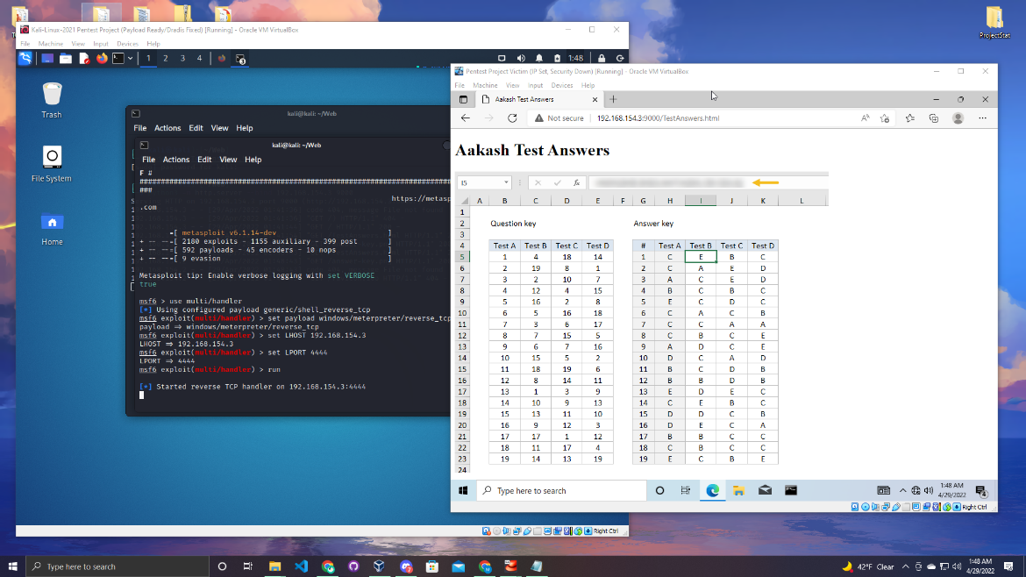

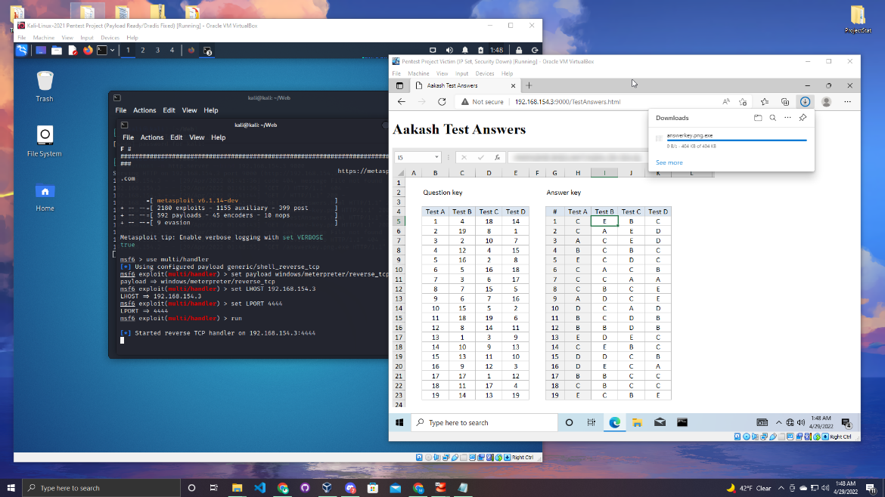

Once it is download go to the downloads folder and open the image.

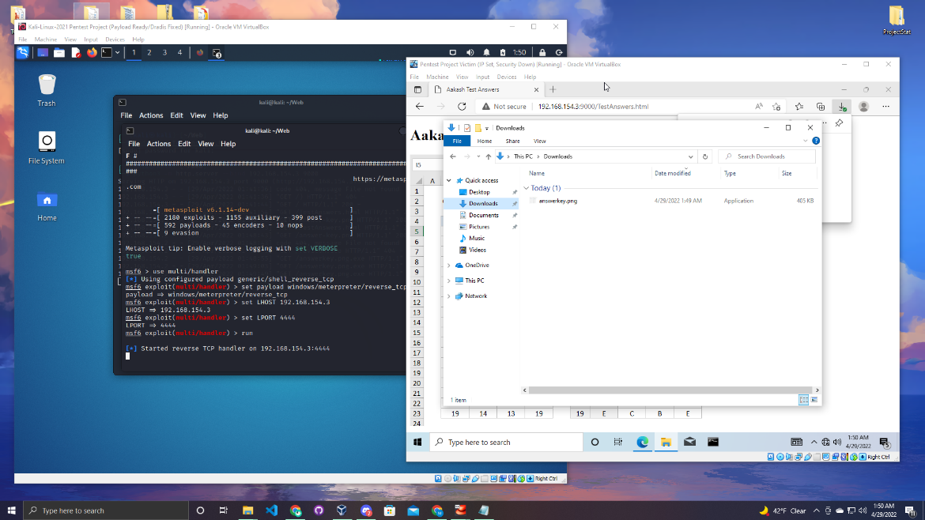

You will receive a pop up click run to run the exploit.

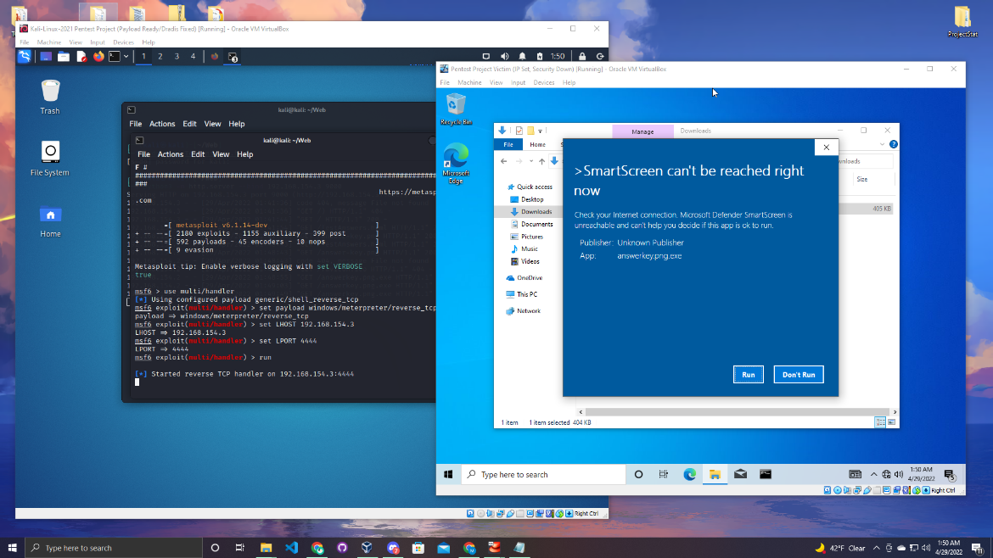

One it is running the image will open up as a normal image. But if you look on the Kali machine meterpreter was activated. Now Joe has full control over Paul’s computer.

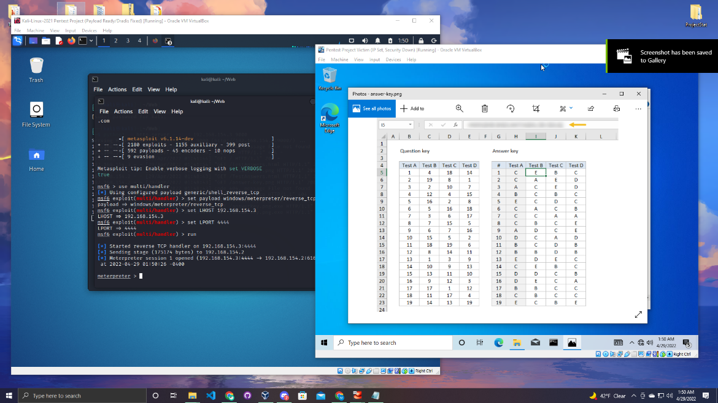  
Once you receive the meterpreter console you can type the pwd command to see what directory you are in.

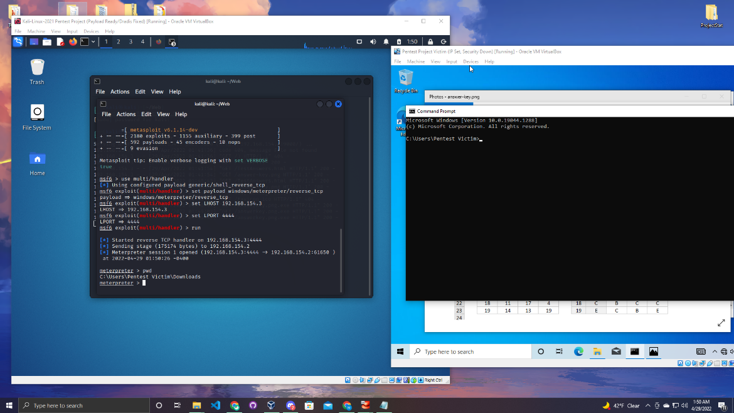

To display how powerful this tool is some of the features can be executed below.

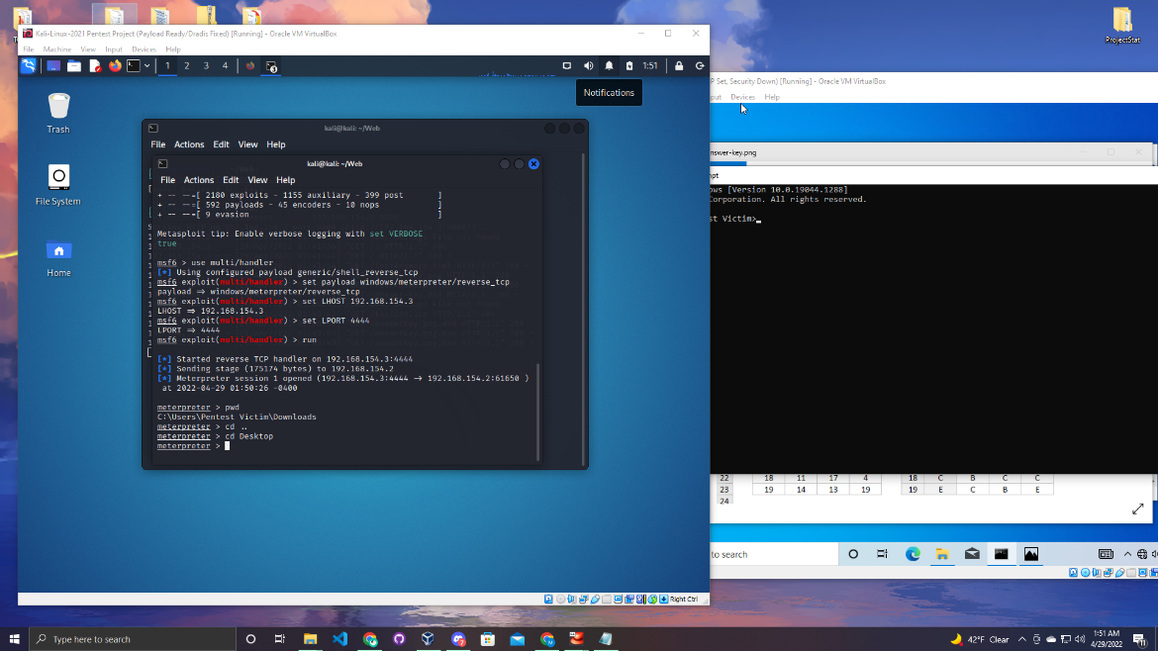

Once on the desktop we run a ls command to see what files are on the desktop. Paul is not a smart guy he keeps his password in a txt file on his desktop.

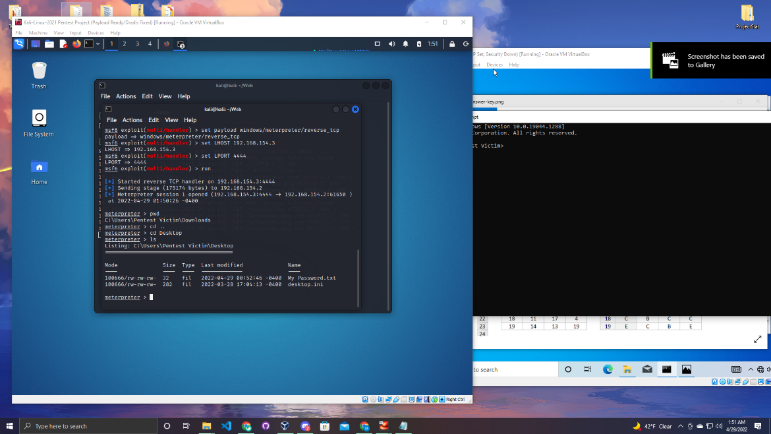

You can run the cat command to see what is in the text file.

Linux Command:

cat file

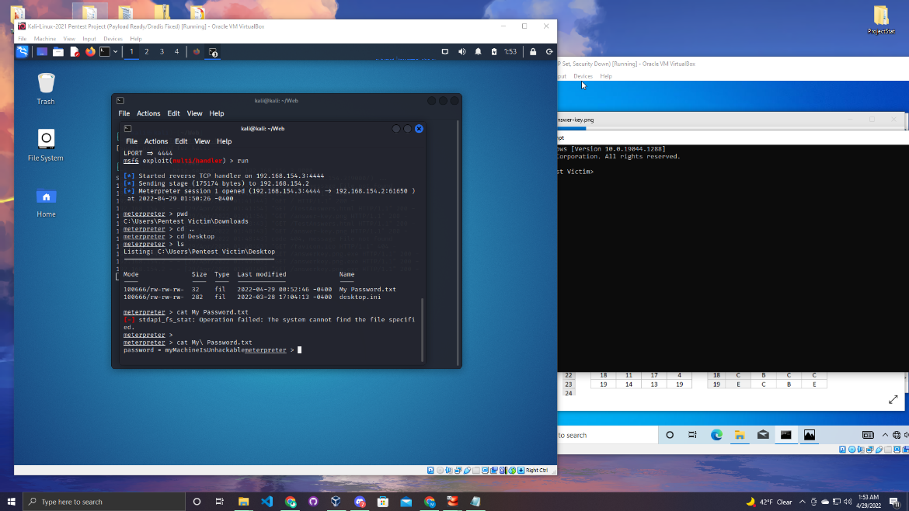

You can also run the edit command to edit the file. In the images below you can see the message will be modified and saved.

Linux Command:

Edit (file)

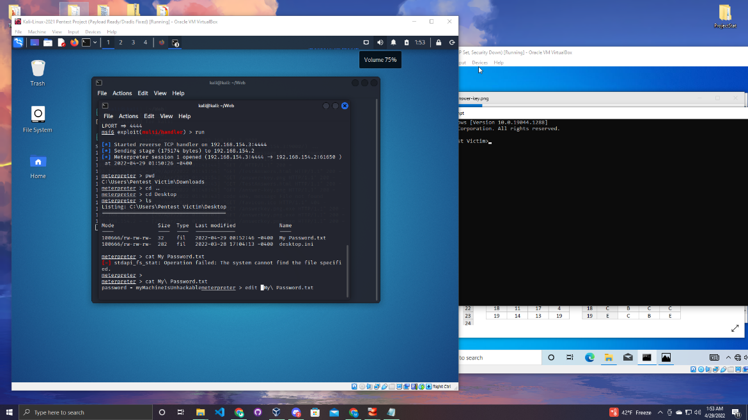

Enter :wq at the bottom of the page to save and exit.

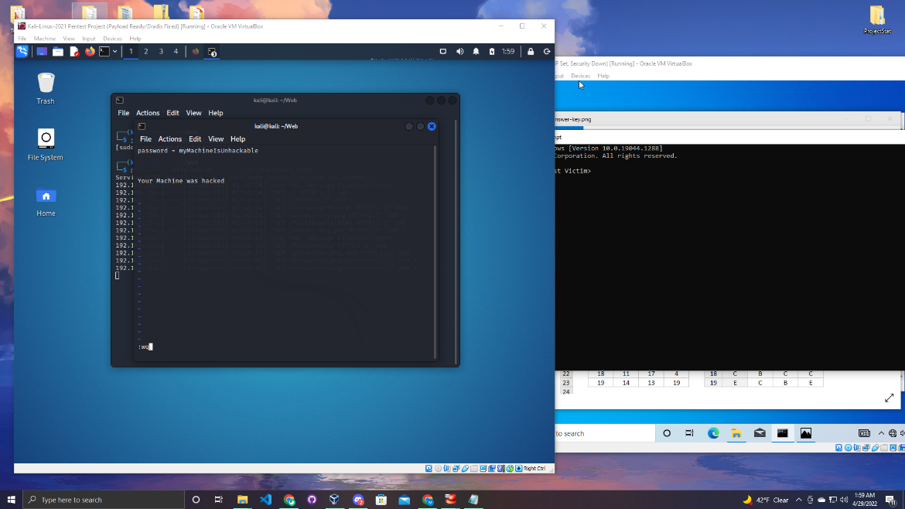

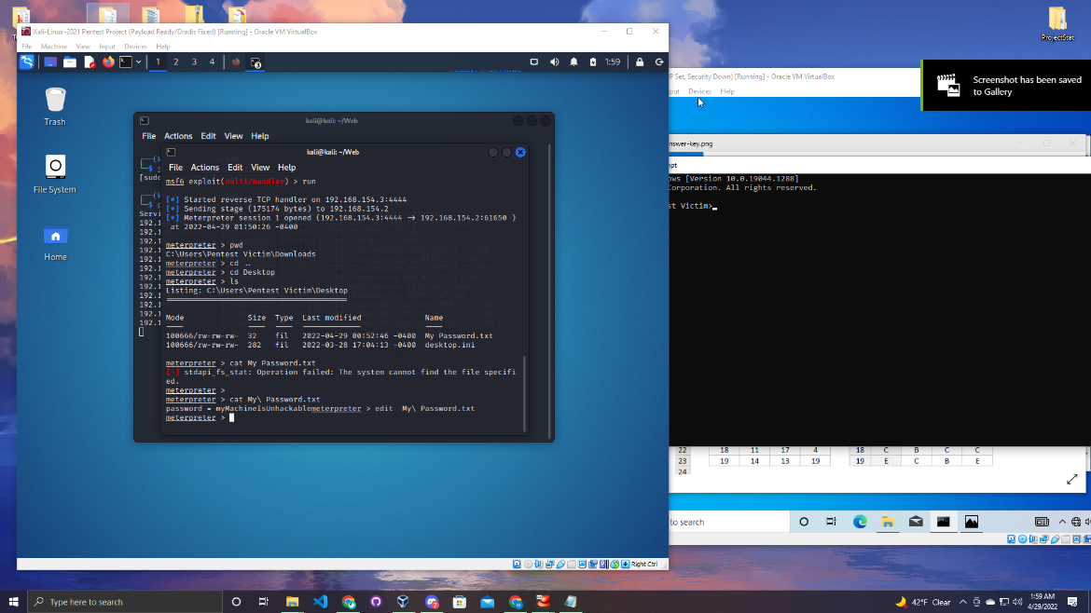

As you can see if you open the Windows machine, you can see the text file has been modified.

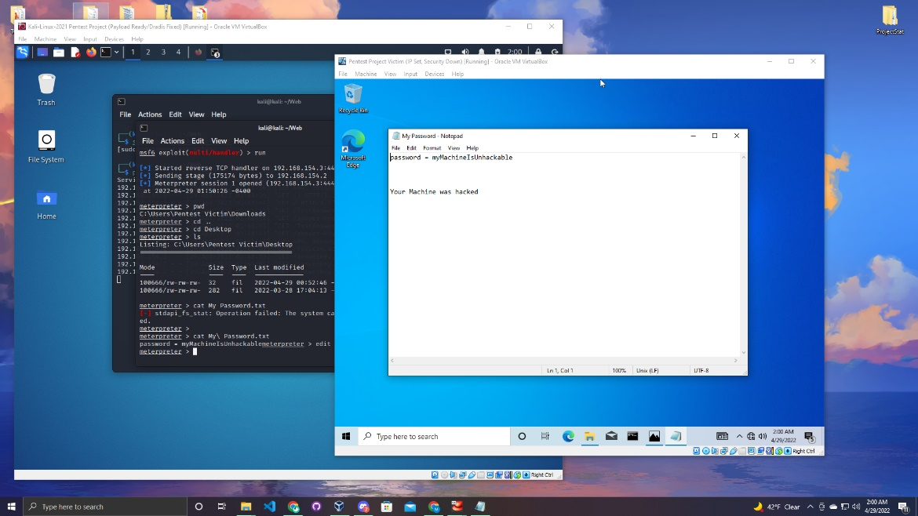

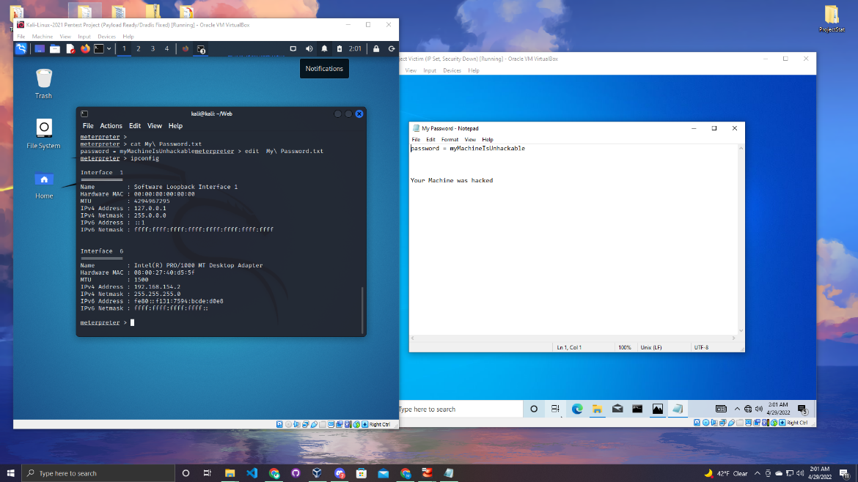

You can also run the shutdown -f command to turn off the victims computer.

Linux Command:

Shutdown -f

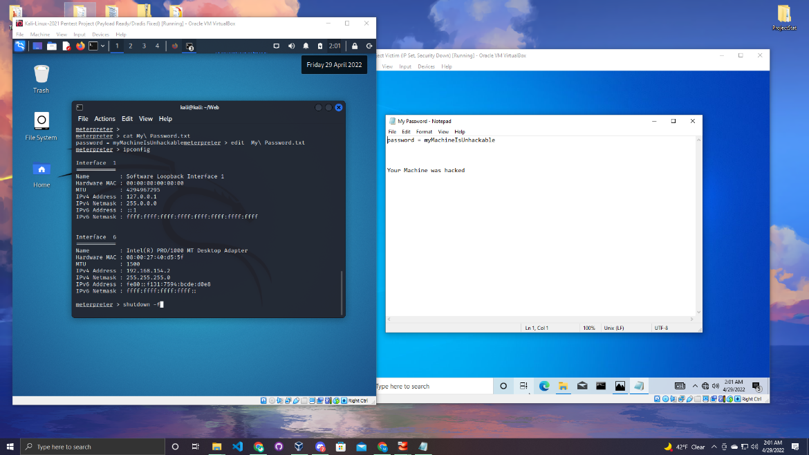

The whole device shuts down in one command.

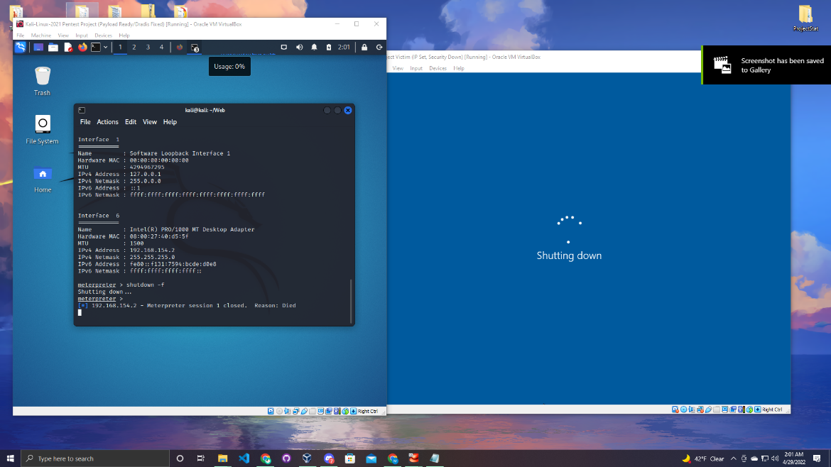

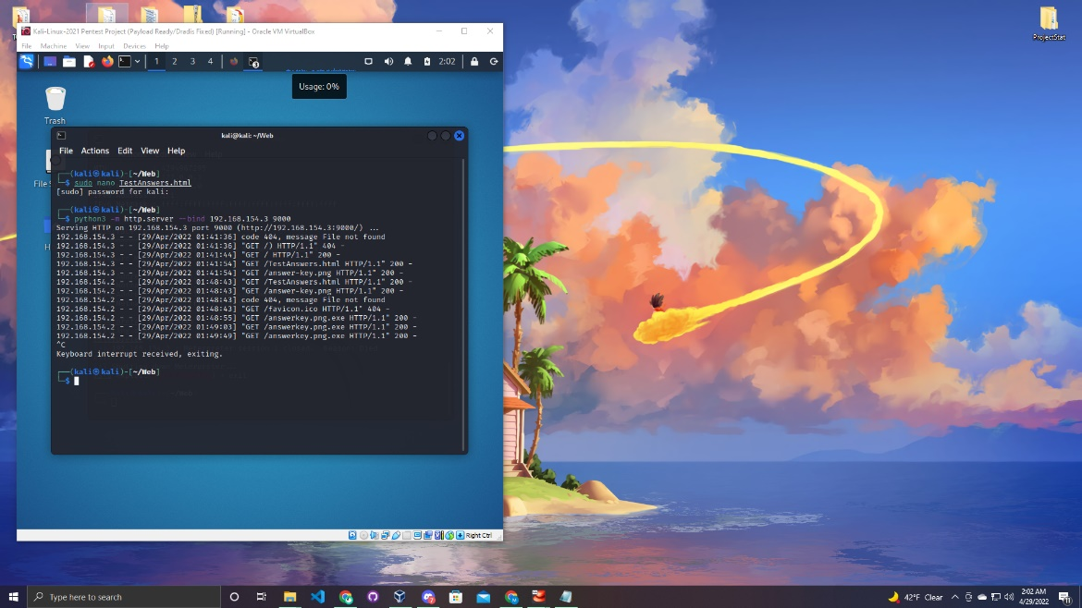

You have successfully attacked a windows machine! Go back in and test out other commands to learn what else you can do with meterpreter.

Section

7

Dradis Reports

In section 7 it will be a small tutorial how to use Dradis and how powerful it can be. First run a nmap scan and use the -oX to generate a xml file after the scan is complete.

Linux Command:

nmap -oX (nameofthefile.xml)(IP address you are scanning)

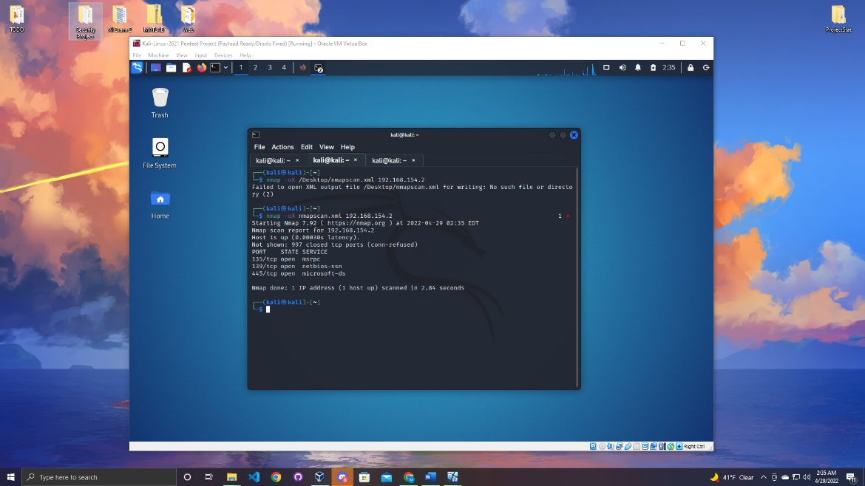

As you can see below the file was created after the scan was complete.

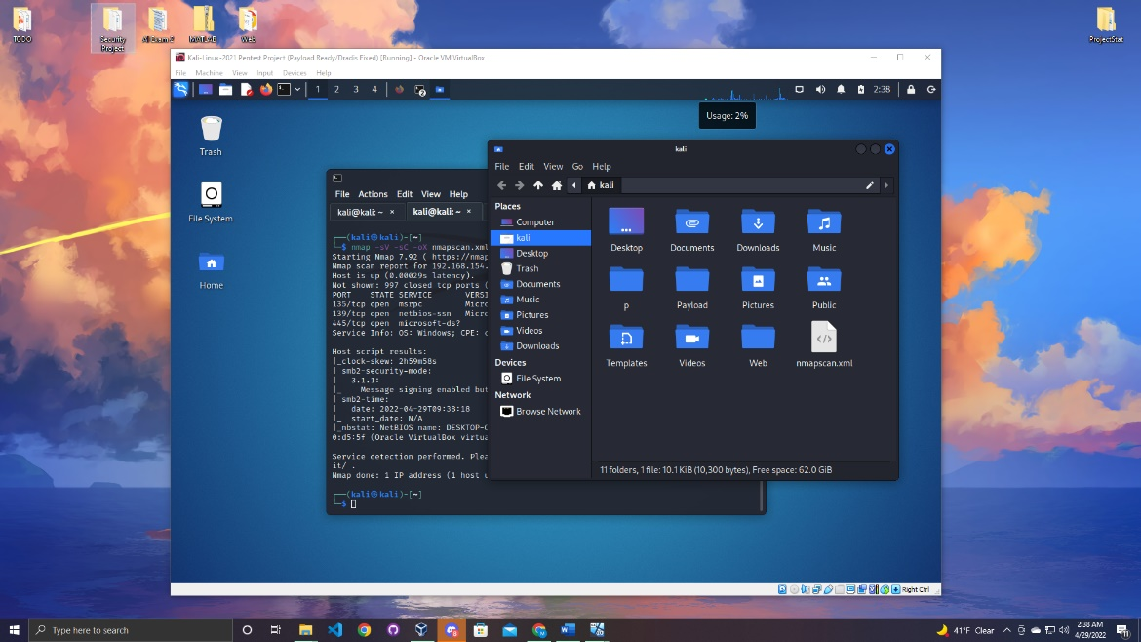

Now Start the dradis server and log in. Once you are logged in and on the home, page click the upload button at the top menu.

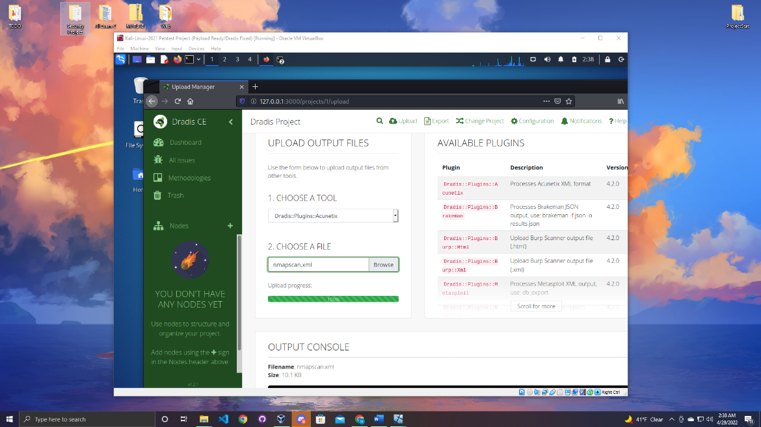

Click the browse and upload the nmap file. As you can see after the file was upload it generated a very neat page of all of the information in that file.

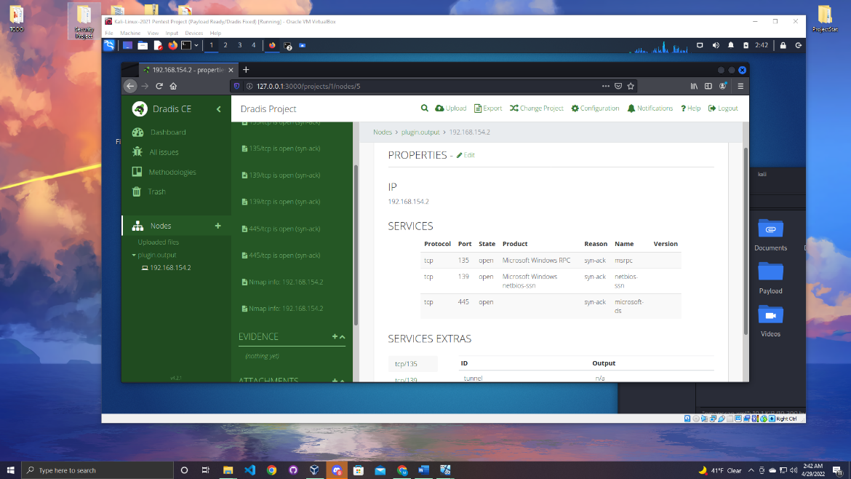

The amazing aspect about Dradis is you can upload all types of files from different applications and it will generate a really thought out report that is very easy to read and understand.

Section

8

Conclusion

In conclusion this project was a wonderful experience. As someone who is striving to be in the security field this lab has helped me learn to set up devices on my own. Now I will be able to set up and conduct safe attacks during the summer. This project was by far the most favorite project I have ever done at Stockton University. The project has given me the skills I need to further develop my skills as a cyber security professional. This project has also taught me how to deal with errors and trouble shooting. Before this project when I would to run tests on machine and try to get into devices I would run into many errors and never be able to understand how to fix the issue. But after this project I am able to solve some errors to proceed forward in the project. As an example, I was having trouble with loading the http server on the Kali machine after doing some research I figured out that there is a slightly different command for python 3. I can confidently say that over the summer I will be using this project to test out more attacks and learn as much as I can about this wonderful field.